RE LESSON 10 WEEK 5
LO: To able to describe and explain the actions of someone who acts as a response to their faith. AT 1 (iii) Levels 3.

HOM: Applying previous knowledge.

Let’s start today with a ‘Reflection’. We have not completed one of these for a while. As you complete this reflection, I want you to focus on remembering that in all that we are personally going through and what the world is going through, at this time, God is always with us.
God is that little soft voice that whispers in your ear
God is the bright sunlight light that reminds us that it is a new day
God is the gentle patter of rain that speaks on the glass of our window’s reminding us that God gently nourishes the earth, so that new life can spring forth
God is the strong wind blowing reminding us to stay strong in our faith and to always live in HOPE.
God is always with us.
REFLECTION
Ensure that as you complete this reflection you try to be in a space that is as quiet as possible. If you are in a room with a TV on, ask your parents if they could put the TV on mute for a while and perhaps join you in your RE reflection.
All ready?........ Take a deep breath……. Click on the link…… Close your eyes and listen.
https://www.youtube.com/watch?v=HIWEHD1wEFc
Think about the message this song is conveying to you. In everything we do, everywhere we go God is right there.
At the end of this reflection say the prayer below aloud as a family.

This is a good time to discuss how you all felt as you meditated on this reflective song.
Blue Hat: How did you feel during this reflection?
________________________________________________________________________________________________________________________________________________________________________________________________________________________________________________________________________________________
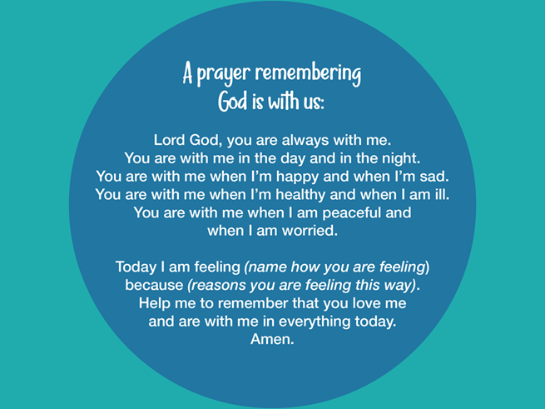
INTRO
This last lesson of 3 is ‘Layer 3, The top layer’. In this lesson we ask a very fundamental question
Is Pope Francis a person of faith?
To complete this task you will need to carry out some independent research in order to be able to confidently answer this question, using supporting evidence.

TASK
Your research will require you to look at
- Pope Francis Twitter account to see what he is doing or saying. https://twitter.com/Pontifex
- Instagram account to see what he is doing or saying. https://www.instagram.com/franciscus/
- Green hat:/Blue hat: Is there evidence in his actions/words that could be used to charge him with being a person of faith?
- You must watch his videos, track his movement and read his tweets….is he a person of faith moved by the Spirit? Prove it!

Make separate notes during your researching of things that you find to be significant and/or quite interesting.

As you track Pope Francis very carefully, use these question prompts to help you organise your ideas for your writing task. On the basis of the ‘evidence’:

- What is Pope Francis like?
- What does he see as his purpose in life?
- What does he regard as important in life?
- What marks a person as successful?
- What drives him to act as he does?
- What motivates him?
- What picture do these actions give us of this man?

Your task will be to write explanatory paragraphs that help answer the BIG QUESTION.
Use the prompts above to help you organise your paragraphs but remember each paragraph should contain detail and strong evidence from the research that you carried out.
Make sure that the work is clearly set out and that you use punctuation accurately throughout

As you complete this work try to remember that this is a levelled piece. I have indicated below some of the factors that will count towards your work being a level 3 or a level 4.
You will be getting your mind focused on going into year five soon, so you need to be pushing the ideas that you include in your RE work towards achieving an emerging level 4 at this point in the academic year.
Give reasons for certain actions by believers
(AT 1 (iii) Level 3)
Here you are using a given source, eg you may only look at Pope Francis’s twitter account
Here you are expressing a point of view
Show understanding of how religious belief shapes life
(AT 1 (iii) Level 4)
Here you are using several sources, this is where your independent research supports your work, as you need to quote your source within your work.
Here you are expressing a point of view and giving reasons for it

Here you are making a judgement
In order to achieve a Level 4 – you need to draw conclusions about what guides a person’s whole life, based on a number of individual actions or behaviours.

