RE LESSON 7 WEEK 5
LO: To know and understand more about the head of the Catholic Church
HOM: Remaining open to continuous learning.
INTRO
The Church believes that the Spirit, which came at Pentecost, remains in the Church and world today. Just as it energised and enabled the disciples to speak to the crowds in Jesus’ day, it now guides Christians today. The Spirit now guides Christians today in how they act and in what they say.
Our learning now is moving on to looking at a particularly important person in the Church today and how they live as a person led and inspired by the Spirit.
Look very carefully at the image below and then answer the questions that follow it.

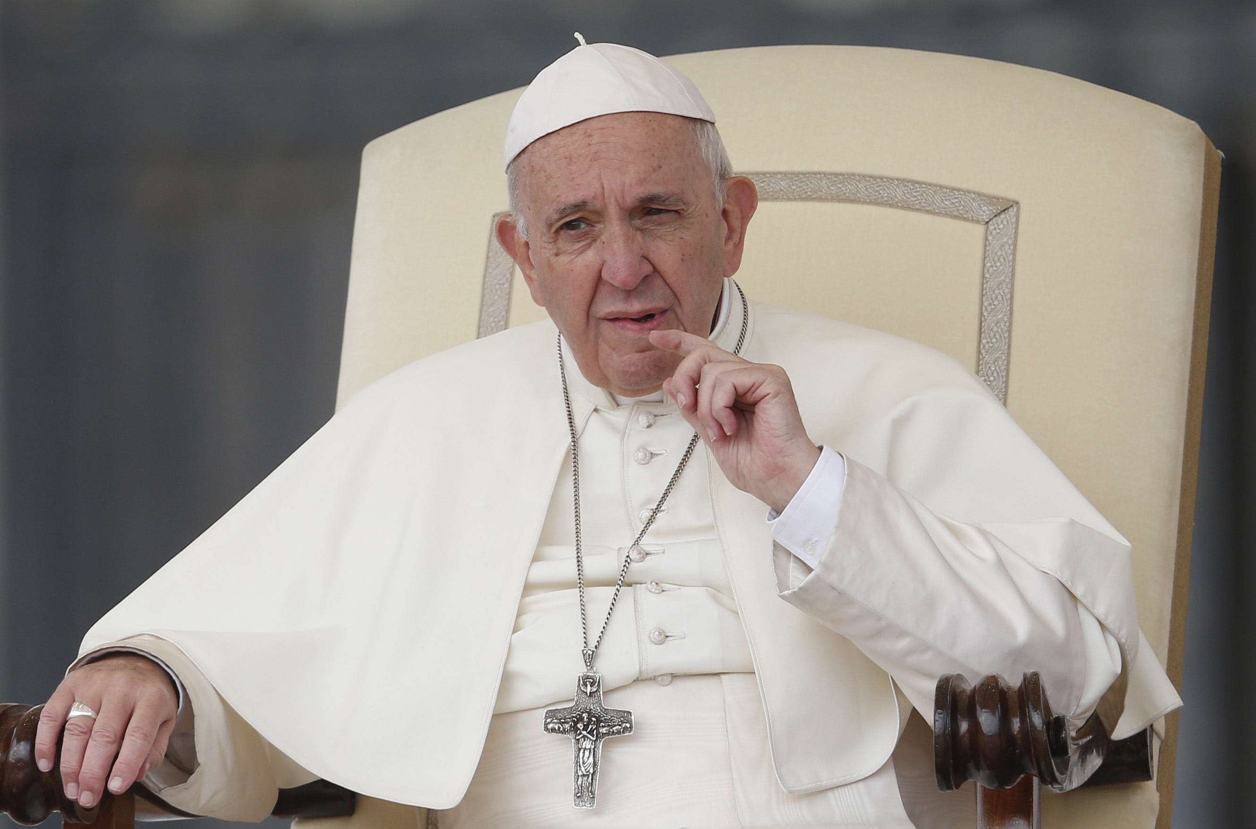
White hat: Who is this person? _____________________________________

White hat: What is his name? _____________________________________

White hat: What does he do? __________________________________________________________________________________________________________________________________________________________________________________________________________________

White hat: What is he wearing?
This question needs you to carry out a little bit of research before you answer the question. This very important person to our Church, has decided to dress very differently to the way others before him have dressed. Do a Google search and see what you come up with, Ask an adult to sit with you and support you as you carry out this task, then list the items being worn below.

HINT: I have given you a hint of how many items you need to name, that the ‘very important person’ in our Church wears.

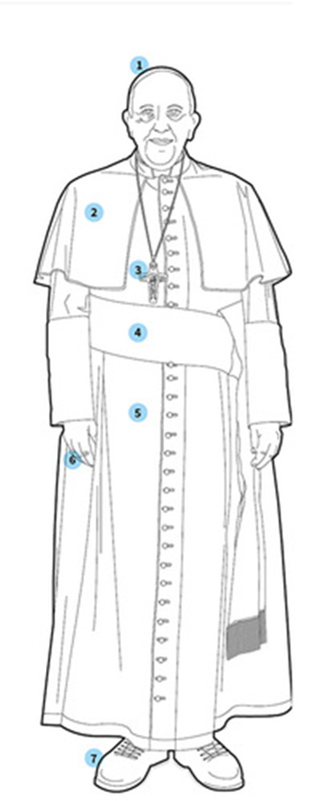
- _____________________________
- _____________________________
- _____________________________
- _____________________________
- _____________________________
- _____________________________
- _____________________________

White hat: Why does he wear white?
_______________________________________
________________________________________
_______________________________________
_______________________________________
_______________________________________
____________________________________________________________________________________________________________________________________________
White hat: Why is this man important?
__________________________________________________________________________________________________________________________________________________________________________________________________________________
Some fun facts about Pope Francis.

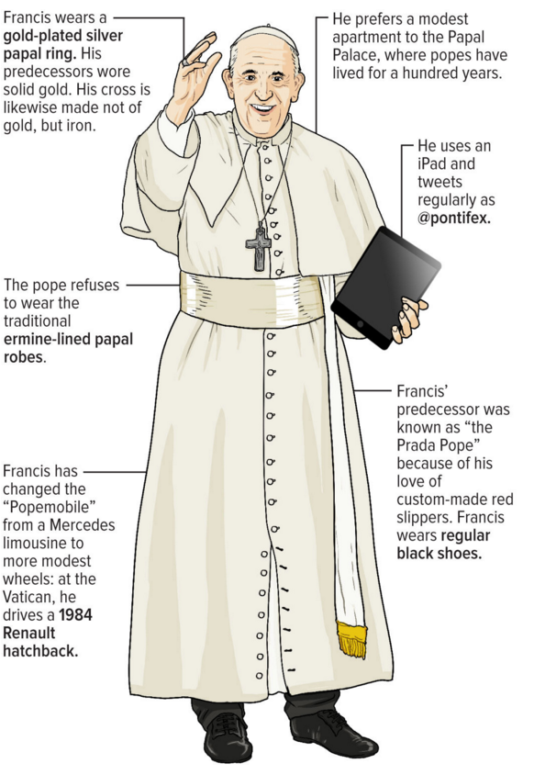
Look at the difference between the items that Pope Francis wears to what was worn by the previous Pope.
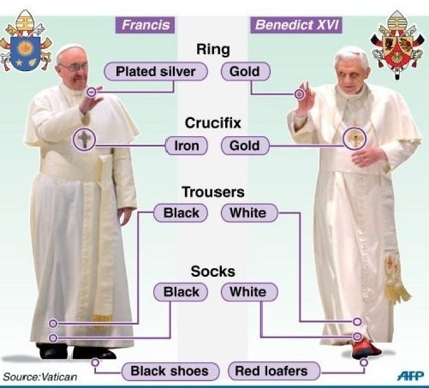
Blue hat: Using this image above what do you think this tells you about the ‘character’ of our present Pope and how he chooses to live his life?
________________________________________________________________________________________________________________________________________________________________________________________________________________________________________________________________________________________________________________________________

TASK
Your task now is to create a fact file/booklet or brochure about Pope Francis. Below you have been given a series of questions that you need to include within the piece of work that you choose to create.
Use these questions as sub-headings for your fact file or brochure or as page headings for your booklet.
You will need to carry out some independent research using the internet in order to complete this task. This means that you will need to make notes so that you can complete the task in a detailed way.
Find pictures from the internet to include in your work to make it more appealing to the reader. (Ask an adult to sit with you whilst you do this!)
QUESTIONS TO BE ANSWEED
- Where and when he was born
- The names of this parents and siblings
- Some information about his early life before becoming a priest
- When he became a priest
- When he became a bishop
- When he became an archbishop
- What his values were during these times and where he lived
- When he became Pope
- Where he chooses to live now?
- How does he live his life now and why does he choose to live like this?
- What do these actions/choices tell us about what Pope Francis believes?
- Why does he act in this way?
- What is his vision for the Catholic Church today?
- Include a section on some of the things he has done to show that he is filled with the Holy Spirit eg washing prisoners’ feet, visiting the poor people in their homes, visiting the sick, raising money to help the hungry, living a simple life.

Creating a lovely booklet would be a really nice choice, as you have the time now to spend on it. Include an image of the Vatican flag and coat of arms when you create your booklet, as these are important symbols/emblems of the Pope.

Enjoy!

