SCIENCE LESSON 5 WEEK 5
LO: To be able to identify different food groups and their purpose.
To understand and be able to recognise what a healthy balanced diet
is.
HOM: Thinking and communicating with precision.
INTRO
In today’s lesson we will be taking a close look at how our food is grouped, which foods are better for us than others and what foods we should ensure that we eat in order to keep our bodies healthy.
There is quite a bit of work to do here, so be sure to read the instructions for the tasks very carefully.
STARTER
In the box below write down everything that you ate yesterday
Breakfast | Lunch | Snacks | Dinner

White hat: What is your favourite food?
In the box below write a favourite food that you have for each section. Remember your favourite food can be a food from a home/heritage country eg, Lasagne, Burritos, Saltfish and dumplings, Banku. It does not have to be British food eg Fish and chips.
Breakfast | Lunch | Dinner

White hat: What does the word ‘diet’ mean? Explain clearly.
________________________________________________________________________________________________________________________________________________________________________________________________________________________________________________________________________________________
STOP! You now need to open the powerpoint presentation called THE BALANCED DIET.
White hat: How much of our body is made up of water?
__________________________________________________________________________________________________________________________________________________________________________________________________________________
White hat: Which organ in our body holds the most water?
__________________________________________________________________________________________________________________________________________________________________________________________________________________
White hat: What is the recommended amount of water for a child to drink daily? What about an adult?
__________________________________________________________________________________________________________________________________________________________________________________________________________________
White hat: Why is water important in our diet?
__________________________________________________________________________________________________________________________________________________________________________________________________________________

Wonderful.
Now you need to go to the second powerpoint in order to complete the next part of this task.
The task that you need to complete is at the end of the powerpoint presentation. Read it carefully then complete the task below. As an extra draw your healthy dinner.

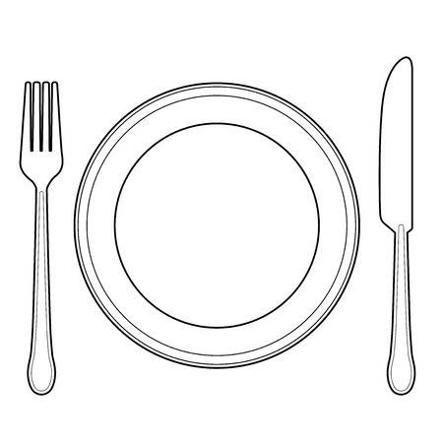
List the foods and the quantity given on the plate under each of the headings, eg a whole tomato sliced. Label your food group headings

