HISTORY/ENGLISH VE DAY WRITING CROSS-CURRICULAR LESSON LINKS.
LO: To understand historical events. HOM: Remaining open to continuous learning.
INTRO
On Friday 8th May the country marked VE DAY. Under the present circumstances it was not marked in the way that the country had intended to celebrate it and this was understandable. ‘Lest we forget’ and in celebration of Victory in Europe Day (V.E. Day) your task will focus on these events. The requirements of this writing focus are: -
- To use your senses to describe a picture
- To write a summary about a video that you watch
- Write a letter explaining how V.E. Day is celebrated today.

TASK 1
Look carefully at the image below. This image shows the bomb damage in London in 1944.
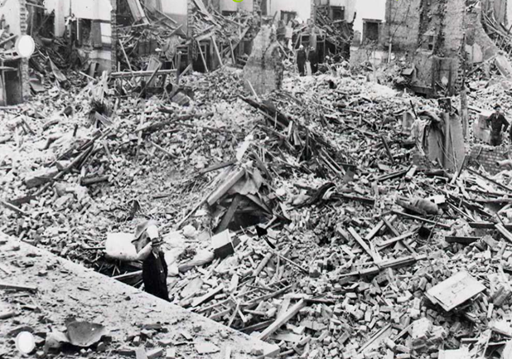

Your task is to image that you are the person walking through this damage surveying what has happened. Take your time to closely observe the image. You will then expertly use your five senses to describe through recording: what you see, hear, taste, feel and lastly what you touch.

Use the chart below to record your answers.
USING AN IMAGE AS A STIMULUS
SENSES | YOUR RECORDING
What you see
What you hear
What you taste
What you feel
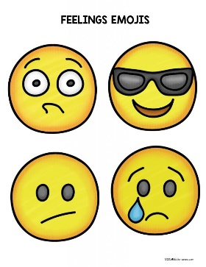

What you touch
TASK 2
Your next task requires that you click on the link below and watch the entire VE Day video. Watch it through once and then re-watch it and complete the task.

https://www.bbc.co.uk/teach/class-clips-video/history-ks2-ve-day/z7xtmfr

On your second watch you need to make notes using bullet points about the key events in the video.
There should be at least 5 key points taken from the video. It is important that you ensure you include as much detail as possible in each point you make as this will help you to complete each of the tasks listed below as we progress through this activity.

Here I have modelled an idea for you. If you use my idea to begin your work, it is essential that you include much more details to this section (bullet point or numbers) than I have.

Example
1. In 1945, WWII had gone on for 6 years. The people of Britain were tired, and life was difficult.

I have used emotion to add detail to my sentence and I have shown that I understand that life could not have been easy for them after all this time. This should be easy for you to relate to, as we are presently feeling the effects of a lockdown, and you are able to express how you feel at this time.
- Read back through each section as you write it.
- Watch the video again checking for accuracy in your details. Have you missed anything that could be important? Have you captured minute details that could add to your work late on?

Below you will find a blank chart that you may find useful to organise and write your ideas in.
Well done for completing an exceptional two pieces of work on this task so far.
EXTRACTING INFORMATION FROM A VISUAL SOURCE
Point 1

Point 2

Point 3

Point 4

Point 5

TASK 3
White hat: Who was Winston Churchill?
__________________________________________________________________________________________________________________________________________________________________________________________________________________
Look carefully at this telegraph that was sent to Winston Churchill.
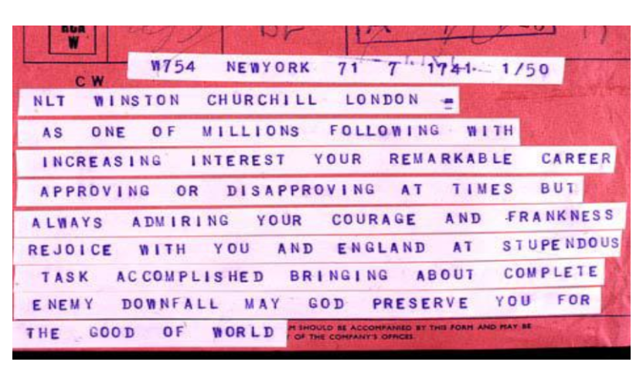
Your next task is a ‘slow write’ so that you are able to put all your ideas together in the best possible way. You are encouraged and challenged here to use emotion words and personification.
White hat: What is personification?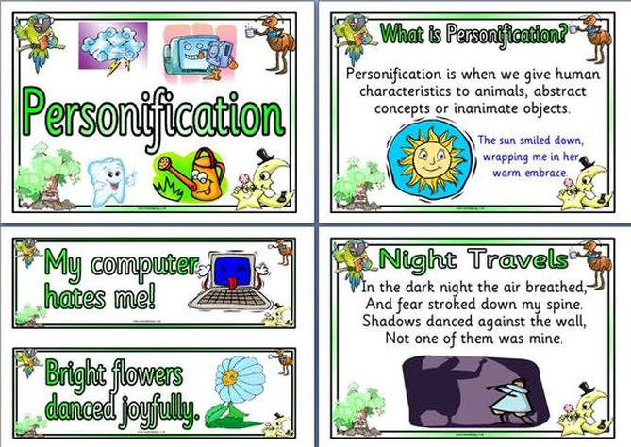
You are to write a letter in the first person as Winston Churchill (former UK Prime Minister), responding to the telegram and explaining FOUR challenges that you (Churchill) faced after V.E. Day.

You must try to think like a Prime Minister
- Your country needs you what will you do?
- Where will you start?
- What is the most important thing to put in place?
- How will you go about rebuilding?
- Do you need to convene a cabinet meeting?
- How did you go about getting all the cabinet together?
- Were you all in agreement of what needed to be done?
White hat: What are the features of a letter?
List them below
- ___________________________________
- ___________________________________
- ___________________________________
- ___________________________________
- ___________________________________
- ___________________________________
- ___________________________________
You can check them against the answers that I have given at the end of this task.
Below you will find a letter starter that you may use if you so wish. If you want to change around the introduction that I have given, please feel free to do so. Remember after the introduction you need to explain the four challenges that you, Churchill faced after VE Day.

FEATURES OF A LETTER ANSWER
- Senders address
- Date
- Reference to whom you are writing eg, Dear Sir,
- Appropriate Greeting
- Introduction
- Conclusion
- Complimentary close
- Senders name/signature

HERE IS MY STARTER:
Dear Sir/Madam,
Thank you for your telegram dated May 9th 1945. I am grateful for your kind words at this time. However, I should stress there is much still to do. To begin with there is still a war to fight against Japan. We also face many challenges back here in Britain and in Europe as a whole. For example…

Have fun writing your letter.

TASK 3
White hat: How is VE Day currently celebrated?
Above is your focus question. This year marks 75 years since the end of the war in Europe. Despite this year’s celebrations being cancelled, the British government and other organisations had set out a blueprint of events that they were going to carry out to mark this very significant date.

Read through parts of the website listed below and write a paragraph in your own words explaining how V.E. Day is commemorated and why.
https://www.veday75.org/

