TASK 2 MODELLING USING SALT DOUGH. – DESIGN AND TECHNOLOGY FOCUS.
To start this task you will need to make some microwaveable salt dough.
This recipe comes from https://rainydaymum.co.uk/the-quickest-ever-salt-dough-recipe/
Click over to her page to get the full clear instructions
What You'll Need:
Pre-made salt dough using
- 1 cup of plain flour (Parents- non expensive please see note below.)
- ½ cup of salt
- ½ cup of warm water
A surface that you can safely wipe down and clear
Your cut sweet pepper
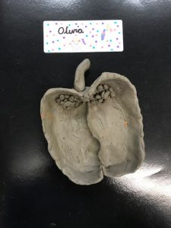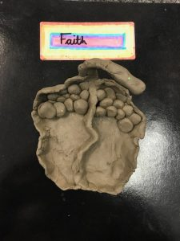

Above are two examples to show you what you need to do. The task is basically self-explanatory.
How persistent can you be at trying to create half a sweet pepper including the seed using salt dough?
Have fun and enjoy.
PS. Perhaps your parents would let you do this task again say with a pomegranate. You want to choose a fruit that has a lot of seeds. Think of some and make a little list, this could be helpful to your parents as they try to support you with this task.

Note to Parents
Flour is difficult to come by at the moment, I know, but the brand that is sold in the Turkish shops is quite suitable for this task.
It is more economical to buy a small bag of salt and then to use the rest in your kitchen. Just a couple of ideas for trying to save on cost here in these challenging times.
Stay safe!

