LO: To know who Henry VIIIs wives were.
HOM: Remain open to continuous learning
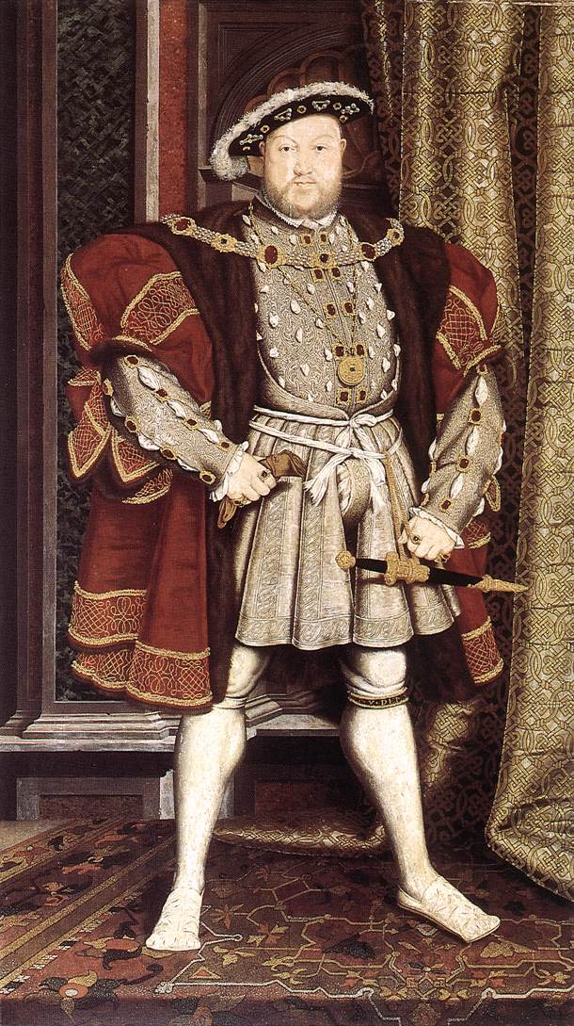
White Hat: What do you know about Henry VIII?
_______________________________________________________________________________________________________________________________________________________________________________________________________________________________________________________________________________________________________________________________________________________________________________________________________________________________________________________________________________________________________________________________________________________________________________________________________________________________________________________________________________________________________________________________________________________________________________________________________________

Henry VIII was a powerful and fierce monarch. He is one of the most famous Tudors in history. Some of the reasons being his total of six marriages that he had in his lifetime and his break with the Roman Catholic Church.

Henry’s Wives:
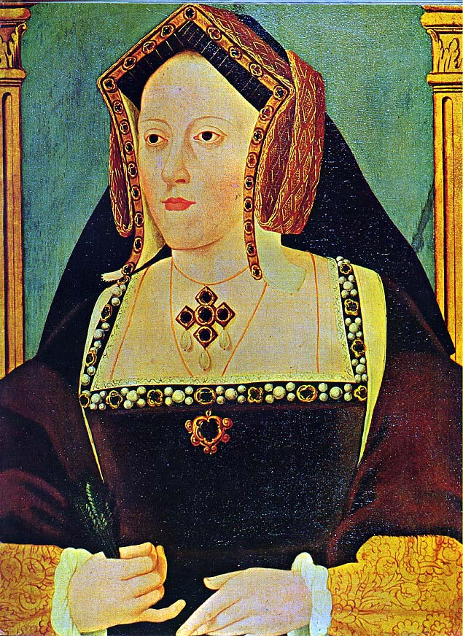
Catherine of Aragon 1509-1533
- Married Henry VIII in 1509
- She was a Catholic
- She had a daughter called Mary who later became Queen Mary I
- Youngest surviving child of the ‘Catholic Kings’ of Spain.
- Age 3, promised to Henry VII eldest son Prince Arthur.
- Age 16, married Prince Arthur until he died 6 months later.
- Age 23, married King Henry VIII on June 11th 1509 in Greyfriars Church, Greenwich.
- Age 30, gave birth to Princess Mary.
- Henry was growing frustrated by his lack of a male heir and divorced her to marry Anne Boleyn.
- Died 7th January 1536 of a broken heart, aged 50.

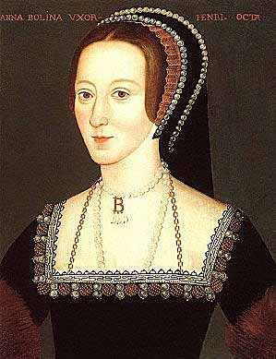
Anne Boleyn 1533-1536
- She married Henry VIII secretly as his divorce was not quite through.
- She gave birth to a daughter who later became Elizabeth I.
But…. no male heir.
- We don’t know her date of birth, it is guessed to be 1501/02.
- She was a lady-in-waiting to Henry VIII sister in France.
- She apparently had an extra finger on her left hand.
- Aged about 31, she married King Henry VIII on January 25th 1533 in Westminster Abbey.
- Aged about 31, she gave birth to Princess Elizabeth.
- Accused of witchcraft and treason she was sentenced to death by her own uncle.
- Died 19th May 1536 in the Tower of London, she was beheaded, aged about 34.

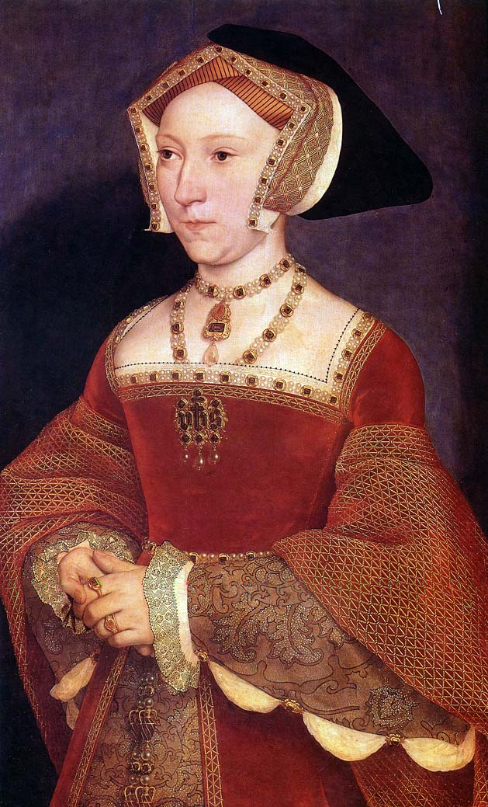
Jane Seymour 1536-1537
- Within 24 hours of Anne Boleyn's execution, Jane Seymour and Henry VIII were formally betrothed.
- She gave Henry a son… Edward.
- We don’t know her date of birth, it is guessed to be between 1504-09.
- She was Lady-in-waiting to Anne Boleyn.
- Aged between 27-32, she married King Henry VIII on 20th May 1536 in York Place.
- It is said that she was the favourite wife of Henry VIII.
- On 12th October 1537 she gave birth to Prince Edward.
- Jane grew sick after giving birth.
- She died on 24th October 1537, aged between 28-33. Henry was heartbroken because he loved Jane very much. Maybe because she gave him a son.

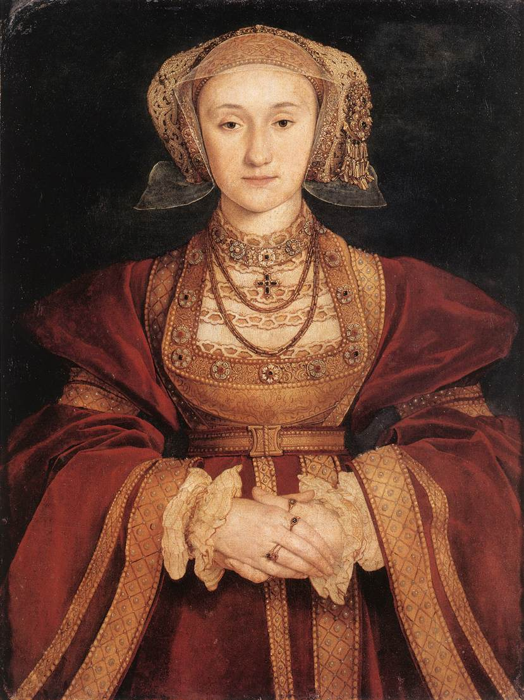
Anne of Cleves January 1540- July 1540
- Born in Dusseldorf (Germany) in 1516.
- After a period of mourning, Henry sent men around western Europe to seek out a new wife for him.
- They were instructed to bring back portraits of the women they believed Henry would be interested in.
- Anne of Cleves was chosen from one such portrait.
- Holbein, a famous artist from the era, was commissioned to paint her portrait for Henry VIII before he met her.
- Age 24, married King Henry VIII on January 6th 1540 in Greyfriars Church, Greenwich.
- 4 months later she allowed King Henry VIII to have the marriage annulled. She did not look very much like her portrait and Henry did not find her attractive.
- Henry ensured she was well taken care of and she lived a happy independent life with many homes in England.
- Died 1557 of illness aged 41.

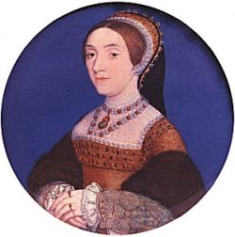
Kathryn Howard 1540 -1542

- We don’t know her date of birth, it is guessed to be 1521.
- She was a lady-in-waiting to Anne of Cleves and the cousin of the ill fated Anne Boleyn.
- Henry called her his ‘Rose without a Thorn’.
- Aged about 19, she married King Henry VIII on July 28th 1540 in Oatlands Palace, Surrey.
- Accused of adultery she was sentenced to death.
- Died 13th February 1542 (6 years after her cousin) in the Tower of London, she was beheaded, aged about 20.

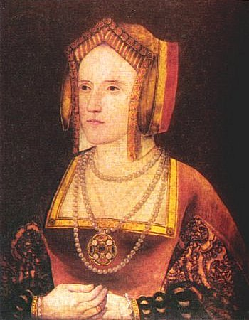
Katharine Parr 1543- 1548
- Katherine Parr was the sixth and last wife of King Henry VIII
- She was also the most intellectual of Henry's wives.
- Born in 1512. She was twice widowed and childless.
- Aged 30, she married King Henry VIII on 12th July 1543 in Hampton Court Palace.
- Henry passed away 28th January 1547.
- She promptly married Thomas Seymour, brother of Jane Seymour, as soon as Henry died.
Katharine had a baby girl on the 30th August 1548 but soon became ill and passed away 6 days later aged 35

Now watch the video below:

https://vimeo.com/90738933

https://www.natgeokids.com/za/discover/history/monarchy/wives-of-henry-viii/
https://www.theschoolrun.com/homework-help/king-henry-viii
https://www.hrp.org.uk/schools/learning-resources/king-henry-viii-and-his-six-wives-fact-sheet/#gs.5qjmr3
https://tudorhistory.org/wives/
https://schoolhistory.co.uk/early-modern/tudors/henry-viii-wives/

TASK: Using the information given and the links above to find out more about Henry VIII wives create a timeline, where you need to include the following information about each wive.

When was she born?
When did she marry Henry?
Did they have any children?
When and why did their married finish?
When did she die?

Here are some examples of how to present a timeline:

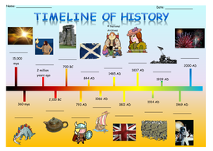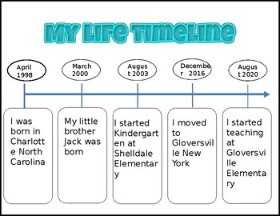

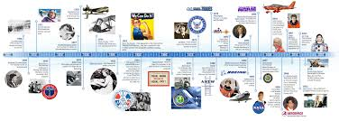

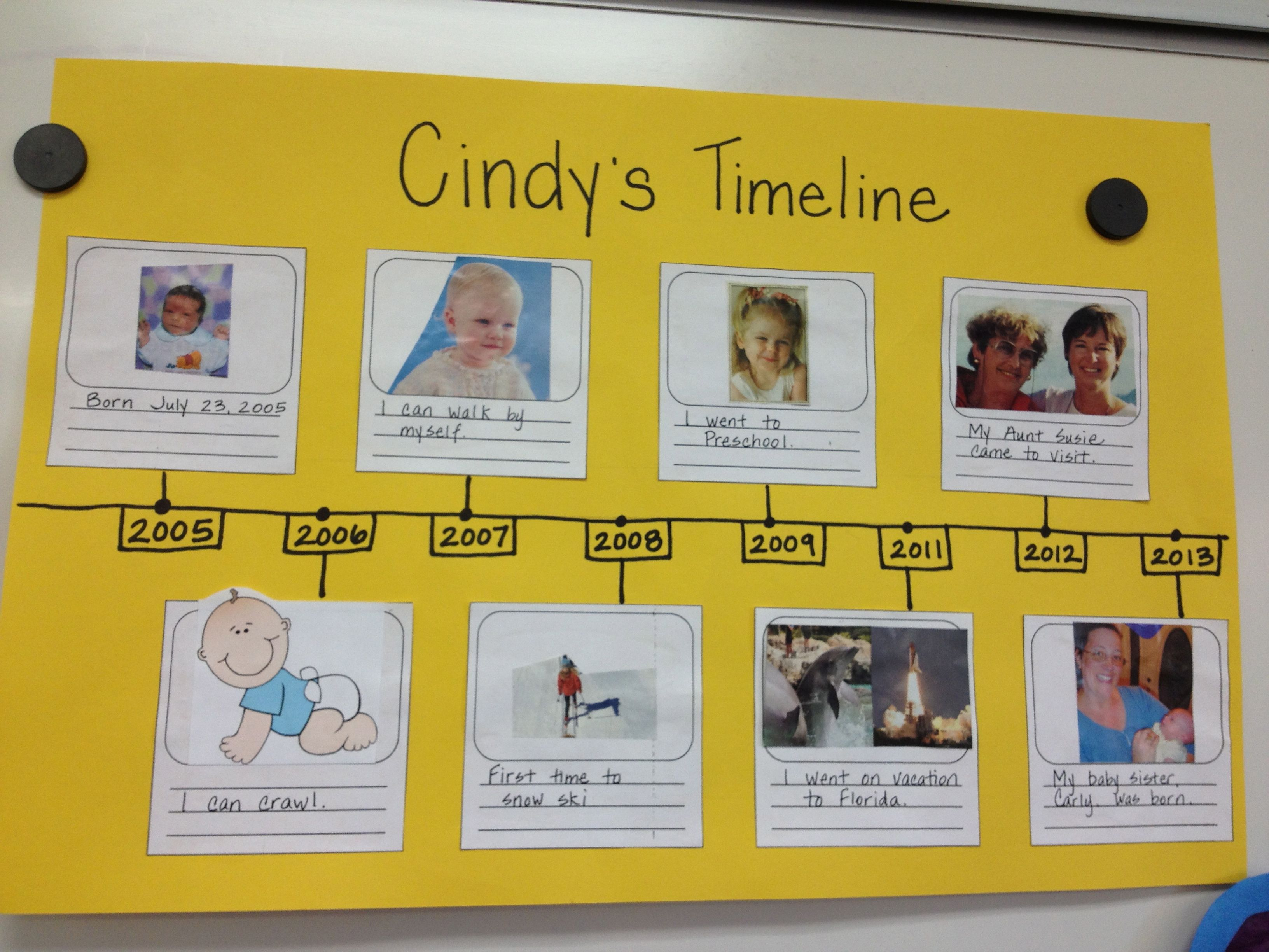

Watch the following video to help you to create a timeline.

https://www.youtube.com/watch?v=842mEdbuTJs

Now is time to create your time line, you can use the blank page provided or you can do it in a separate piece of paper to make it bigger. Be creative, but don’t forget to include all the important information from the questions.

