ISLAM
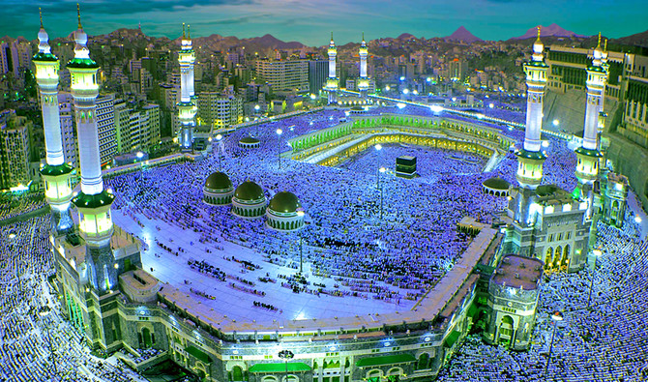
THE GRAND MOSQUE OF MECCA
Key vocabulary
Islam, Muslim, Allah, Creator, Muhammad (pbuh,) prophet, mosque, Qur’an, Arabic, calligraphy, angel Jibril, salah (prayer,) adhaan, call to prayer, worship, belief, faith, wudu, Ka’bah, Mecca, imam, prayer mat, Islamic compass, holy, madrasa, pattern, geometric shape, unity, respect.
Name;
Note to parents/carers.
This topic on Islam forms part of our studies on ‘Other Faiths’, that our children need to explore as part of our religious education programme.
Our aim is to provide the children with activities that support a respect for a faith other than their own. In so doing, our children become knowledgeable and this helps towards our wider community contribution of creating more tolerant and respectful members of society,
We pride ourselves in the activities and tasks that we set, as they ignite or children’s interest and wherever possible or necessary, parallels in similarities can be made with our Catholic faith, the children are always keen to recognise how this comes about.
As we cannot be together to complete this task in school, please support your child with their research and completion of this booklet.
Children
Your tasks explained here
There are ?? tasks for you to do in order to complete your booklet. In places I have made it easier for you by including pictures and prompts and you will need to research the information needed in order to complete the task.
Task 1. WHAT IS ISLAM? You need to carry out some research about Islam.
Who was its founder? When did it begin? What is their sacred text called? Name of Sacred building, Holy Places etc
Task 2. THE SIX BELIEFS OF MUSLIMS. Go to this website below. You will
find the information here very useful.
http://www.primaryhomeworkhelp.co.uk/religion/Islam.htm

Task 3. PROPHET MUHAMMAD. On this page you need to complete a fact file about the Prophet Muhammad. Explain things such as where and
when he was born, name of parents and siblings, how he became a
prophet etc. these are some ideas. Make your factfile as interesting
as possible.

Task 4. INFORMATION ABOUT THE SACRED SPACE WHERE MUSLIMS PRAY.
Go to this website to help you find the information that you need to
record on this page. https://kids.kiddle.co/Mosque and
https://www.ducksters.com/history/islam/mosques.php

Task 5. FEATURES OF THE MOSQUE. Use the same websites above to carry
out your research and complete your task.

Task 6. HOW MUSLIMS PRAY, Research your information and record
then draw a picture to support your recording. Now design your
prayer mat.

Task 7. BEAUTIFUL SIGNIFICANT ISLAMIC MOSQUES AROUND THE WORLD

Task 8. THE FIVE PILLARS OF ISLAM Research and record your findings.

Task 9. WHAT IS THE SIGNIFICANCE OF THE MONTH OF RAMADAN

WHAT IS ISLAM?
An important fact to note here is that Muslims accept all of the biblical prophets, including Noah, Abraham, Moses, and Jesus. Muslims believe that their faith is a confirmation of the message that these prophets brought: to believe in One Almighty God and to follow (submit to) His guidance.
Write the information you collected to answer this question below.
___________________________________________________________________________________________________________________________________________________________________________________________________________________________________________________________________________________________________________________________________________________________________________________________________________________________________________________________________________________________________________________________________________________________________________________________________________________________________________________________________________________________________________________________________________

THE SIX MAIN BELIEFS OF MUSLIMS.
The basic on Islam is the Belief in the Oneness of God: Muslims believe that God is the creator of all things, and that God is all-powerful and all-knowing. This is their first belief to help you with your recording but what do they call their God?
BELIEF 1
____________________________________________________________________________________________________________________________________________
BELIEF 2
____________________________________________________________________________________________________________________________________________
BELIEF 3
____________________________________________________________________________________________________________________________________________
BELIEF 4
____________________________________________________________________________________________________________________________________________
BELIEF 5
____________________________________________________________________________________________________________________________________________
BELIEF 6
____________________________________________________________________________________________________________________________________________

WHITE HAT: Did you notice any similarities that the Islamic faith has to Christianity?

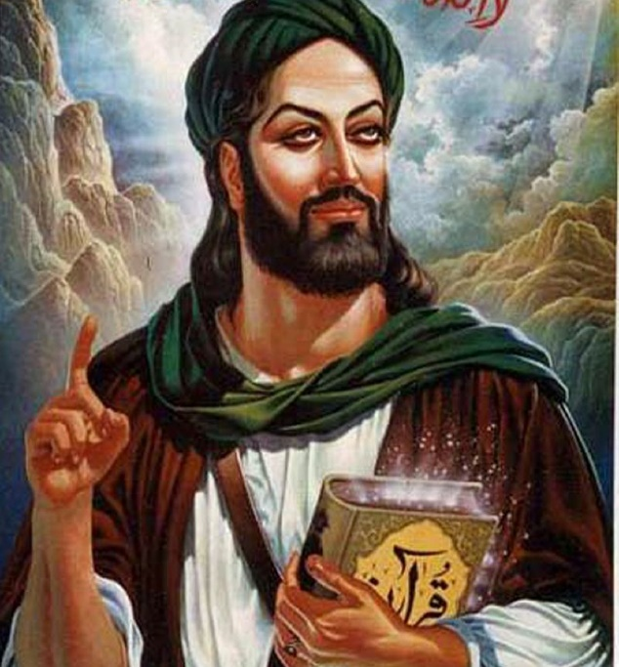
THE PROPHET MUHAMMAD (pbuh)
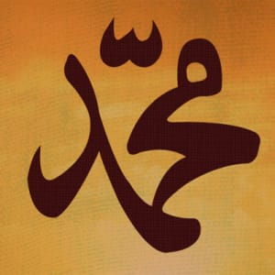
_ ____________________________________________________________________________________________________________________________________________________________________________________________________________________________________________________________________________________________________________________________________________________________________________________________________________________________________________________________________________________________________________________________________________________________________________________________________________________________________________________________________________________________________________________________________________________________________________________________________________________________________________________________________________________________________________________________________________________________________________________________________________________________________________________________________________________________________________________________________________________________________________________________________________________________________________________________________________________________________________________________________________________________________________________________________________________________________________________________________________________________________________________________________________________________________________________________________________________________________________________________________________________________________________________________________________________________________________________________________________________________________________________________________________________________________________________________________________________________________________________________________________________________________________________________________________________________________________________________________________________________________________________________________________________________________________________________________________________________________________________________________________________________________________________________________________________________________________________________________________________________________________________________________________________________________________________________________________________________________________________________________________________________________________________________
INFORMATION ABOUT THE SACRED SPACE WHERE MUSLIMS PRAY.
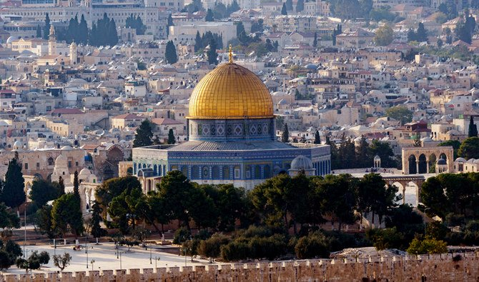
Mosques are _______________________________________________________________________________________________________________________________________________________________________________________________________________________________________________________________________________________________________________________________________________________________________________________________________________________________________________________________________________________________________________________________________________________________________________________________________________________________________________________________________________________________________________________________________________________________________________________________________________________________________________________________________________________________________________________________________________________________________________________________________________________

IMPORTANT FEATURES IN A MOSQUE
Find out what they are and record some information about them.
Feature | Function
Quiblah wall
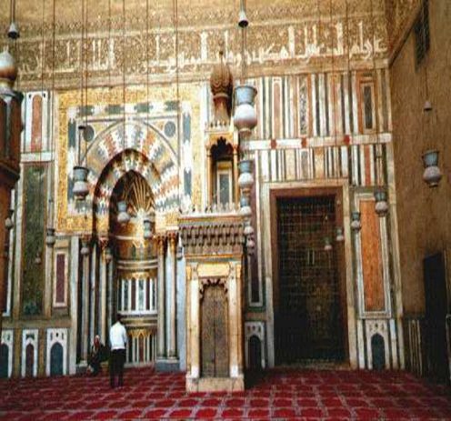

Mihrab
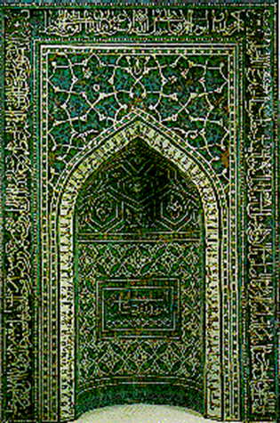

Minbar
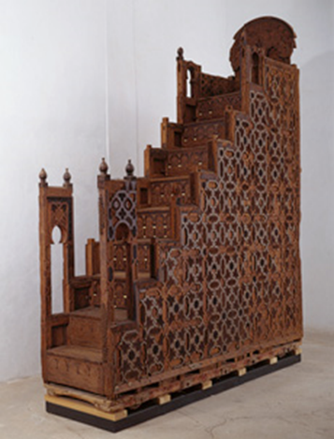

Washing area
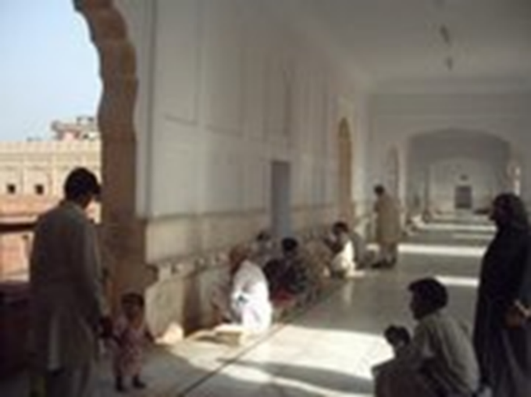

Minaret
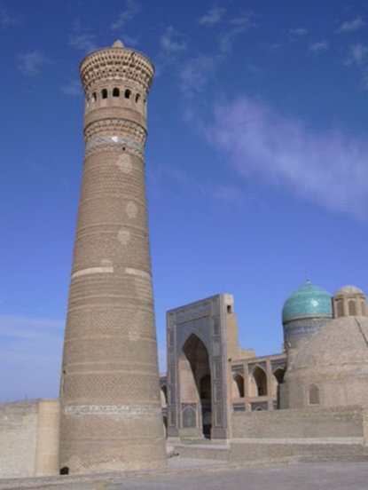

Prayer Mat
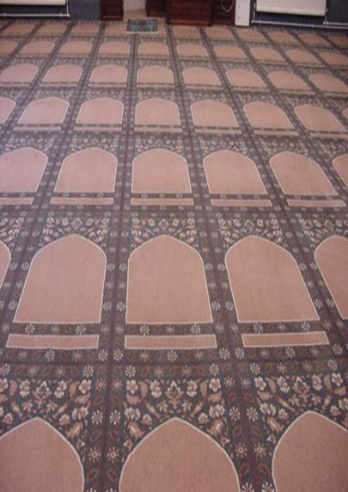

Well done for researching and explaining these important features inside a mosque.

HOW DO MUSLIMS PRAY?
Each period for prayer has a special name and each time is separated by two hours.
These essential times are:
- After first light and before sunrise
- Between the sun reaching its height and mid-afternoon
- Between mid-afternoon and sunset
- After the sun has finished setting
- In the dark of the night
You need to find out the Arabic names for each of these prayer times and record the name beside each phase. Below you need to record the process that Muslims follow before, during and after prayer. Record this as an explanation piece below.
______________________________________________________________________________________________________________________________________________________________________________________________________________________________________________________________________________________________________________________________________________________________________________________________________________________________________________________________________________________________________________________________________________________________________________________________________________________________________________________________________________________________________________________________________________________________________________________________________________________________________________________________________________________________________________________________________________________________________________________________________________________________________________________________________________________________________________________________________________________________________________________________________________________________________________________________________________________________________________________________________________________________________________________________________________________________________________________________________________________________________________________________
Islamic Prayer Mat
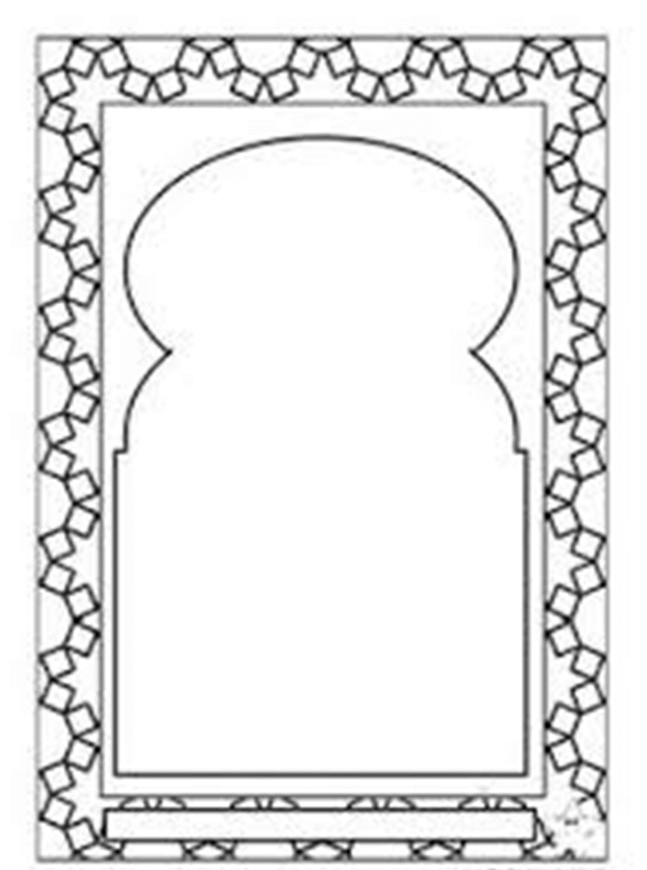
FIND OUT SOME IMFORMATION ABOUT THESE BEAUTIFUL ISLAMIC MOSQUES AND RECORD WHAT YOU FIND OUT BELOW EACH ONE.
Al Haram Mosque, Mecca
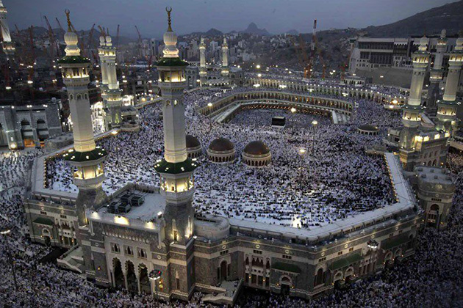
_______________________________________________________________________________________________________________________________________________________________________________________________________________________________________________________________________________________________________________________________________________________________________________________________________________________________________________________________________________________________________________________________________________________________________________________________________________________________________________________________________________________________________________________________________________________________________________________________________________________________________________________________________________________________________________________________________________________________________________________________________________________________________________________________________________________________________________________________________________________________________________________________________________________________________________________________________________________________________________________________________________________________
Al Nabawi Mosque, Medina, Saudi Arabia
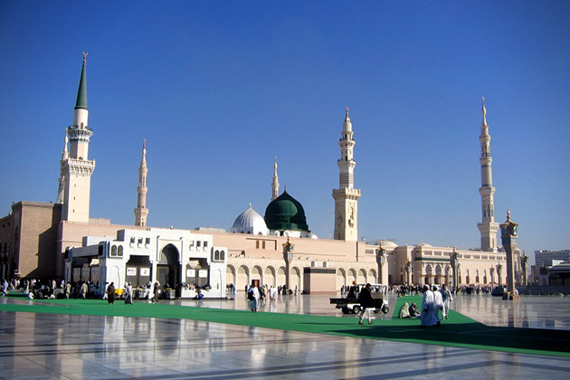
___________________________________________________________________________________________________________________________________________________________________________________________________________________________________________________________________________________________________________________________________________________________________________________________________________________________________________________________________________________________________________________________________________________________________________________________________________________________________________________________________________________________________________________________________________________________________________________________________________________________________________________________________________________________________________________________________________________________________________________________________________________________________________________________________________________________________________________________________________________________________________________________________________________________________________________________________________________________________________________________________________________________________________________________________________________________________________________________________________________________________________________________________
Al Aqsa Mosque, Jerusalem
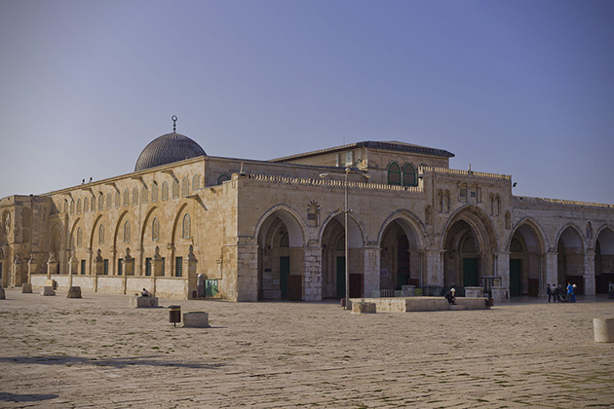
____________________________________________________________________________________________________________________________________________________________________________________________________________________________________________________________________________________________________________________________________________________________________________________________________________________________________________________________________________________________________________________________________________________________________________________________________________________________________________________________________________________________________________________________________________________________________________________________________________________________________________________________________________________________________________________________________________________________________________________________________________________________________________________________________________________________________________________________________________________________________________________________________________________________________________________________________________________________________________________________________________________________________________________________________________________________________________________________________________________________________________________________________
Dome Of The Rock Mosque, Jerusalem
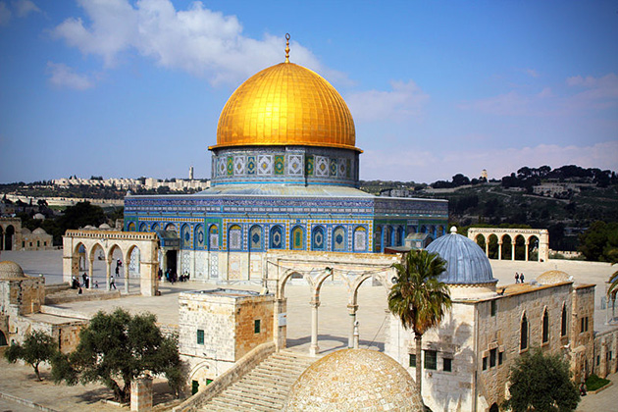
___________________________________________________________________________________________________________________________________________________________________________________________________________________________________________________________________________________________________________________________________________________________________________________________________________________________________________________________________________________________________________________________________________________________________________________________________________________________________________________________________________________________________________________________________________________________________________________________________________________________________________________________________________________________________________________________________________________________________________________________________________________________________________________________________________________________________________________________________________________________________________________________________________________________________________________________________________________________________________________________________________________________________________________________________________________________________________________________________________________________________________________________________
THE FIVE PILLARS OF ISLAM
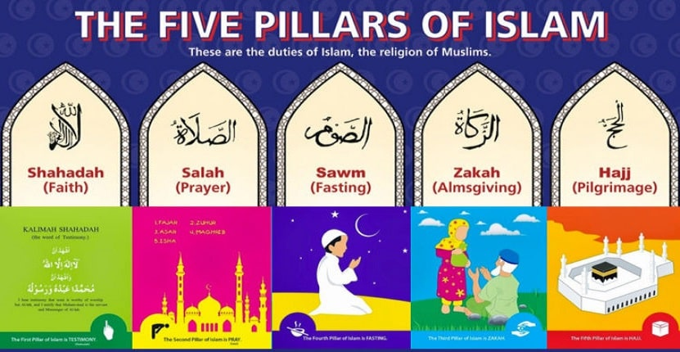
Find out and record the importance of each of these pillars.
WHAT IS THE SIGNIFICANCE OF THE MONTH OF RAMADAN?



