**LO: To recognise that living things live in habitats suited to their needs  
  
HOM: Remain open to continuous learning**

**RED HAT:**

**How do we know if something is living?**

_________________________________________________________________________________________________________________________________________________________________________________________________________________________________________________________________________________________________________________________________________________________

**WHITE HAT:**

**Which of the below are living? Can you explain why?**

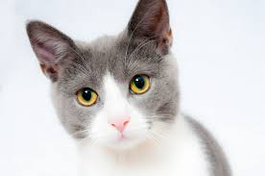

________________________________________________________________________________________________________________________________________________________________________________________________________________________________________________________________________________________________________________________________________________________________________

________________________________________________________________________________________________________________________________________________________________________________________________________________________________________________________________________________________________________________________________________________________________________

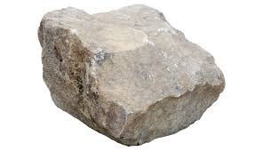

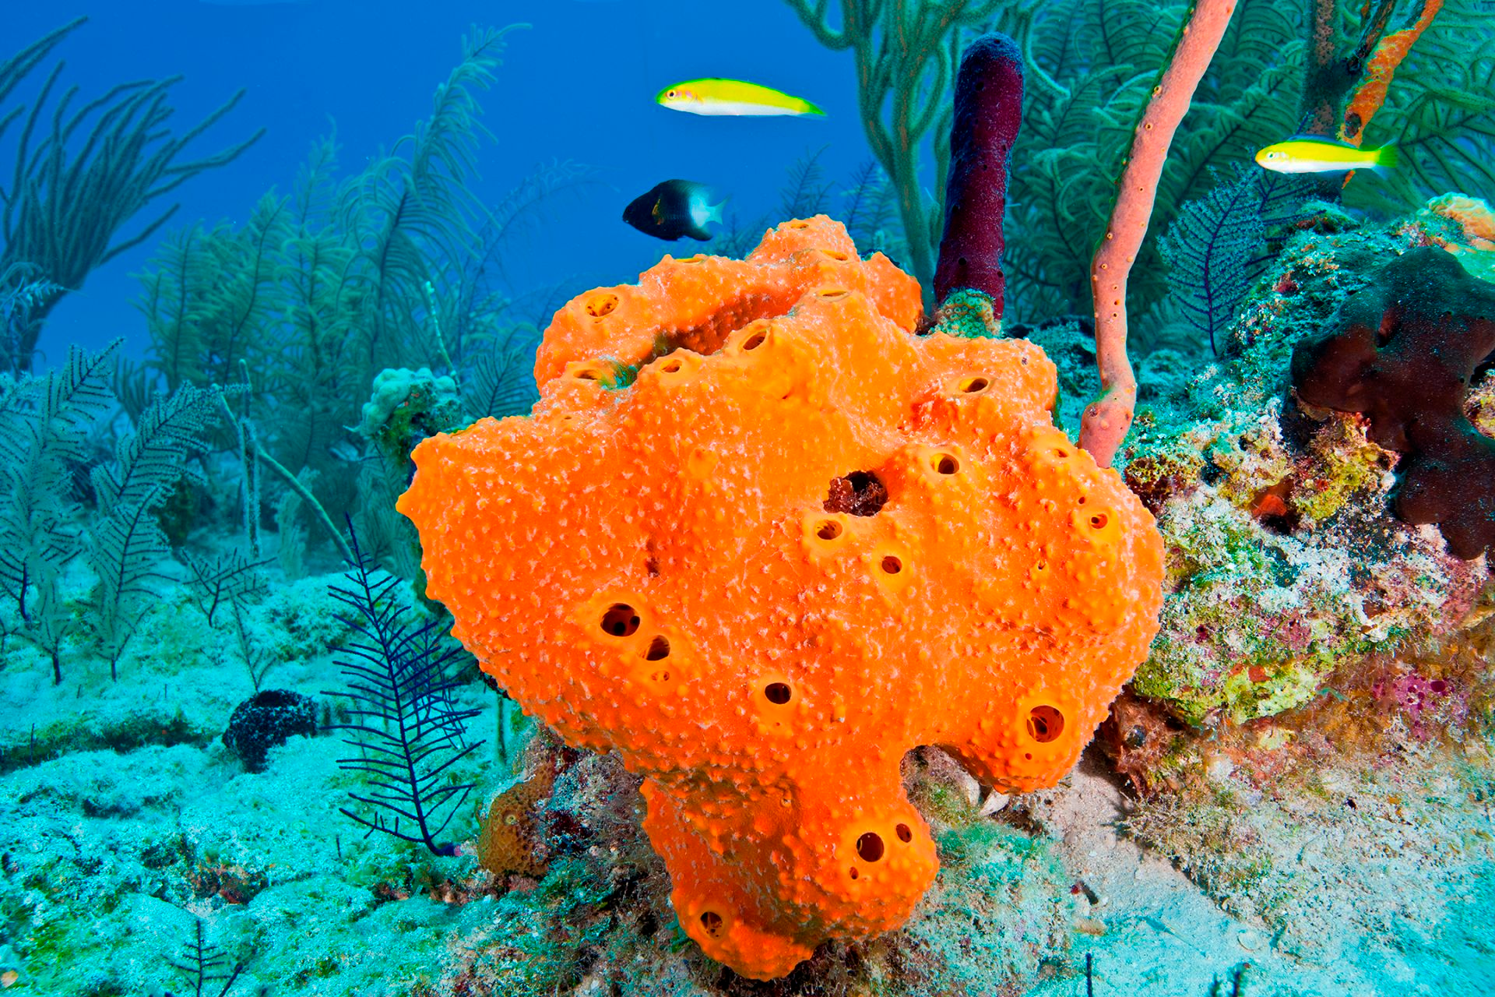

________________________________________________________________________________________________________________________________________________________________________________________________________________________________________________________________________________________________________________________________________________________________________

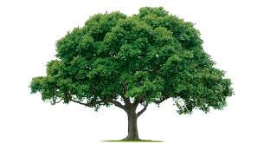

________________________________________________________________________________________________________________________________________________________________________________________________________________________________________________________________________________________________________________________________________________________________________

________________________________________________________________________________________________________________________________________________________________________________________________________________________________________________________________________________________________________________________________________________________________________

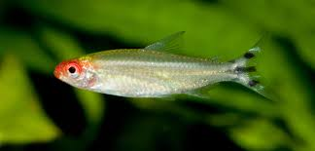

**WHITE HAT:**

What are the characteristics of living things?

______________________________________________________________________________________________________________________________________________________________________________________________________________________________________________________________________________________________________________________________________________________________________________________________________________________________

**The characteristics of living things are:**

Movement

All living things move in some way. This may be obvious, such as animals that are able to walk, or less obvious, such as plants that have parts that move towards the sun.

Respiration

Making energy from food using oxygen.

Sensitivity

The ability to detect changes in the surrounding environment.

Growth

All living things grow. Increase in size and weight.

Reproduction

The ability to produce others of its kind

Excretion

Getting rid of waste for example, water faeces

Nutrition

The intake of food. This occurs in very different ways in different kinds of living things

**WHITE HAT**

**What is a habitat?**

A habitat is the environment in which a living (plant or animal) lives and grows.

GREEN HAT

Can you think of any habitats (places where plants/animals live)? For example a lion, a bird, a fish…

______________________________________________________________________________________________________________________________________________________________________________________________________________________________________________________________________________________________________________________________________________________________________________________________________________________________

**WHITE HAT:**

**What is an organism?**

The term organism is the name given to any living thing.

Draw the habitat of a:

* Badger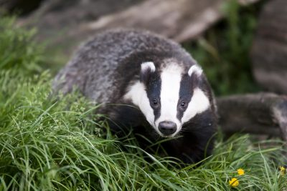
* Dog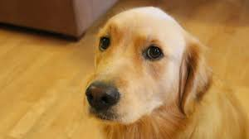
* Woodlouse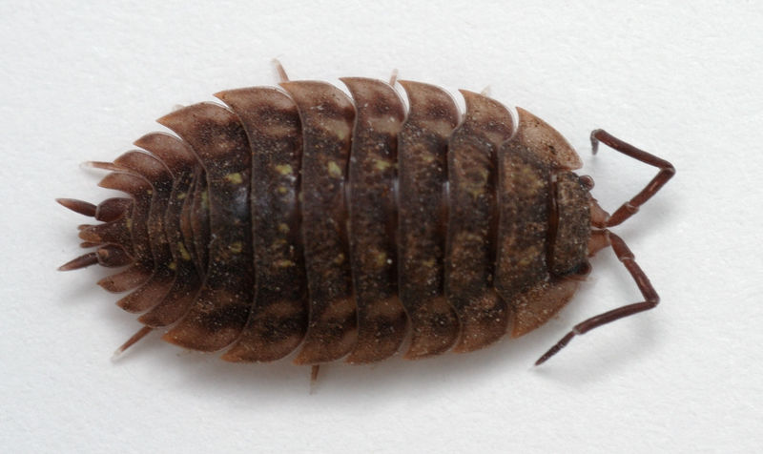
* Ant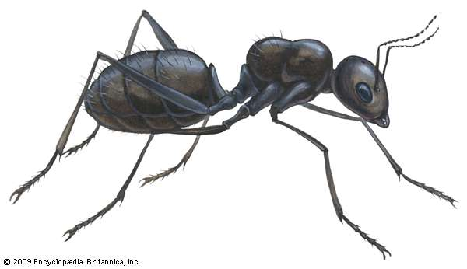
* Bee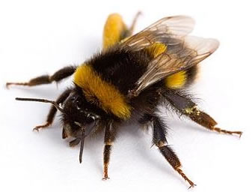
* Tiger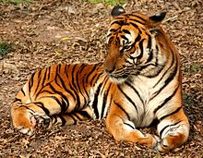
* Dolphin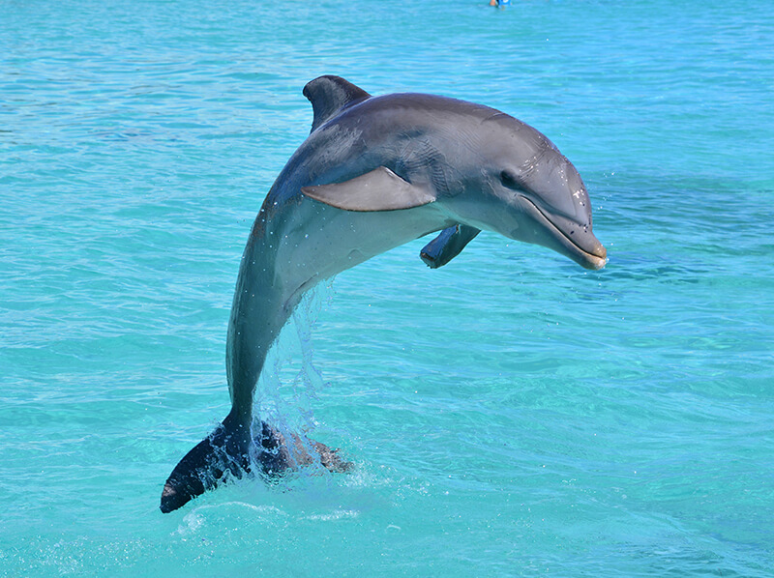

TASK:

What would the conditions be like in each of these environments?

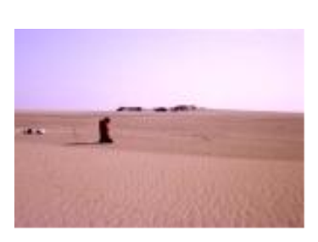

* What living organisms might you find in each of these environments?

______________________________________________________________________________________________________________________________________________________________________________________________________________________________________________________________________________________________________________________________________________________________________________________________________________________________

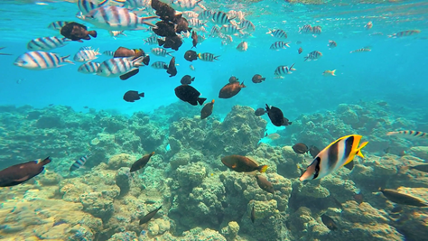

* What living organisms might you find in each of these environments?

______________________________________________________________________________________________________________________________________________________________________________________________________________________________________________________________________________________________________________________________________________________________________________________________________________________________



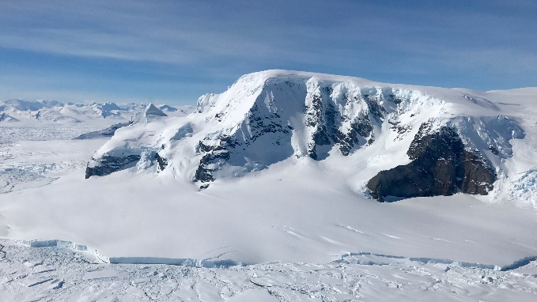

* What living organisms might you find in each of these environments?

______________________________________________________________________________________________________________________________________________________________________________________________________________________________________________________________________________________________________________________________________________________________________________________________________________________________



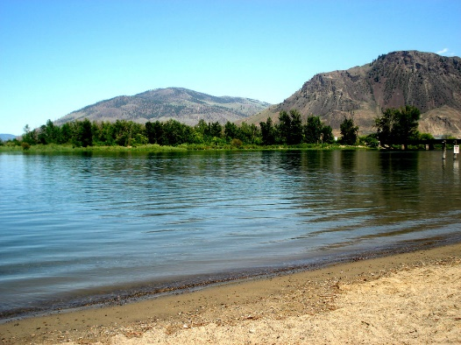

* What living organisms might you find in each of these environments?

______________________________________________________________________________________________________________________________________________________________________________________________________________________________________________________________________________________________________________________________________________________________________________________________________________________________

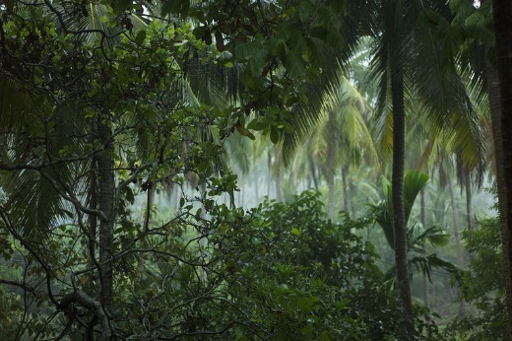

* What living organisms might you find in each of these environments?

______________________________________________________________________________________________________________________________________________________________________________________________________________________________________________________________________________________________________________________________________________________________________________________________________________________________