WRITING LESSON 2 WEEK 6
LO: To be able to write from a point of view
To be able to describe a setting
To be able to express an opinion in writing
HOM: Thinking with clarity and precision
Watch this video from the Literacyshed website ‘Catch it’ .
https://www.literacyshed.com/catchit.html
A group of meerkats lovingly tend to a beloved and unique fruit in the middle of the savannah.
One day, their peaceful existence is disrupted by a vulture intent on stealing their pride and joy.
Will the meerkats be able to get it back?

TASK 1
Think about the story from a meerkat’s point of view. Record some ideas for each stage of the story.
You can do this with drawings and speech bubbles or as a short comic strip.

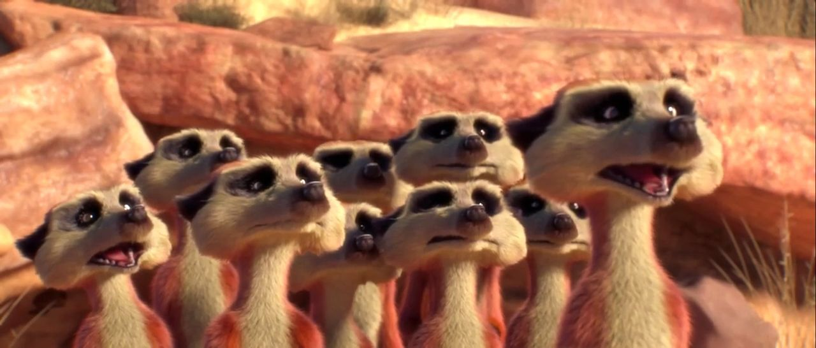

TASK 2
Describe the beautiful setting of the African plains using adjectives, expanded noun phrases and similes. Write in full sentences for this narrative.
Eg; The savannah is a rolling grassland with scattered trees and shrubs. For miles all you can see is dusty sand with the occasional lonely shoots.

TASK 3
Think about the vulture in the clip. In your opinion, is the vulture the villain of the film? Why do you think the vulture was trying to take the fruit from the meerkats? As you give your answers remember that this is not a narrative and it should be written as you giving your opinion and supported by your reasons.

E.g – In my opinion, after watching the film, the vulture is/is not the villain because….

Or- After watching the film it is my opinion that the vulture is/is not the villain because……
I believe that the vulture is/is not the villain. My opinion of whether the vulture is/is not the villain is since…….

NOTE TO PARENTS
There are 3 tasks to this writing activity. It is in the format that we would carry out in class using a given stimulus. We ask that you support your child with completing this activity by
- Watching the video clip with them
- Discuss each task and the ideas that your child could add to each one
- Read through the work with your child checking things like spellings and punctuation- very simple,
We would like to thank you in advance for your support with your child’s home learning.

