NEW RE UNIT OF WORK
THE KINGDOM OF HEAVEN
Today we start our final RE unit of work for this academic year. Where has the year gone you ask? In the midst of how your parents, other family members and yourself have had to come to terms with a change to our lives, affected by things outside of our control, I think that this topic is a beautiful and very fitting way to end this academic year.
Never was there a time, children, when the spiritual outcomes of a unit of work will serve to comfort us with all the strange changes happening around us. I have highlighted the spiritual outcomes of this unit of work below, so that you become familiar, just as you would have done in class, of what the spiritual element of this topic is trying to uplift and fulfill in you and your understanding.
Spiritual Outcomes:
It is hoped that pupils will develop:
- A sense of the relationship between learning about faith and living faith-filled lives
- Respect for those who actively seek the kingdom of God
- A commitment to action for the kingdom of God
- An ability to wonder about questions that are difficult to answer
- Reflectiveness in prayer
How beautiful is this!
When we studied the Beatitudes, we explored the idea of the Kingdom of God, when Jesus preached on the Sermon on the Mount and gave us good advice as to how we should live, both for ourselves and one another, so that we could enter the Kingdom of Heaven.
The first thing to note is that the concept or notion of the kingdom of God is the dominant teaching of Jesus. After his baptism Jesus announced that the kingdom of God had arrived…it was now! Christians take this belief seriously, however, we also believe that it will come more fully after our death
The second thing is that Matthew does not use the phrase Kingdom of God at all – he refers to the concept of ‘God’s time or era’ as the Kingdom of Heaven. During this year we have explored aspects of Matthew’s writing which is different from the writing of the other Gospel writers. In this unit of work we do so again.
Why does Matthew not use the phrase which is used in the other Gospels? You may recall children, that Jew’s did not (and do not) say the word ‘God’, rather, they say Adonai (which means ‘Lord’). Matthew’s decision to rewrite the phrase kingdom of God as kingdom of heaven most likely reflects his observance of Jewish law and custom, a reality which supports the view that he himself was Jewish writing for a Jewish community.

The third thing is that the first few lessons of this unit of work teaches parables, and in particular, parables of the kingdom.

The fourth thing to note is that to call God ‘king’ is to use a metaphor for God. Metaphors for God were part of the work that we completed in the autumn term with our first unit of study called ‘Beginning with God’. Metaphors are a figure of speech is which one thing is said to be another.
So for example, God is like a king is a metaphor, if we said God is different from a king –we confuse God with an actual monarch and making God human, and monarchs gods!
So, this is a little background knowledge to help you with your understanding of the theme of this unit of work.

LESSON INTRO

The stories you are going to be studying are a particular type of narrative (story form) called a parable.
White hat: What is a parable?
A parable is a type of narrative based on a metaphor: two things are compared – the kingdom of God and something else (an activity)
  - Parables are intended to make you think – parables suggest (propose that) ‘something is like something else’…but they leave you to figure out how the two things are alike and unalike.
  - A parable is made up, but it uses people and actions and events that could have happened to someone
In the Gospel of Matthew, he has grouped a number of parables into one chapter (Chapter 13) rather like he grouped all the sayings of Jesus into the Sermon on the Mount. If you have a bible in the house find Matthew Chapter 13 and identify all the parables about the Kingdom of God within this chapter. List them below.

Kingdom of Heaven Parables found in the Gospel of Matthew.

Task 1
Now we are going to closely examine and understand our first Parable from this gospel.
Matthew 13: 31-32 (NRSV)

The Parable of the Mustard Seed
³¹ He put before them another parable: “The kingdom of heaven is like a mustard seed that someone took and sowed in his field; ³² it is the smallest of all the seeds, but when it has grown it is the greatest of shrubs and becomes a tree, so that the birds of the air come and make nests in its branches.”
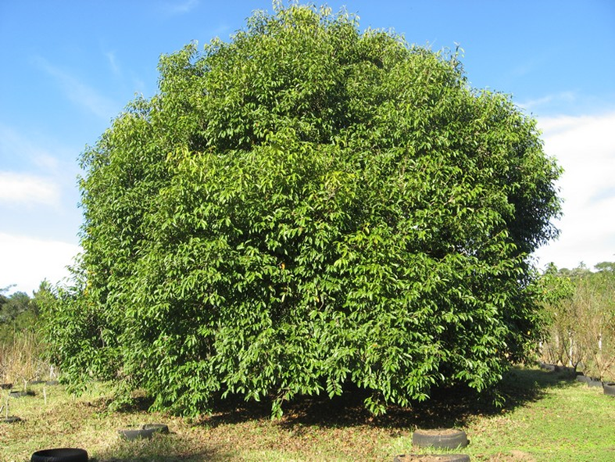

White hat: What is the name of this story?

_________________________________________________________________

White hat: What is the Bible reference?

_________________________________________________________________

White hat: Who is the He being referred to at the beginning of the scripture passage?

_________________________________________________________________

Blue hat: What is the Kingdom being compared to?

____________________________________________________________________________________________________________________________________________
Blue hat: What are we to learn from a tiny seed becoming a large tree?
________________________________________________________________________________________________________________________________________________________________________________________________________________________________________________________________________________________
Blue hat: What does this have to do with us and the Kingdom of heaven?
________________________________________________________________________________________________________________________________________________________________________________________________________________________________________________________________________________________
REFLECTION QUESTION
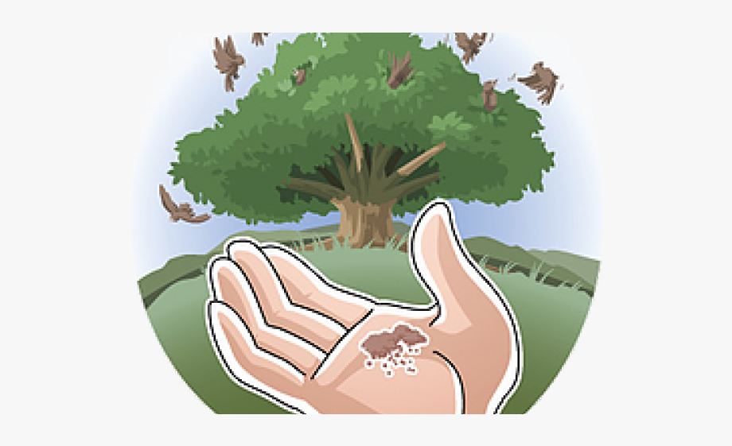
Blue hat: How can you apply this parable today?
________________________________________________________________________________________________________________________________________________________________________________________________________________________________________________________________________________________________________________________________________________________________________________________________________________________
Task 2 of this lesson is to draw the three main parts of this parable and write a caption inside each frame. Complete the task on the sheet below.
PARABLE OF THE MUSTARD SEED

