RE LESSON 2 PARABLE 2 WEEK 7
LO: To understand and interpret parables
HOM: Remaining open to continuous learning.
TASK 1
In our last lesson we explored the parable of ‘The Mustard Seed’.
White hat: What is a parable?
__________________________________________________________________________________________________________________________________________________________________________________________________________________
White hat: What is the purpose of a parable?
__________________________________________________________________________________________________________________________________________________________________________________________________________________
Blue hat: Why did Jesus tell parables?
_________________________________________________________________________________________________________________________________________________________________________________________________________________
Blue hat: Are parables a good way of making a point? Why/Why not? Explain your answer in a detailed way.
______________________________________________________________________________________________________________________________________________________________________________________________________________________________________________________________________________________________________________________________________________________________
When Jesus used parables, he was able to relate truths by using intriguing stories with familiar settings to the listener. Basically, Jesus used examples of things around his followers that they could relate to.
For us to fully understand parables we need to get a good grasp and understanding of the key elements and be able to explain them.
In the Parable of the Mustard Seed, Jesus was trying to get several points across to us.
- He wanted them to know that everything we do to help others is important. The big things are important and the little things are important. Sometimes we do a little thing and it ends up making a BIG difference.
In reference to the kingdom of Heaven, Jesus wanted us to understand that
- Things might look very small at the beginning but just wait – someday they can be very, very, very big! Just keep doing the little things and God will make them grow.
We call this INTERPRETING the parable. We are trying to fully understand the lessons and the message that Jesus weaved in a very smart way into the stories that he told, so that our understanding of the Kingdom of heaven develops.
Our grasp of this parable relied upon a correct understanding of its key elements: the sower, the mustard seed, the great tree which grew from it, and the birds which perched on its branches.
Let’s read the parable again

The Parable of the Mustard Seed
³¹ He put before them another parable: “The kingdom of heaven is like a mustard seed that someone took and sowed in his field; ³² it is the smallest of all the seeds, but when it has grown it is the greatest of shrubs and becomes a tree, so that the birds of the air come and make nests in its branches.”
TASK 2
Now that you have read the parable again, use it to record words and short phrases which might ‘be like’ God’s kingdom. Ask an adult at home to help you as they may have some great ideas. Record your answer below. I have giving you an example to start you off.
White hat: Interpret: How is the Kingdom of God is like planting and growing seeds.
Needs patience

The Kingdom of God

Has no disappointments

TASK 3
On the next sheet you will find a list of different sentence starters that you will use to create a Kingdom of God (Heaven) poem. Take your time to read each sentence starter carefully. NO TWO SENTENCE should have the same ideas recorded. EACH SENTENCE MUST BE DIFFERENT. Think!!!
You have a lot of ideas that you can record. Think back to the topics that we have covered this year and some of the ideas that we have shared and explored.

THE KINGDOM OF GOD
Gods kingdom will
__________________________________________
In God’s kingdom people will __________________________________________
God’s kingdom is for __________________________________________
God’s kingdom is…
__________________________________________
God’s kingdom demands…
__________________________________________
God’s kingdom values…
__________________________________________
God’s kingdom happens when…
__________________________________________

God will be a ________king.

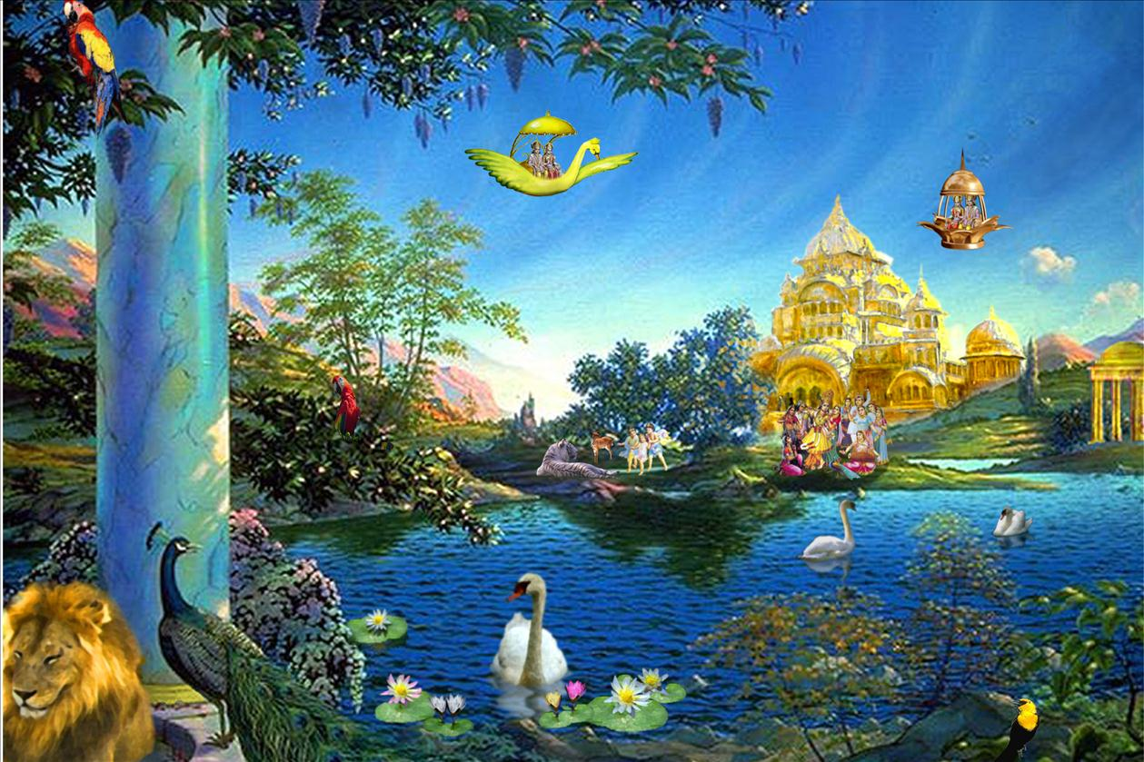
TASK 4
Retell and explain a parable of the kingdom according to Matthew (AT 1 (i)
A member of your class has had to go away suddenly but has written to you asking that you help them to keep up with the RE lessons and to help them understand what the class is being taught. You are to
- Retell the parable of the ‘Mustard seed’ and within your writing
- Explain the meaning of the parable and the message held within it that Jesus is trying to convey.
Write your letter of response below.
Remember to set your letter out formally. Include your address and the date
_______________________________________________________________________________________________________________________________________________________________________________________________________________________________________________________________________________________________________________________________________________________________________________________________________________________________________________________________________________________________________________________________________________________________________________________________________________________________________________________________________________________________________________________________________________________________________________________________________________________________________________________________________________________________________________________________________________________________________________________________________________________________________________________________________________________________________________________________________________________________________________________________________________________________________________________________________________________________________________________________________________________________________________________________________________________________________________________________________________________________________________________________________________________________________________________________________________________________________________________________________________________________________________________________________________________________________________________________________________________________________________________________________________________________________________________________________________________________________________________________________________________________________________________________________________________________________________________________________________________________________________________________________________________________________________________________________________________________________________________________________________________________________________________________________________________________________________________________________________________________________________________________________________________________________________________________________________________________________________________________________________________________________________________________________________________________________________________________________________________________________________________________________________________________________________

