LO: To understand the reasons why Henry VIII married 6 times
HOM: Remain open to continuous learning

Why did Henry VIII marry six times?
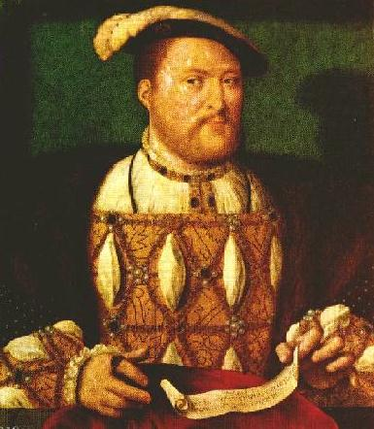
Henry was big and handsome and wore fine clothes.
He loved games, horse-riding and hunting.
He spoke four languages, wrote poetry and played music.
He wanted to be a strong king, with a firm hold on the throne.
He most wanted a son to succeed him.

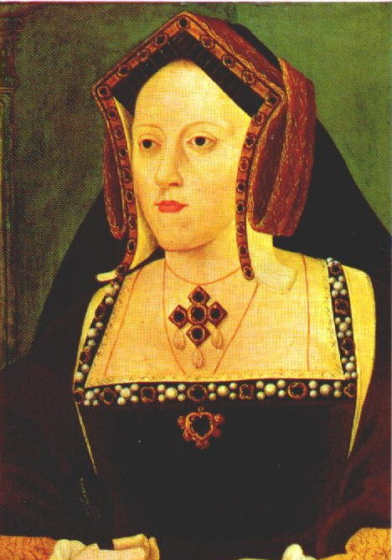
What can you remember about his wives?
Catherine of Aragon

Henry divorced her because she gave him a daughter not a son. Then become older to have more children, so she couldn’t give him the son he wanted.

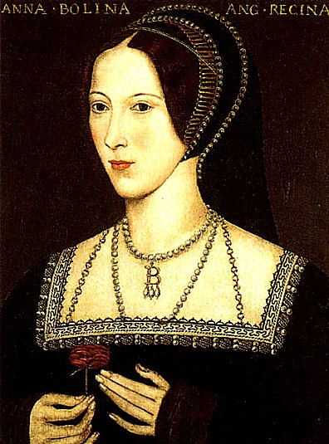
Anne Boleyn

She had a daughter. She was beheaded for being unfaithful in 1536.

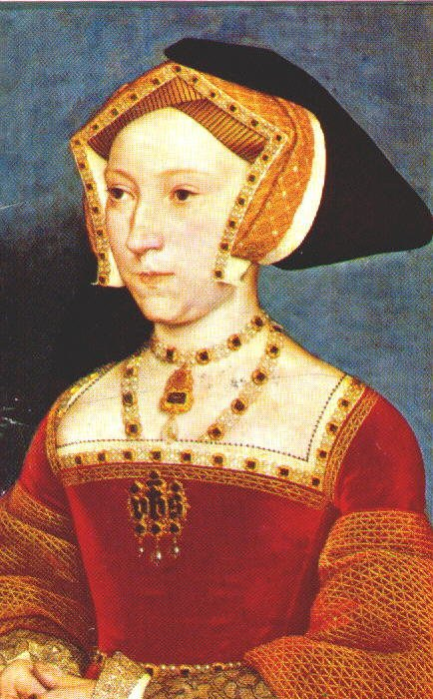
Jeyne Seymour

Henry probably loved her best of all his wives. She had a son, Edward, but died soon after (1537).

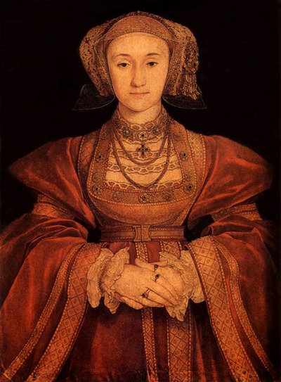
Anne of Cleves

Henry saw her through paintings and agreed to marry her. When he saw her in person he felt disappointing. Henry though she was ugly so he divorced her.

Catherine Howard
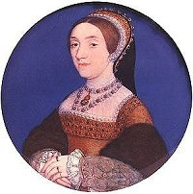

When Henry married her, he was 29 years older than her. She was found to be unfaithful she was executed.

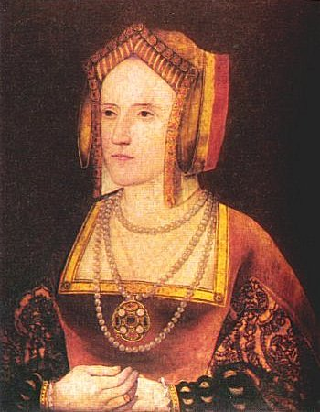
Catherine Parr

Nothing actually happened to her. Henry died before her.

HENRY VIII AND HIS PROBLEMS
Henry married Catherine of Aragon from Spain soon after becoming King.
A king did not marry for love in those days. They usually married an important person chosen by their parents.
Catherine of Aragon was from Spain and was chosen by Henry's father because England and Spain were friends at that time.
Henry and Catherine got on quite well for a time, and they had a daughter. They called her Mary.
Henry wanted to be a strong king and wanted an heir to the throne when he died.
Henry wanted a son to become king when he died. Henry did not fall out with Catherine, but after 20 years of marriage he had some serious thinking to do.
Henry VIII wanted to divorce Catherine. The head of the Catholic Church as the Pope.
People were not allowed to divorce in the Roman Catholic religion
Henry was king of a powerful country, but he was in a difficult position. He was also running out of money.
The Church took money out of England in taxes to help build St Peter’s in Rome but Henry VIII got nothing in return.
Henry separates from the Catholic Church and makes himself the head of the Church of England.
Now he is able to make his own rules and divorces Catherine of Aragon.
He meets Anne Boleyn who is young and pretty. He decides to marry her and hopes she will give him a son.
Anne Boleyn had a daughter. They called her Elizabeth.
Henry was still unhappy. He wanted a son.
The people who worked for Henry VIII told him that Anne Boleyn was being unfaithful and eventually she was beheaded.
Henry was now looking for a new wife.
11 days after Anne Boleyn was executed Henry married Jane Seymour.
She gave him a son. He was so happy. He loved Jane very much. More than any of his other wives. Sadly, Jane died after giving birth to their son Edward. Henry was heartbroken.
The people working for Henry try to find him a new wife. A painting of a princess is sent from Germany. They tell Henry it would be a good idea to become friends with Germany and that he should marry the princess called Anne of Cleves.
He thinks she looks beautiful in the painting and agrees.
When he meets her he says she is ugly and looks ‘like a horse’. He divorces her.
He meets Catherine Howard who is young and pretty. He marries her and hopes she will give him a son.
Unfortunately, Catherine had many boyfriends and she is executed.
Henry is now old. He needs to have a new wife and queen.
He meets Catherine Parr. She is a good woman. He marries her. She looks after Henry and his children very well.
Henry is now quite old and still sad because he never had any sons to take over the throne despite being married 6 times.

Have a look to the following links to help you to learn more about Henry’s wives.

https://vimeo.com/90738933
https://www.natgeokids.com/za/discover/history/monarchy/wives-of-henry-viii/
https://www.theschoolrun.com/homework-help/king-henry-viii
https://www.hrp.org.uk/schools/learning-resources/king-henry-viii-and-his-six-wives-fact-sheet/#gs.5qjmr3
https://tudorhistory.org/wives/
https://schoolhistory.co.uk/early-modern/tudors/henry-viii-wives/

YOUR TASK:
Imagine you are Henry VIII. You are now an old man and you are thinking back about your life.
You are going to write a diary entry explaining about the women you married, why you separated from the Catholic church in Rome and why you were always unhappy.
Give plenty of detail and explanation, especially about how you felt.

Dear diary:
________________________________________________________________________________________________________________________________________________________________________________________________________________________________________________________________________________________________________________________________________________________________________________________________________________________________________________________________________________________________________________________________________________________________________________________________________________________________________________________________________________________________________________________________________________________________________________________________________________________________________________________________________________________________________________________________________________________________________________________________________________________________________________________________________________________________________________________________________________________________________________________________________________________________________________
________________________________________________________________________________________________________________________________________________________________________________________________________________________________________________________________________________________________________________________________________________________________________________________________________________________________________________________________________________________________________________________________________________________________________________________________________________________
________________________________________________________________________________________________________________________________________________________________________________________________________________________________________________________________________________________________________________________________________________________________________________________________________________________________________________________________________________________________________________________________________________________________________________________________________________________
________________________________________________________________________________________________________________________________________________________________________________________________________________________________________________________________________________________________________________________________________________________________________________________________________________________________________________________________________________________________________________________________________________________________________________________________________________________
________________________________________________________________________________________________________________________________________________________________________________________________________________________________________________________________________________________________________________________________________________________________________________________________________________________________________________________________________________________________________________________________________________________________________________________________________________________
________________________________________________________________________________________________________________________________________________________________________________________________________________________________________________________________________________________________________________________________________________________________________________________________________________________________________________________________________________________________________________________________________________________________________________________________________________________
________________________________________________________________________________________________________________________________________________________________________________________________________________________________________________________________________________________________________________________________________________________________________________________________________________________________________________________________________________________________________________________________________________________________________________________________________________________
________________________________________________________________________________________________________________________________________________________________________________________________________________________________________________________________________________________________________________________________________________________________________________________________________________________________________________________________________________________________________________________________________________________________________________________________________________________
____________________________________________________________________________________________________________________________________________________________________________________________________________________________________________________________________________________________________________________________________________________________________________________________________________________________________________________________________________________________________________________

