WRITING TASK WEEK 7
LO: To be able to use a stimulus to write a story.
HOM: Thinking imaginatively, creating and innovating.
INTRO
The beauty of this task is that the film that you will be watching is wordless. Wordless short clips are great, as you can really allow your imagination to go places that you would not be able to do if the clip had words. Complete Task 1 first then click on the link below and watch the short clip. You may find that you need to watch it a few times, in order to take in all the elements of the film.
La Luna is a short Pixar Movie
https://www.youtube.com/watch?v=vbuq7w3ZDUQ
TASK 1
Blue hat: What could possibly be happening or going to happen in this picture? Record a few suggestions around the picture.

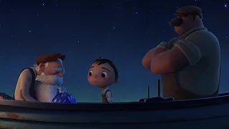

TASK 2: Answer the questions below after you have watched the film.
Think very carefully about the characters. Re-watch the clip to help you.
Why do you think it is important to the older men that the boy should wear a cap?
________________________________________________________________________________________________________________________________________________________________________________________________________________________________________________________________________
Why do you think the boy chooses to turn his cap around and uses a rake at the end?
________________________________________________________________________________________________________________________________________________________________________________________________________________________________________________
What evidence is there that the boy might be sporty or athletic?
________________________________________________________________________________________________________________________________________________________________________________________________________________________________________________
Do you think the three men are related? Justify your decision using evidence.
____________________________________________________________________________________________________________________________________________________________________________________________________________________________________________________________________________________________________________
How might the boy have felt before he climbed the ladder? Use evidence to justify your opinion.
____________________________________________________________________________________________________________________________________________________________________________________________________________________________________________________________________________________________________________
What time of year might this be?
____________________________________________________________________________________________________________________________________________________________________________________
Do you feel this is set in the 'present' day or in the past? Why?
____________________________________________________________________________________________________________________________________________________________________________________________________________________________________________________________________________________________________________

Well done for completing the first two tasks

Task 3
Your next task is to break the story down into 10 events. You will need to be very clear about this as you need to keep the events in chronological order.
So, I suggest you watch the clip again.
https://www.youtube.com/watch?v=vbuq7w3ZDUQ
On a separate sheet of paper quickly make some notes as you watch the film clip. Watch the clip again.
White hat: Have you identified the 10 events?
Blue hat: Have you recorded the events in chronological order or do you need to change anything around?
Here is an example of how I would begin to record my events.
- There are three characters on a boat.
Get the idea! I can’t help you too much as I need you to do the thinking.
My sentence example was very bland because once you have listed your 10 events, you are going to need to PURPLE POLISH IT ( that’s just a new fancy thing that I’ve come up with, ha, ha.) This means that you are going to turn them into 10 Wow Super sentences.
The 10 super sentences should tell the story (without the added detail, that will come later) This will be your plan to help you to retell the story. Each part will have to be developed into its own paragraph.
EVENT | SUPER SENTENCE
1.

2.

3.

4.

5.

6.

7.

8.

9.

10.

Good job! Take a break and do the next task tomorrow.
Task 4. All refreshed and ready to go today?
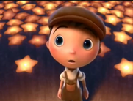
I have listed below a very long list that supports the success of the piece that you are going to write by including all the possible elements that you need to include to make this a great piece of writing.
SUCCESS CRITERIA
- Past Tense
- Third Person
- Detailed descriptions of the setting – Using your 5 senses
- Short sentences for effect – one or two word sentences followed by complex or compound sentences (FANBOYS- coordinating conjunction For, And, Nor, But, Or, Yet, So)
- Expanded noun phrases.
- Fronted adverbials.
- Implied emotion- actions of the characters describing how they are feeling (his heart was in his mouth)
- Exciting vocabulary choices
- Similes and metaphors
- Onomatopoeia

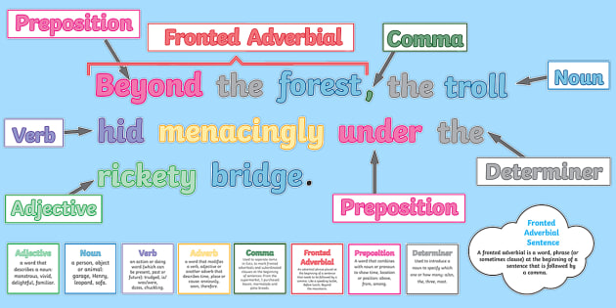

Reminder- Compound sentence
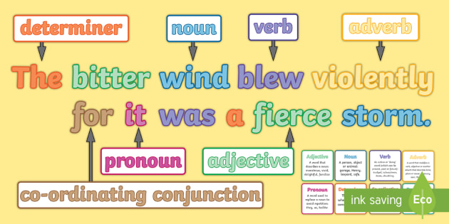
Complex sentence
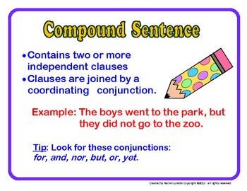
The coordinating conjunctions reminder here is our FANBOYS.

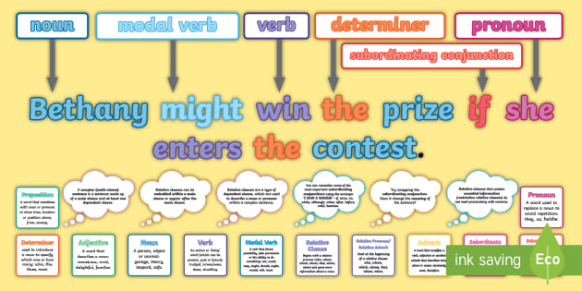
I have included these posters as a reminded of sentence types. The work that you have completed in English over the last few weeks have also given you further practice and reminders as to how to construct these types of sentences.
Everything in the success criteria – YOU KNOW HOW TO DO! If you really can’t remember go to BBC bitesize, type in what you want to recall because you are unsure and a short clip or some other form of information will come up.
Blue hat: Have I left anything off the success criteria list that you think should be added? Record them below.
- ____________________________________________
- ____________________________________________
Now settle down to the actual writing part of the task.
Write the first 3 short paragraphs.
Remember to refer to the Success Criteria.

Include details of the setting and atmosphere. How are the characters feeling?
How do you want the reader to feel?

PARAGRAPH 1
____________________________________________________________________________________________________________________________________________________________________________________________________________________________________________________________________________________________________________________________________________________________________________________________________________________________________________________________________________________________________________________________________________________________
PARAGRAPH 2
____________________________________________________________________________________________________________________________________________________________________________________________________________________________________________________________________________________________________________________________________________________________________________________________________________________________________________________________________________________________________________________________________________________________
PARAGRAPH 3
____________________________________________________________________________________________________________________________________________________________________________________________________________________________________________________________________________________________________________________________________________________________________________________________________________________________________________________________________________________________________________________________________________________________
Now take a rest. Next part of the task TOMORROW.
TASK 5: THE MIDDLE PART.
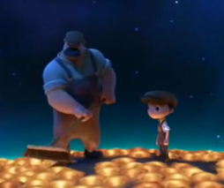
Move on to the middle part of your story.
Continue to write using the past tense and in the third person (remember no I or me).

You need to be careful not to use the same sentence openers.
Use resources like the internet, a thesaurus or a dictionary to help you improve you work. Once again, refer back to the success criteria to help you identify what your work is missing. Tick off features that you are confident that you have included.

Carefully read over your work.
Read it aloud then read it aloud to an adult. Look out for any missing punctuation or obvious spelling mistakes. Make sure that as you read through your work, it makes sense.
Reading your work aloud to an adult will help you with this.

________________________________________________________________________________________________________________________________________________________________________________________________________________________________________________________________________________________________________________________________________________________________________________________________________________________________________________________________________________________________________________________________________________________________________________________________________________________________________________________________________________________________________________________________________________________________________________________________________________________________________________________________________________________________________________________________________________________________________________________________________________________________________________________________________________________________________________________________________________________________________________________________________________________________________________________________________________________________________________________________________________________________________________________________________________________________________________________________________________________________________________________________________________________________________________________________________________________________________________________________________________________________________________________________________________________________________________________________________________________________________________________________________________________________________________________________________________________________________________________________________________________________________________________________________________________________________________________________________________________________________________________________________________________________________________________________________________________________________________________________________________________________________________________________________________________________________________________________________________________________________________________________________________________________________________________________________________________________________________________________________________________________________________________________________________________________________________________________________________________________________________________________
TASK 6: THE ENDING AND PUTTING IT ALL TOGETHER.
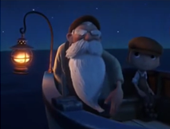
Re-watch the video for further inspiration
https://www.youtube.com/watch?v=vbuq7w3ZDUQ

Before you start writing today, look at your last piece that you created. What can you change today to make it even better? Include this in your success criteria to make today’s writing even better.

Today you need to focus on the ending of your story. Where did you stop when writing the middle part of your story? How do you continue from there? These are the elements that will help you organise your thoughts when writing your ending. At this point your ending may not be too long, but a detailed and descriptive paragraph (or two) is what is needed.

Once this is completed, you will need to put all the parts (the different tasks that you completed) together, to write your version of La Luna.
THE ENDING
________________________________________________________________________________________________________________________________________________________________________________________________________________________________________________________________________________________________________________________________________________________________________________________________________________________________________________________________________________________________________________________________________________________________________________________________________________________________________________________________________________________________________________________________________________________________________________________________________________________________________________________________________
LA LUNA MY VERSION

