LO: To create landscape using different shapes
HOM: To use past knowledge

In this lesson you will be using your knowledge about shapes. Use any kind of colourful paper you can find at home. Using 2D shapes to recreate a Tudor version of Paul Klee’s Castle and Sun.
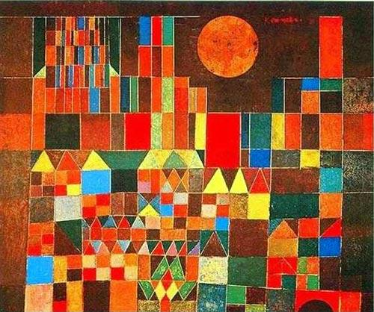

Today you will be creating The Tower of London based on Paul Klee’s Castle in the Sun.
Castle in the Sun:

Castle and Sun is an innovative painting by Swiss artist Paul Klee. The stylish images are created out of different geometric shapes and various shades of color. The lone sun shines in the ingeniously designed sky created by strong lines and structure. In addition, various rectangular sizes add depth to the abstract image.
You will need colourful paper, pencils, felt tips, paint or any other kind of colouring forms to colour your papers, glue stick, scissors and a piece of card paper of card board where you are going to stick your shapes.
If you do not have colourful paper at home use normal paper and colouring with the colours you want. You can use felt tips, colouring pencils, paint etc. to give colour to a white piece of paper.
Once that you have your colourful papers cut different 2D shapes, such as squares, rectangles, triangles, pentagons, circles….
Arrange your shapes in a way that they look as they have more or less the shape of the Tower of London.
Remember it doesn’t have to have the same colours as we are doing our Tower of London inspired by Paul Klee’s Castle in the sun.

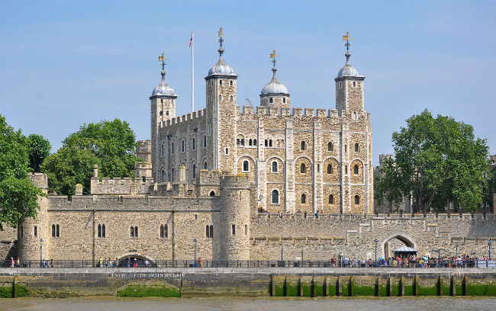
The Tower of London was a site often used by the Tudors, most famously as a prison. Elizabeth I before she became Queen was imprisoned in the Bell Tower by her sister Mary.
Choices:
To create my version I chose to use __________________________________________
________________________________________________________________________________________________________________________________________________
Because________________________________________________________________________________________________________________________________________________________________________________________________________________________________________________________________________________________________________________________________________________________________________________________________________________________

