RE LESSON 3 WEEK 8 PARABLE 2
LO: To be able to interpret a parable
HOM: Remaining open to continuous learning
INTRO
Our next parable also comes from the Gospel of Matthew. Just for your information this parable can also be found in Luke. Can you find the bible reference for it and record it below?
White hat: Where is the Parable of the Sower located in the Gospel of Luke?
______________________________________________________________________
The word “parable” comes from the Greek word: parabole. It literally means “a placing beside”. This would refer to the way a parable compares, or places side by side, two meanings. Sometimes the second meaning of a parable is not explained.
In today’s parable Jesus explains the meaning. Jesus explains that the seeds represent his teachings about the kingdom of God. The soils represent four different ways that his word is received in the hearts of men.
Let’s now read this parable together.

Matthew 13:1-9 New Revised Standard Version (NRSV)

The Parable of the Sower
13 That same day Jesus went out of the house and sat beside the sea. ² Such great crowds gathered around him that he got into a boat and sat there, while the whole crowd stood on the beach. ³ And he told them many things in parables, saying: “Listen! A sower went out to sow. ⁴ And as he sowed, some seeds fell on the path, and the birds came and ate them up. ⁵ Other seeds fell on rocky ground, where they did not have much soil, and they sprang up quickly, since they had no depth of soil. ⁶ But when the sun rose, they were scorched; and since they had no root, they withered away. ⁷ Other seeds fell among thorns, and the thorns grew up and choked them. ⁸ Other seeds fell on good soil and brought forth grain, some a hundredfold, some sixty, some thirty. ⁹ Let anyone with ears^{[a]} listen!”
Imagine just how exciting it would have been to sit beside a lake (probably the Sea of Galilee near Capernaum) and listen to Jesus speaking from a boat just off the shore, reciting this parable to his followers. After that day people probably thought of Jesus every time they passed that place or when they saw a boat or were beside a lake.

Matthew 13:18-23 New Revised Standard Version (NRSV)

The Parable of the Sower Explained
¹⁸ “Hear then the parable of the sower. ¹⁹ When anyone hears the word of the kingdom and does not understand it, the evil one comes and snatches away what is sown in the heart; this is what was sown on the path. ²⁰ As for what was sown on rocky ground, this is the one who hears the word and immediately receives it with joy; ²¹ yet such a person has no root, but endures only for a while, and when trouble or persecution arises on account of the word, that person immediately falls away.^{[a]} ²² As for what was sown among thorns, this is the one who hears the word, but the cares of the world and the lure of wealth choke the word, and it yields nothing. ²³ But as for what was sown on good soil, this is the one who hears the word and understands it, who indeed bears fruit and yields, in one case a hundredfold, in another sixty, and in another thirty.”
White hat: What is the name of this story?
_____________________________________________________________________
White hat: What is the bible reference?
_____________________________________________________________________
White hat: What is the kingdom being compared to?
__________________________________________________________________________________________________________________________________________________________________________________________________________________
HEAR AND ENCOUNTER THE WORD. Background to help you complete your tasks.
Let us unpick this story a little more. Read through the information that I have given you very carefully in order to help you fully understand the meaning in all its layers behind this parable. Try to think back to being in Palestine in Jesus’ time and how they lived.
Most people listening to Jesus would have been familiar with planting seeds. If a field had been recently used, then a farmer would have to plough it twice. Oxen pulling a plow helped the process. After first breaking up the soil, the farmer carried a basket full of seed and used his hands to scatter the seed. Wheat and barley were sown in late autumn. Then the field was ploughed again to cover the seed. Finally, the farmer often used a stick to smooth and flatten the soil.

Paths were formed when people walked often in the same place. The soil was packed down so seeds that fell on a path could not even germinate. You can imagine birds keeping an eye out for just such an opportunity! Since it was totally exposed the seed was quickly eaten. This soil represents someone who hears God’s word but does not understand.
Although soil around Palestine appeared to be good it was often only a thin layer of soil. When you dig through the soil you would quickly hit rock. Plants quickly sprout but die when the roots have no place to flourish. This soil represents the person who readily and genuinely accepts the word of God but then quickly falls away. Nothing develops under the surface.
The third situation involves seed sprouting and growing among thorns. The plants grow but the thorns and weeds take all of the nourishment and the plant barely hangs on. The plant is worthless because it never bears any fruit. This soil represents people who become Christians but are over-influenced by the world. Worry and wealth deny them the spiritual nutrition they need. They may attend church and live moral lives but they never really mature to a point that they teach others and become truly Christ-like.
TASK ONE
Now go to the Y Chart resource and complete this
TASK TWO
Use the grid below to illustrate and show your understanding of the different parts of this parable. You can turn the paper sideways.
RE LESSON 4 WEEK 8 COMPARISON AND REFLECTION
LO: To be able to explain belief in the Kingdom of God expressed in the parables. (AT 1 (i) Level 3)
HOM:
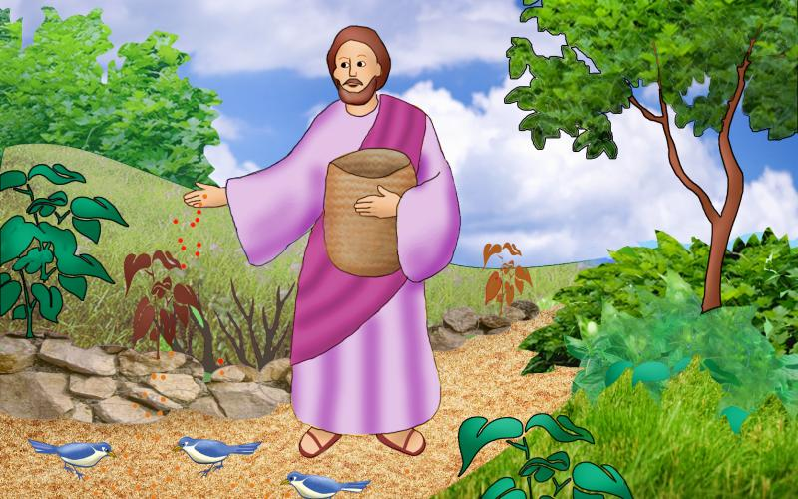
Go back and bring out your 1st Y Chart that you completed for the Parable of the Mustard seed and then bring out the Y Chart that you completed for the Parable of the sower. Go back and re read both of the parables and the background information given.
Compare your answers in the different sections of your Y Chart and then complete the questions below.
Answer these hat questions in a reflective way showing clear understanding of how your knowledge developed as you completed the related tasks.
TASK 1
Blue hat: What will it feel like to work for the kingdom?
________________________________________________________________________________________________________________________________________________________________________________________________________________________________________________________________________________________
Blue hat: What do we need to do to bring about the kingdom?
_______________________________________________________________________________________________________________________________________________________________________________________________________________________________________________________________________________________
Blue hat: What will God’s kingdom be like?
__________________________________________________________________________________________________________________________________________________________________________________________________________________
Blue hat: How will we know the kingdom is here?
__________________________________________________________________________________________________________________________________________________________________________________________________________________
TASK 2
You need to write a letter to a friend who is not a Catholic explaining
- What you have learnt about each parable (you will need to give a synopsis- a short breakdown of the actual story. DO NOT RETELL THE STORY, THIS IS NOT THE TASK.
- What each parables message about the Kingdom of heaven is
- How we can prepare for the Kingdom of Heaven
Take your time and read back our work after writing each paragraph.
Start your letter on the next page provided.
Good working……Enjoy.

____________________________________________________________________________________________________________________________________________________________________________________________________________________________________________________________________________________________________________________________________________________________________________________________________________________________________________________________________________________________________________________________________________________________________________________________________________________________________________________________________________________________________________________________________________________________________________________________________________________________________________________________________________________________________________________________________________________________________________________________________________________________________________________________________________________________________________________________________________________________________________________________________________________________________________________________________________________________________________________________________________________________________________________________________________________________________________________________________________________________________________________________________________________________________________________________________________________________________________________________________________________________________________________________________________________________________________________________________________________________________________________________________________________________________________________________________________________________________________________________________________________________________________________________________________________________________________________________________________________________________________________________________________________________________________________________________________________________________________________________________________________________________________________________________________________________________________________________________________________________________________________________________________________________________________________________________________________________________________________________________________________________________________________________________________________________________________________________________________________________________________________________________________________________________________________________________________________________________________________________________________________________________________________________________________________________________________________________________________________________________________________________________________________________________________________________________________________________________________________________________________________________________________________________________________________________________________________________________________________________________________________________________________________________________________________________________________________________________________
TASK
Below are some artistic impressions of what the Kingdom of Heaven could possibly look like. We don’t know, that is why they are called ‘impressions’.
On the next sheet have a go at drawing your own artistic impression of the Kingdom of heaven.
