LO: To recognise that living things can be grouped in various ways
HOM: striving for accuracy

White hat: What is an organism?
An organism is an individual animal, plant or single-celled living form. On Earth there are around 9 million of organisms. They all have their own names.

Can you remember the characteristic of a living thing? What are the things that makes a living thing?
M_______________________________
R________________________________
S________________________________
G________________________________
R________________________________
E________________________________
N________________________________

To be able to sort all 9 million organisms into groups, a system is needed. This is call classification.
Watch the following video about classification.

http://www.bbc.co.uk/guides/z3nbcwx

Think of a way you could sort these organism into two groups.

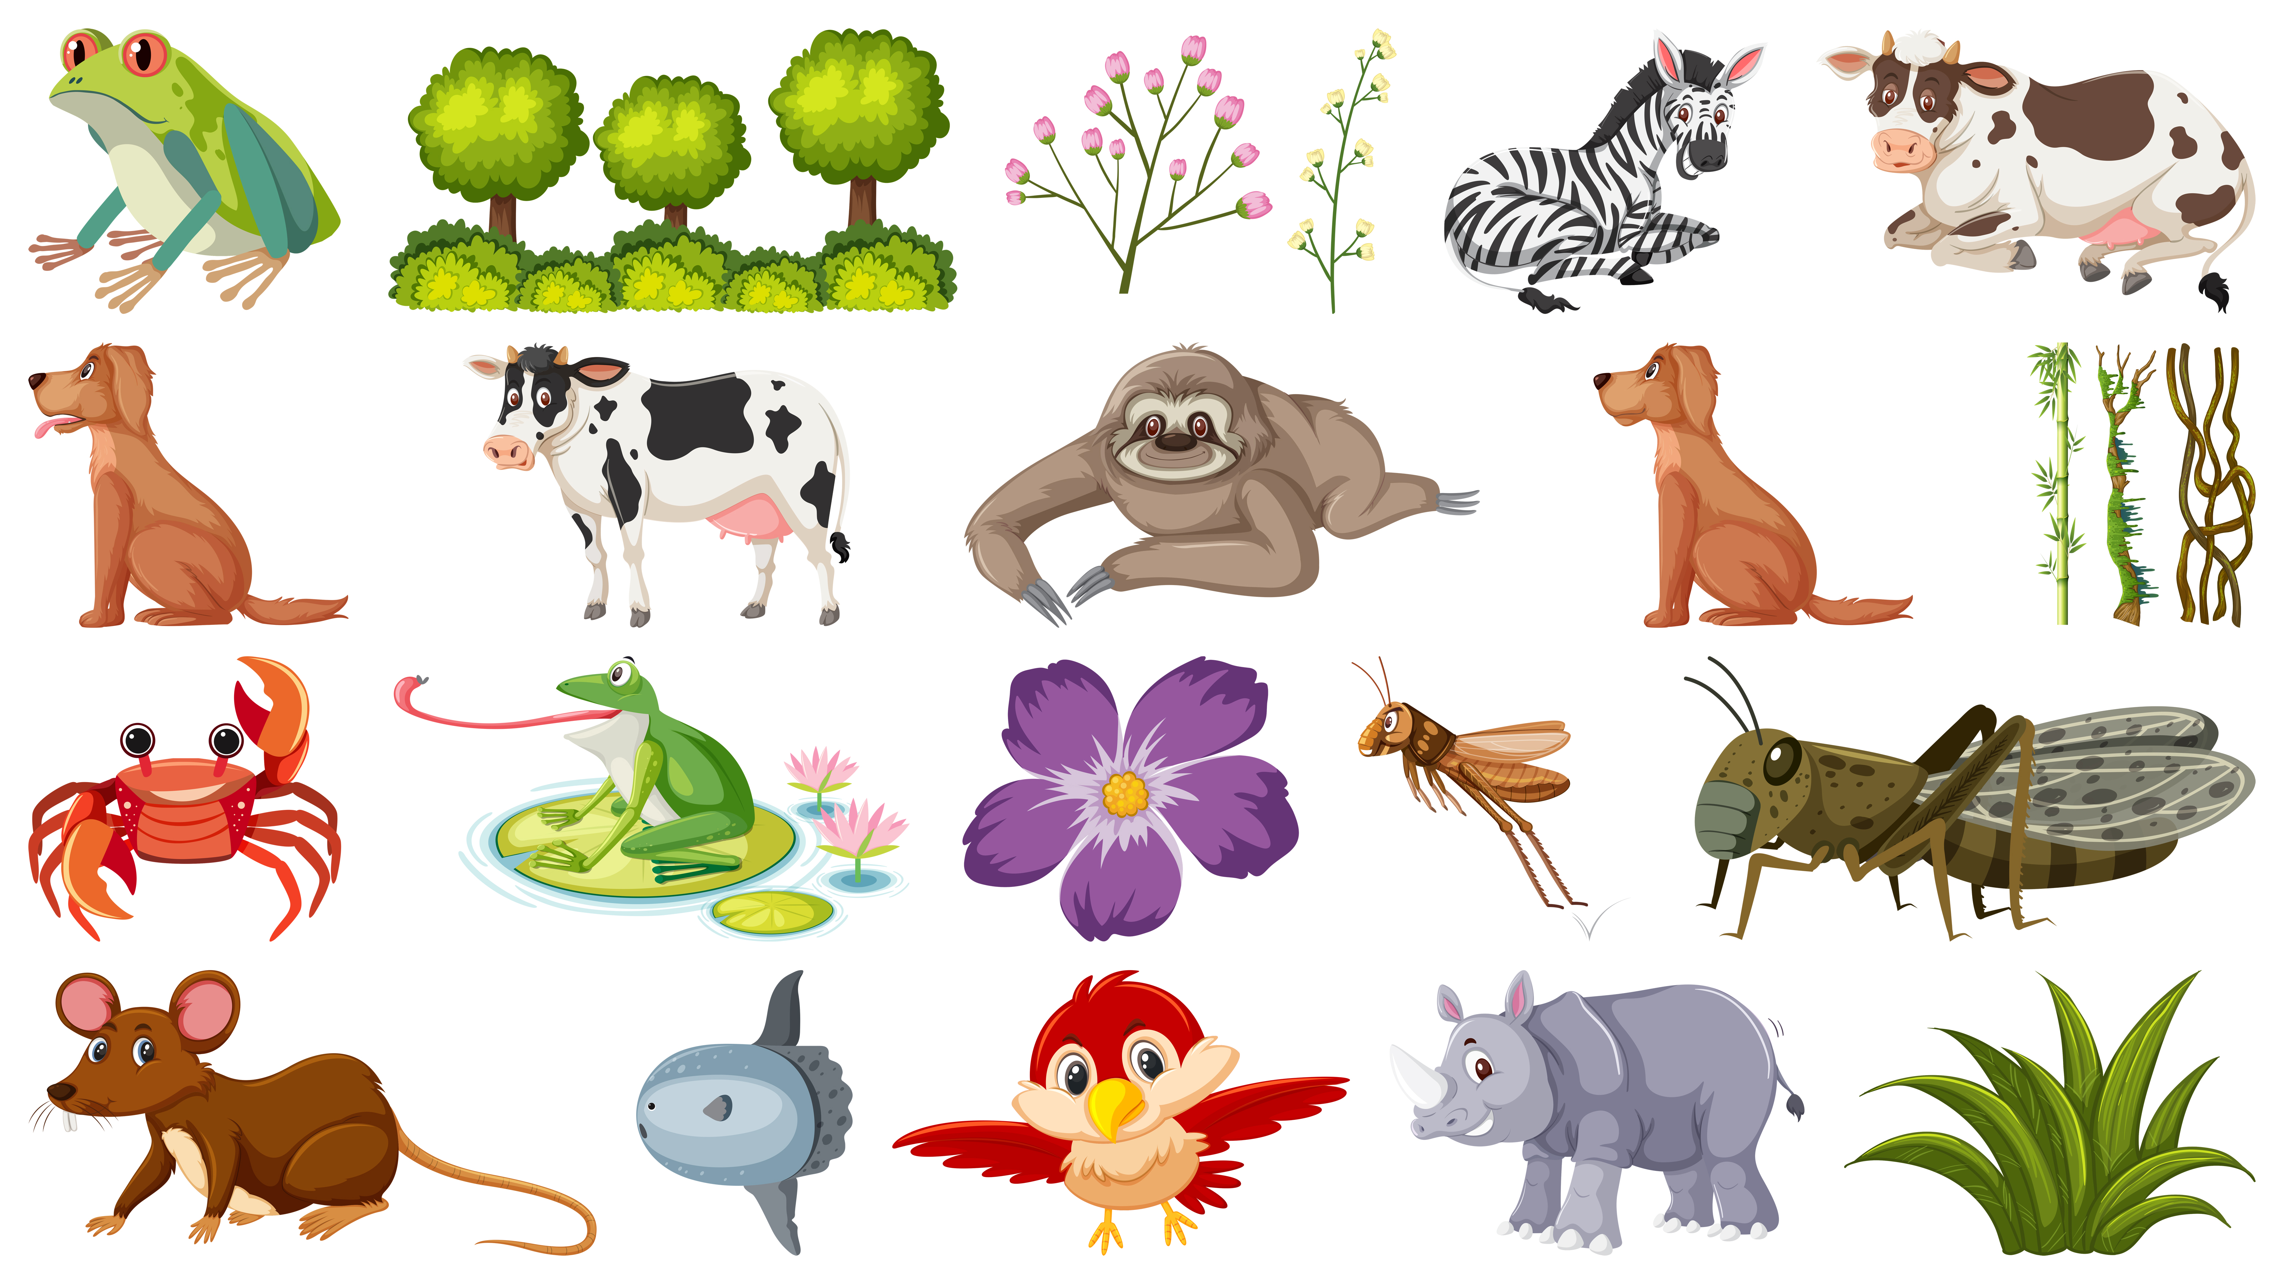
There are 5 main groups that all organisms are sorted into called Kingdoms. Two of these Kingdoms are plants and animals.

Sort the organisms from the previous page into the different options.

ANIMALS
PLANTS

Can an organism be in both groups at the same time? Why?
________________________________________________________________________________________________________________________________________________________________________________________________________________________________________________________________________________________________________________________________________________________________________________________________________________________________________________________________________________________________________________________________________________________________________

This is a Carroll Diagram. Can you name an animal to go in each section of this diagram? You can use the picture above for some examples.

 | Lives in water | Lives in land
Has legs
Does not have legs
Animals are then split into 2 groups: vertebrates and invertebrates.
Vertebrates are animals with a backbone. They have a hard skeleton made of bone. It holds their body up and gives them shape.
Invertebrates do not have a backbone, or a skeleton made of bones. Many have a hard shell outside their bodies to protect them. Others have soft, flexible bodies.

Can you name some animals for each group?

VERTEBRATES | INVERTEBRATES

Vertebrates can be separated into five broad groups:
Mammals have warm blood, and have hair or fur on their bodies.
Mammal babies are born alive.
The mothers feed their babies milk.
Amphibians live on land and in water.
They are cold-blooded.
They have gills when they are young.
They have smooth skin.
They lay their eggs in water.
Birds have a beak, wings, feathers and 2 legs.
They lay eggs on land.
They have warm blood.
Fish live in water.
They have fins instead of legs and gills instead of lungs.
They lay their eggs in water.
They have cold blood and scaly skin.
Reptiles. Some reptiles live on land, and some in water. They have lungs that breathe air.
They have scales and are cold-blooded.
They lay their eggs on land.

TASK 1:
Look at the different animals they are all vertebrates. Write the name of the animal and classify them into mammas, amphibians, birds, fish and reptiles? You need to give reasons why you put them into that group.
_______________________________________________________________________________________________________________________________________________________________________________________________________________________________________________________________________________________________________________________________________________________________________________________________________________________________________________________________________________________________________________
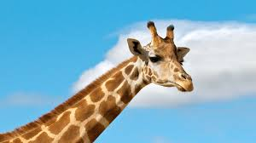
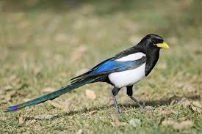
_______________________________________________________________________________________________________________________________________________________________________________________________________________________________________________________________________________________________________________________________________________________________________________________________________________________________________________________________________________________________________________
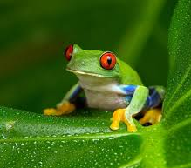
_______________________________________________________________________________________________________________________________________________________________________________________________________________________________________________________________________________________________________________________________________________________________________________________________________________________________________________________________________________________________________________
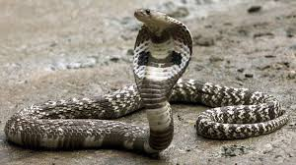
_______________________________________________________________________________________________________________________________________________________________________________________________________________________________________________________________________________________________________________________________________________________________________________________________________________________________________________________________________________________________________________
_______________________________________________________________________________________________________________________________________________________________________________________________________________________________________________________________________________________________________________________________________________________________________________________________________________________________________________________________________________________________________________
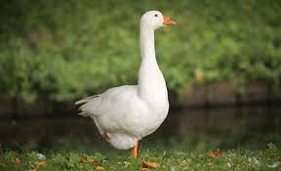
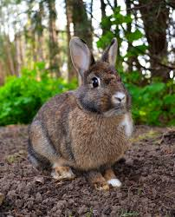
_______________________________________________________________________________________________________________________________________________________________________________________________________________________________________________________________________________________________________________________________________________________________________________________________________________________________________________________________________________________________________________
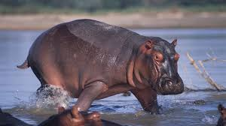
_______________________________________________________________________________________________________________________________________________________________________________________________________________________________________________________________________________________________________________________________________________________________________________________________________________________________________________________________________________________________________________
_______________________________________________________________________________________________________________________________________________________________________________________________________________________________________________________________________________________________________________________________________________________________________________________________________________________________________________________________________________________________________________
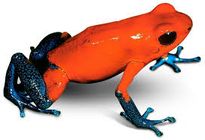
_______________________________________________________________________________________________________________________________________________________________________________________________________________________________________________________________________________________________________________________________________________________________________________________________________________________________________________________________________________________________________________
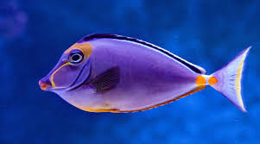
_______________________________________________________________________________________________________________________________________________________________________________________________________________________________________________________________________________________________________________________________________________________________________________________________________________________________________________________________________________________________________________
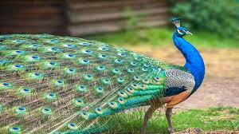
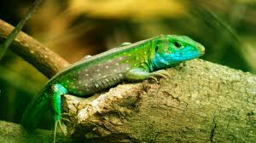
_______________________________________________________________________________________________________________________________________________________________________________________________________________________________________________________________________________________________________________________________________________________________________________________________________________________________________________________________________________________________________________
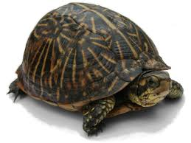
_______________________________________________________________________________________________________________________________________________________________________________________________________________________________________________________________________________________________________________________________________________________________________________________________________________________________________________________________________________________________________________
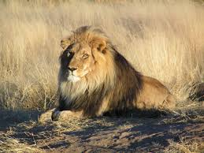
_______________________________________________________________________________________________________________________________________________________________________________________________________________________________________________________________________________________________________________________________________________________________________________________________________________________________________________________________________________________________________________
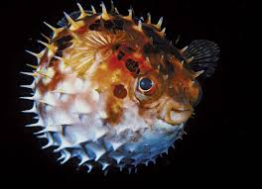
_______________________________________________________________________________________________________________________________________________________________________________________________________________________________________________________________________________________________________________________________________________________________________________________________________________________________________________________________________________________________________________
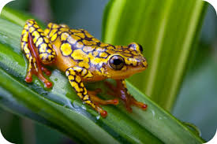
_______________________________________________________________________________________________________________________________________________________________________________________________________________________________________________________________________________________________________________________________________________________________________________________________________________________________________________________________________________________________________________

TASK 2: Observing and collecting Guidelines
What is it? Do you know what it is? Check on internet for help if you need it. | Where did you see it? Write down which area do you think this animal live. Add details about the habitat conditions such as shady, light, damp, dry. | What does it look like? Draw a quick sketch, jot down details like how many legs or wings.
Look around your area, in your garden, in the park when you go for a walk, in your road when you are looking through the window… Look for different animals or insects, look at them carefully and complete the following table. You can look for animals over a week or two. As the more you record the better.
LOCAL LIVING THINGS

