LO: To learn the differences how people houses were during Tudor’s times
HOM: Remaining open to continuous learning.

The Tudor era was a time of great wealth and extravagance. Affluent people demonstrated how rich they were by the houses they owned.

Can you match the people to their houses?
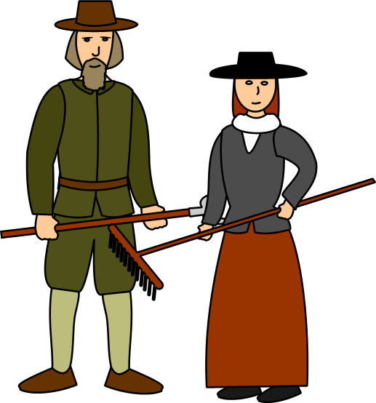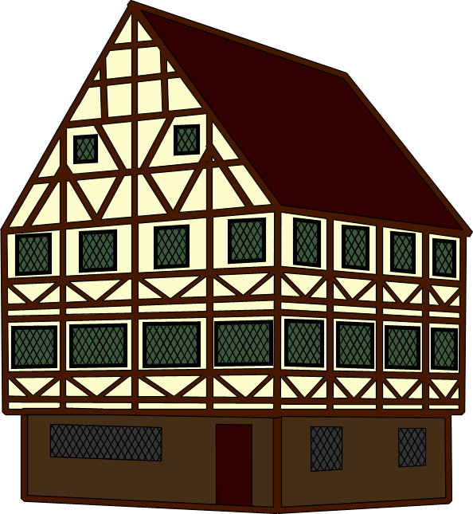
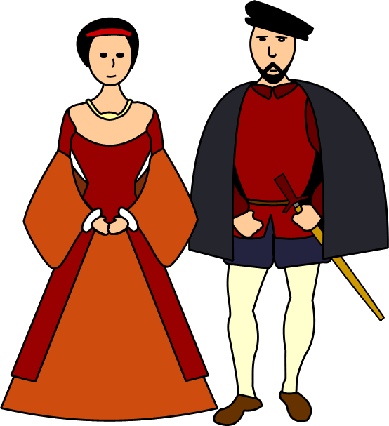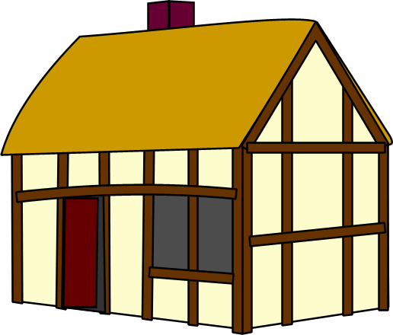

Explain why you made the choices you did
____________________________________________________________________________________________________________________________________________________________________________________________________________________________________________________________________________________________________________________________________________________________________________________________________________________________________________________________________________________
____________________________________________________________________________________________________________________________________________________________________________________________________________________________________________________________________________________________________________________________________________________________________________________________________________________________________________________________________________________
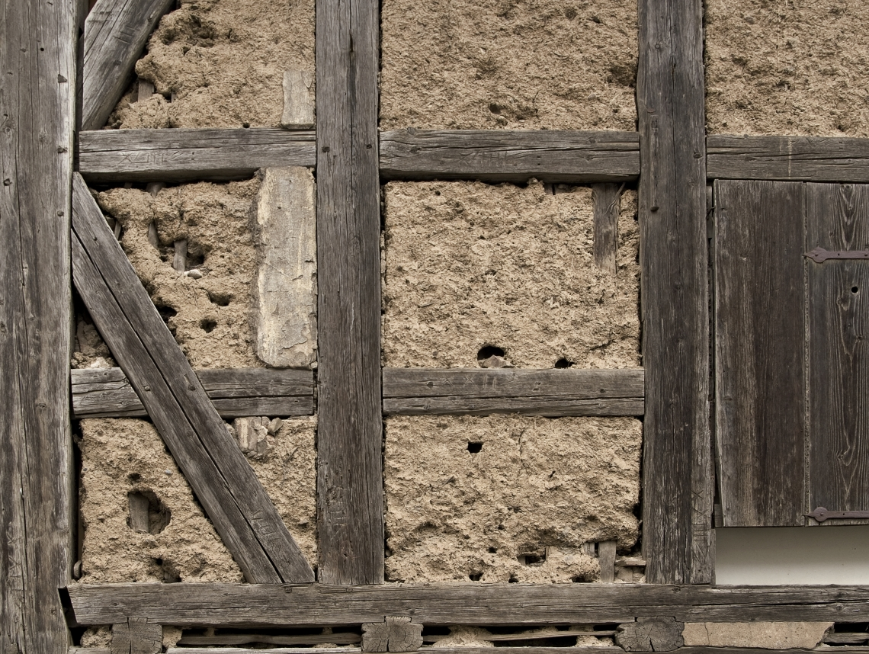
Ordinary Tudor houses were built from wooden beams which formed the ‘skeleton’ of the building. Small wooden sticks and twigs were woven together – called wattle – and a mixture of clay, sand and animal dung daubed all over the wattle – called daub – was then attached to the frame.

The daub was then painted in limewash to look white, and the wooden beams were left exposed.

The wealthy could afford houses made from bricks. These homeowners made sure everyone knew they had money. Houses were built in a symmetrical formation.

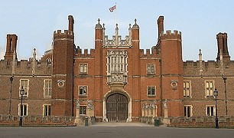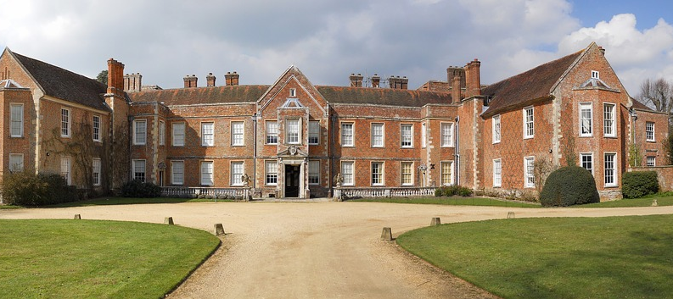

The beams were uneven because they were cut by hand and not machines.
The beams were evident from the outside.
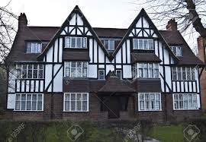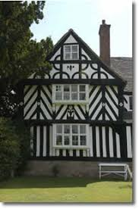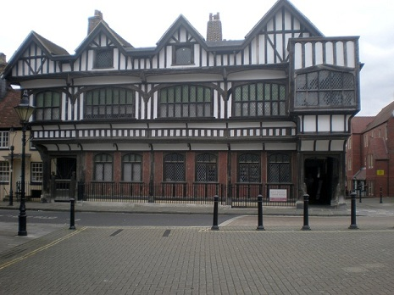

Buying land to build a property was expensive, especially in London. Tudor builders had the ingenious idea of building the first floor, and sometimes the second floor, wider than the ground floor.
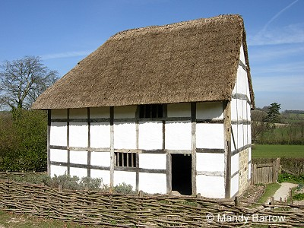
This created an overhang, which was called a gallery or jetty.

Most Tudor houses had a hatched roof made from straw and water weed.
Many Tudor houses had tiled roofs made from clay or stone tiles.

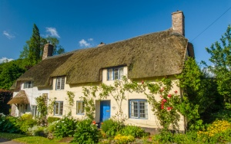
Only wealthy Tudors could afford to have chimneys. These were ornate, tall and thin structures using moulded or cut brick.
The poor had a hole cut into the roof to allow smoke to escape.
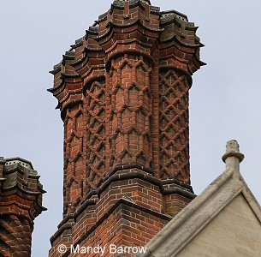
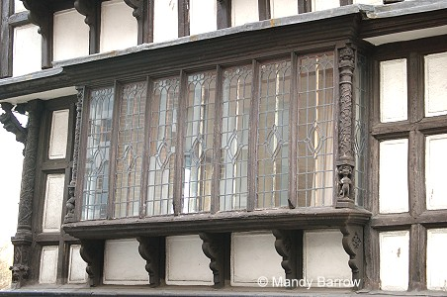
The best way to show off how wealthy you were in Tudor times was to have as many windows as possible. They were expensive, as each pane had to be made by hand, and were very tiny. These are called casement windows.
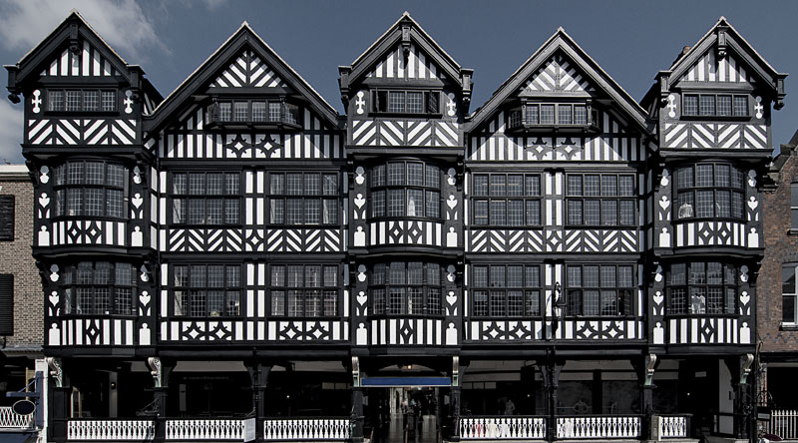

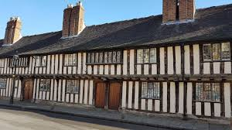

Furniture was wooden, often made from oak but sometimes elm.
It would have been very heavy. People tended to sit on benches and stools rather than chairs. The furniture would have been made for practical reasons rather than comfort.

Only wealthy Tudors could afford carpets, however, these were often hung on the walls.
Instead, the floor would be covered in rushes and reeds.

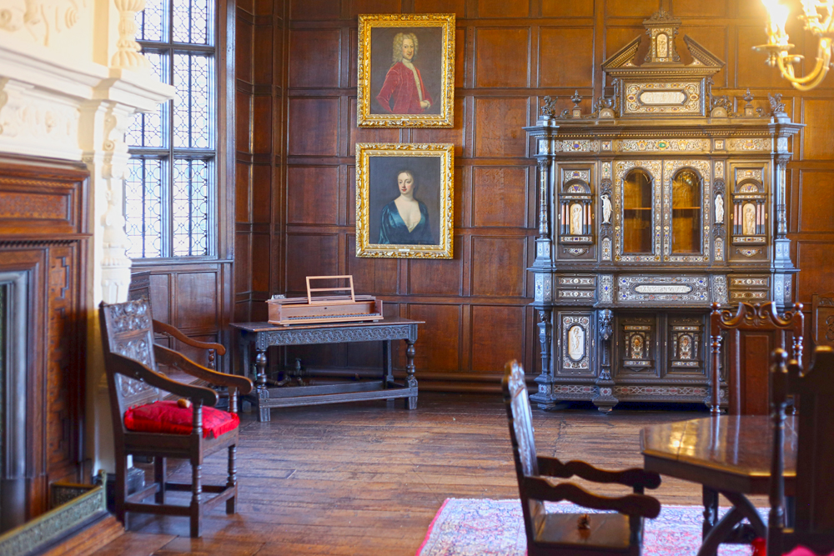

Check the following links in order to get more information about how Tudor houses were:

http://www.primaryhomeworkhelp.co.uk/houses/tudor.htm
https://kidskonnect.com/history/tudor-houses/
https://primaryfacts.com/1695/tudor-houses-and-homes-facts-and-information/
https://www.funkidslive.com/learn/building-london/the-tudor-house/#
https://www.youtube.com/watch?v=ifkTmPUZD3c

TASK: You will need to draw two houses. You will need to explain the different features of each house and what do they show us about the people that live in there.
1st House: Rich Tudor house.
2nd House: Poor Tudor house.

