LO: To draw a portrait of Henry VIII
HOM: Managing impulsivity

A portrait is a painting, photograph, sculpture, or other artistic representation of a person, in which the face and its expression is predominant. The intent is to display the likeness, personality, and even the mood of the person. A portrait often shows a person looking directly at the painter or photographer, in order to most successfully engage the subject with the viewer.

Look at the following portraits from Tudor’s time.

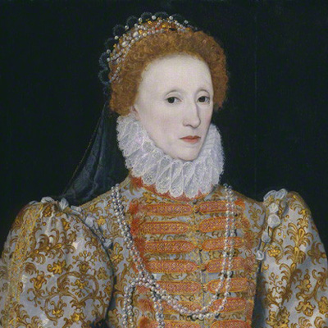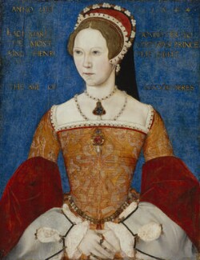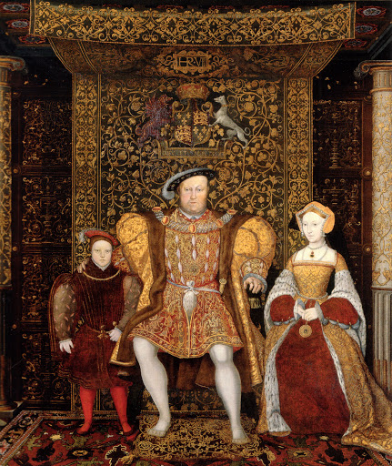

To draw a portrait from a picture follows the following steps:

- Select the picture you want to portrait and divide into different sections using straight lines.
- Draw horizontal and vertical lines to make small sections of your picture.
- Divide the paper where you are going to draw your portrait using the same straight lines you draw in your picture.
- Make sure your blank paper has as many sections as the picture you want to draw.
- Select one of the sections from the picture and sketch what you can see from the picture in your paper. Take your time, copy as many details as you can.
- Remember to use your pencil lightly, just in case you need to correct a mistake.
- To help you with the face draw an egg shape. Then draw a centre line vertically right through the centre of the egg, so you will make sure that you line up the nose, mouth and eyes correctly.

Look at the following videos to help you to see how to draw a portrait.

https://www.bbc.co.uk/teach/class-clips-video/how-to-draw-a-portrait/zk28qp3
https://www.youtube.com/watch?v=IRp3sBQ-NFU

TASK: You will draw a portrait of Henry VIII.

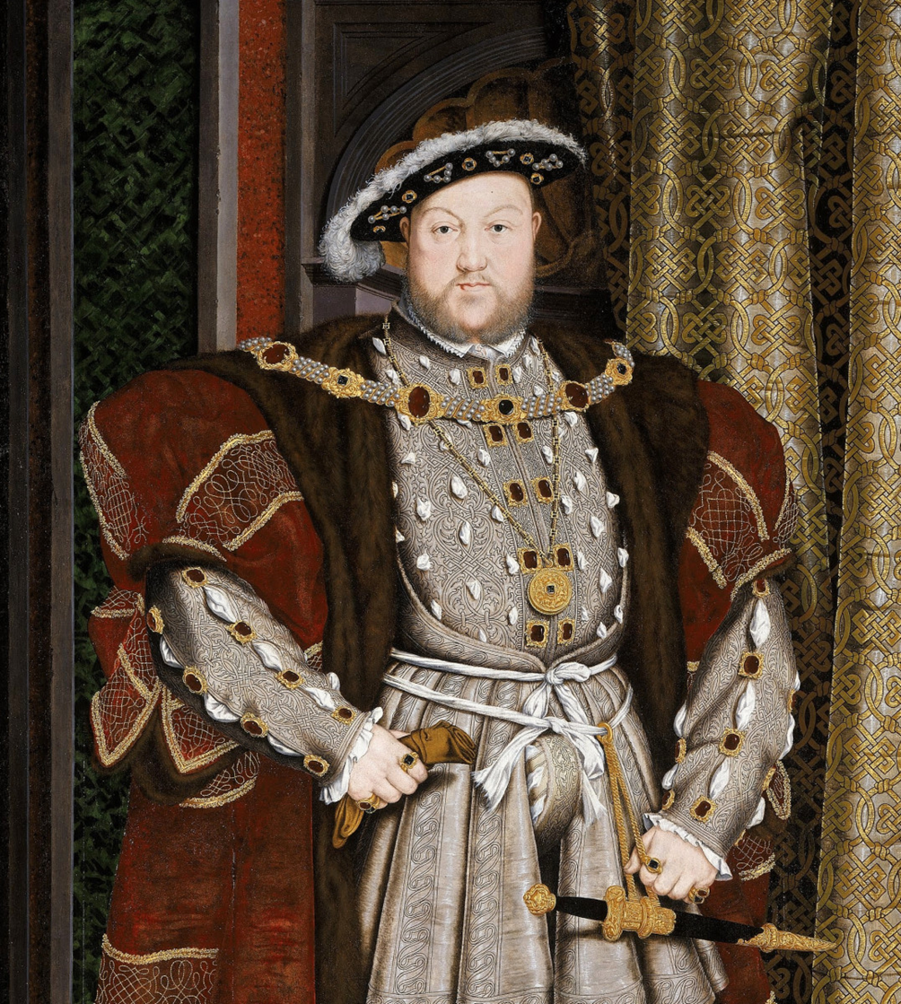

Use the following picture to help you how to draw the lines to separate the portrait into sections.

