LO: To learn what people ate during Tudor’s times.
HOM:

In Tudor times there were many differences between the food poor people ate and the food rich people ate.

POOR PEOPLE

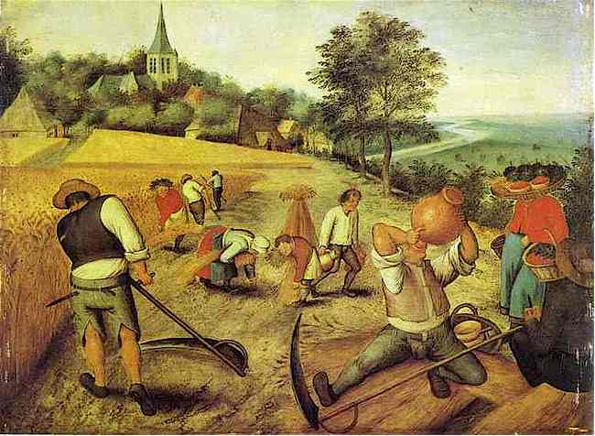
Poor people and peasants (farmers) mostly farmed and grew their own food.
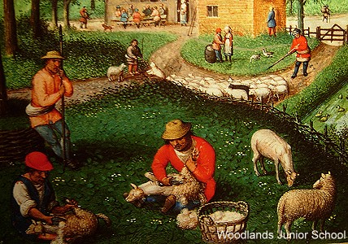
Peasants and poor people had to grow their own cereal crops (Wheat and Barley), fruit and vegetables and make their own food.

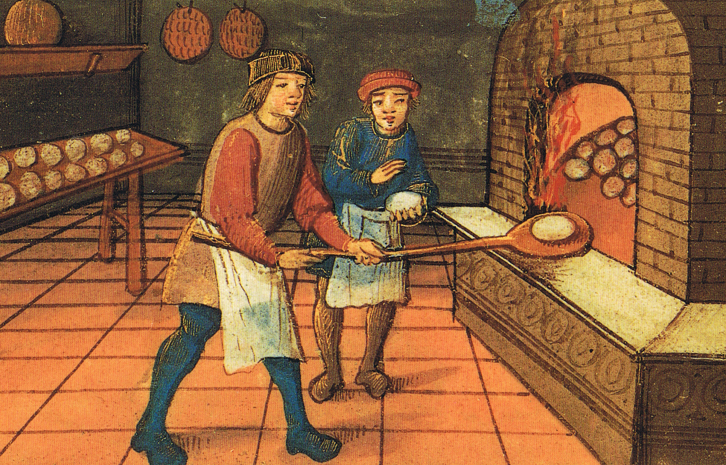
The only food they would not make themselves was bread. They would take their wheat to a miller who would grind it into flour. Then they would take the flour to a baker who would make it into bread. 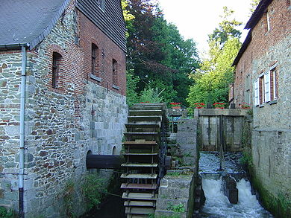

Because poor people in Tudor times grew and made their own food they ate mainly cereal crops, vegetables and fruit. They would often eat a food called potage
(a vegetable broth thickened with oats). 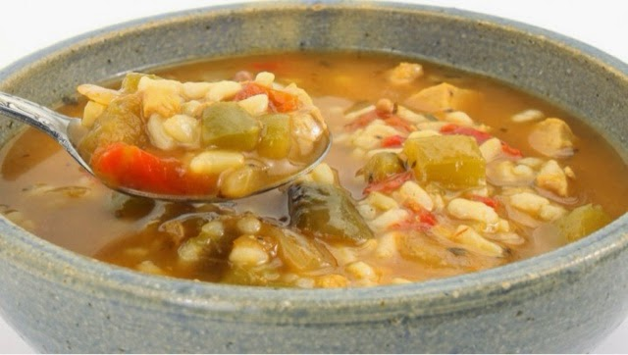 (potage)
During the Tudor times, fish was mainly eaten in places near rivers and the coast. However, due to religious rules, people had to eat fish on Fridays and during Lent. Eels, pike, perch, trout, sturgeon and salmon were a part of the Tudor diet.
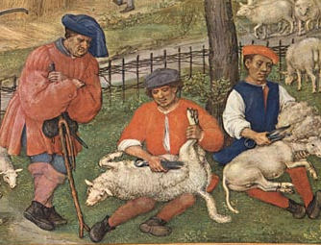
Poor people did not eat much meat at all. If they did it would have been rabbit or pigeon. 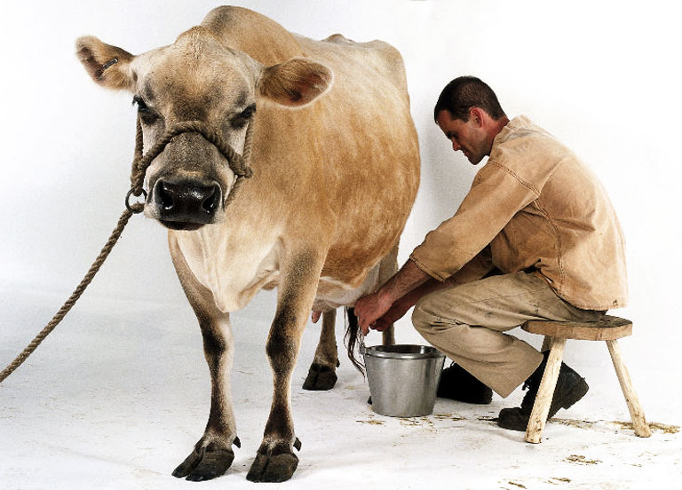

Poor Tudor people often ate food at Inns. These were like restaurants and served food to people that was sometimes better than they would be able to cook themselves.
Poor Tudor people would often eat their food on a plate that was made of wood or a hard, flat, round piece of bread. Both the wood plate and the flat, round bread were called a Trencher. Some wood trenchers were made square with a small hollow to rest a cup in. This is where the saying ‘a square meal’ comes from.
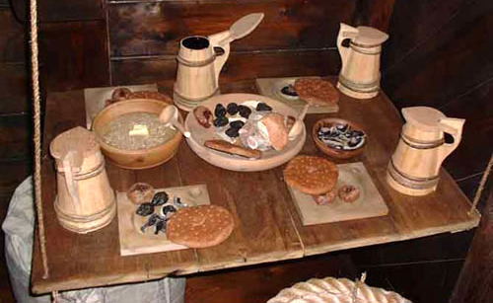

RICH PEOPLE
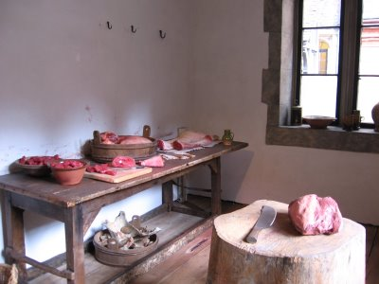
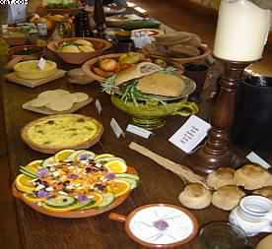
Rich people in Tudor times wanted to show everyone that they were very different to poor people. Rich Tudors ate very different food. They hardly ate any vegetables, unless the vegetables were cooked in a dish with meat. They did not eat fruit raw, straight off the tree or bush. Rich Tudors liked to eat fruit cooked into pies or tarts, mixed with honey or sugar.

Meat made up three-quarters of the Tudor diet. Animals like cows, pigs and sheep were killed just before they were needed for food.
Many other types of meat were eaten during the Tudor era.
Water was not used as a drink as it was often unsafe due to sewerage. Instead, poorer people drank weak ale – even the children –
and the wealthy drank wine.
Very Rich Tudors, Lords, Noblemen and the Kings and Queens of Tudor times had very large kitchens in their houses and palaces. Henry VIII’s kitchens at Hampton Court Palace are enormous, with a huge fireplace where all the cooking would be done.
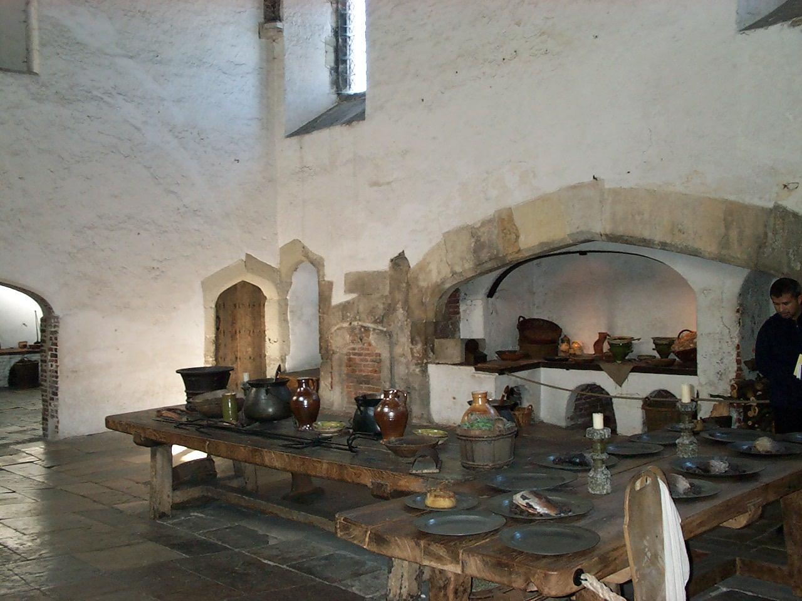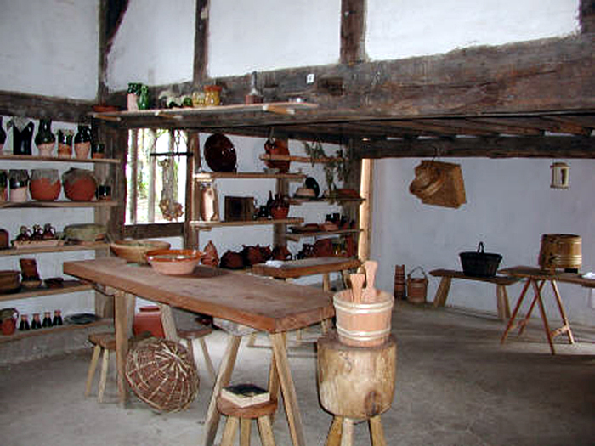
Most Rich Tudors had servants and a kitchen in their house. The Rich Tudors had their servants buy food from markets and then cook it to be eaten by the rich Tudors of the house.
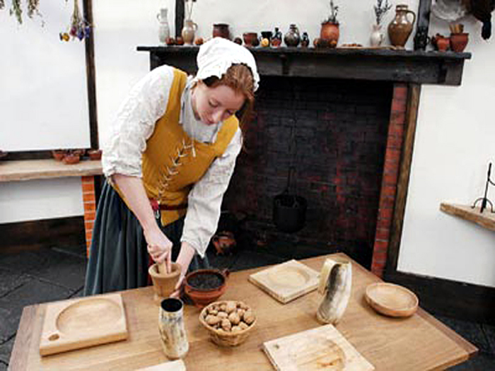
Henry VIII’s Kitchens at Hampton Court Palace were huge. The Kitchen had a room for keeping fruits and vegetables; a room for chopping up meat; a room for hanging game animals killed in hunting trips; and a preparation and cooking room with large tables and a huge fireplace.
Rich Tudors liked to eat lots of meat, because it showed that they were rich and could buy meat or hunt it on their own land (which they owned). Henry VIII liked to eat meat very much, and he liked to make sure that all his rich guests who stayed with him at Hampton Court Palace also ate lots of meat. Henry would entertain his guests in the Great Hall at his palace with huge meals that would have 30 courses and last 6 hours!
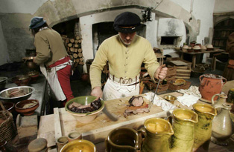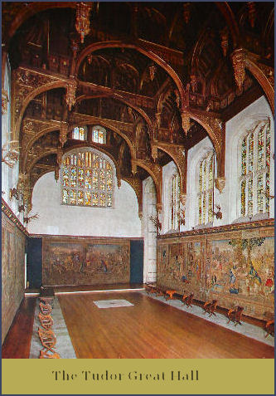

Have a look at the following links to get more information about what people ate during Tudor’s time:

https://slideplayer.com/slide/5682517/
https://www.bbc.co.uk/bitesize/clips/zjbg9j6
https://primaryfacts.com/476/tudor-food-and-drink-facts-and-information/
http://history.parkfieldprimary.com/tudors/tudor-food

Here are 3 pictures of Tudors eating.
Do you think they are Rich or Poor Tudors?
What clues help you?
What can you see in each picture? Describe the details.

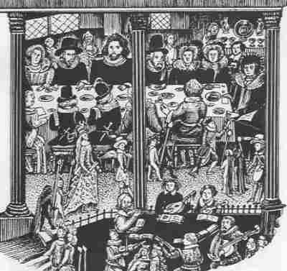

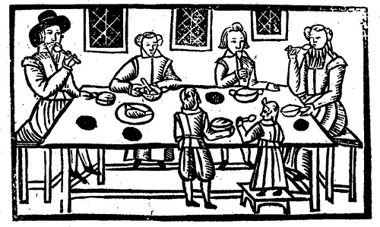

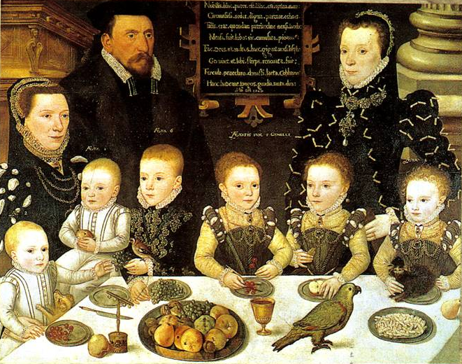

YOUR TASK:
You will need to describe what poor and rich people ate during Tudor’s time. Draw a table with the food these two groups used to eat and label the different kind of food is on the table. Then write a paragraph explaining how did they get the food.

