LO: To use evidences to classify and identify invertebrates.
HOM: Thinking flexibly

White hat: What is an organism?
_______________________________________________________________________________________________________________________________________________________________________________________________________________________________________________________________________________________________________________________________________________________________

White hat: What are the two groups we can classify animals? Explain the main characteristics.
_______________________________________________________________________________________________________________________________________________________________________________________________________________________________________________________________________________________________________________________________________________________________
_______________________________________________________________________________________________________________________________________________________________________________________________________________________________________________________________________________________________________________________________________________________________

Invertebrates are animals without a backbone, or a skeleton made of bones.
Some have a hard shell on the outside of their body called an exoskeleton.

Can you think of any animals like this?
__________________________________________________________________________________________________________________________________________________________________________________________________________________________________________

Others have no skeleton at all and are filled with a fluid substance. They are soft with flexible bodies.

Can you think of any animal like this?
__________________________________________________________________________________________________________________________________________________________________________________________________________________________________________

More than 80% of living things on the planet, and 98% of animals are invertebrates.

What kind of skeleton do these creatures have?
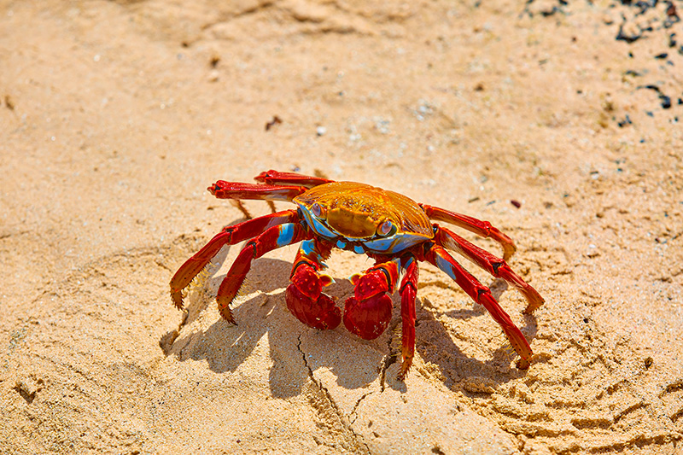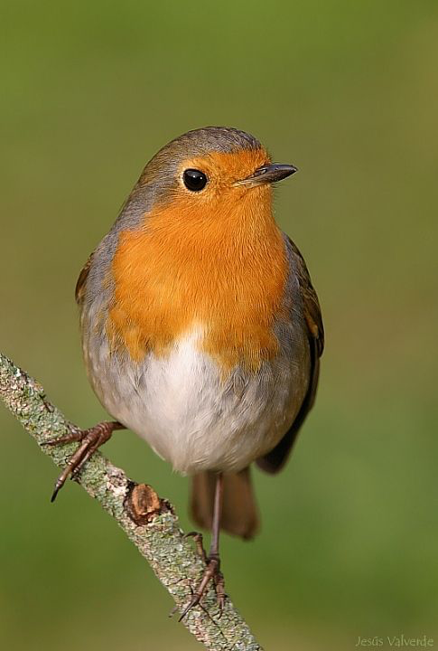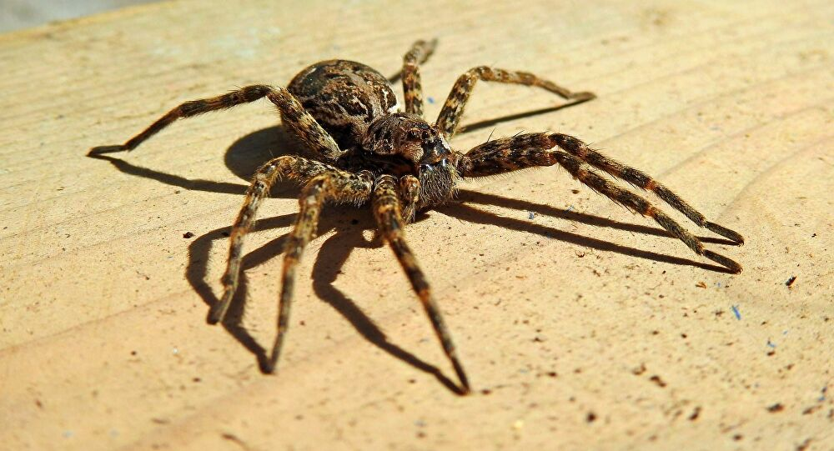
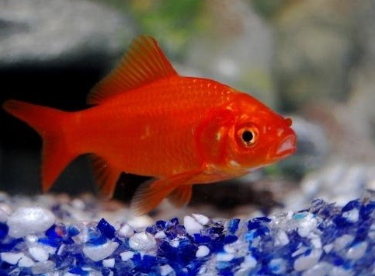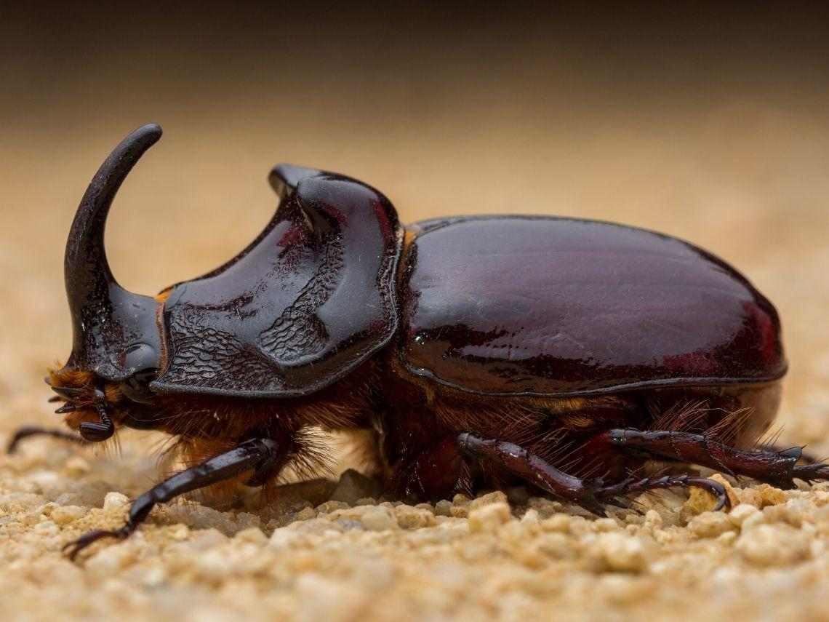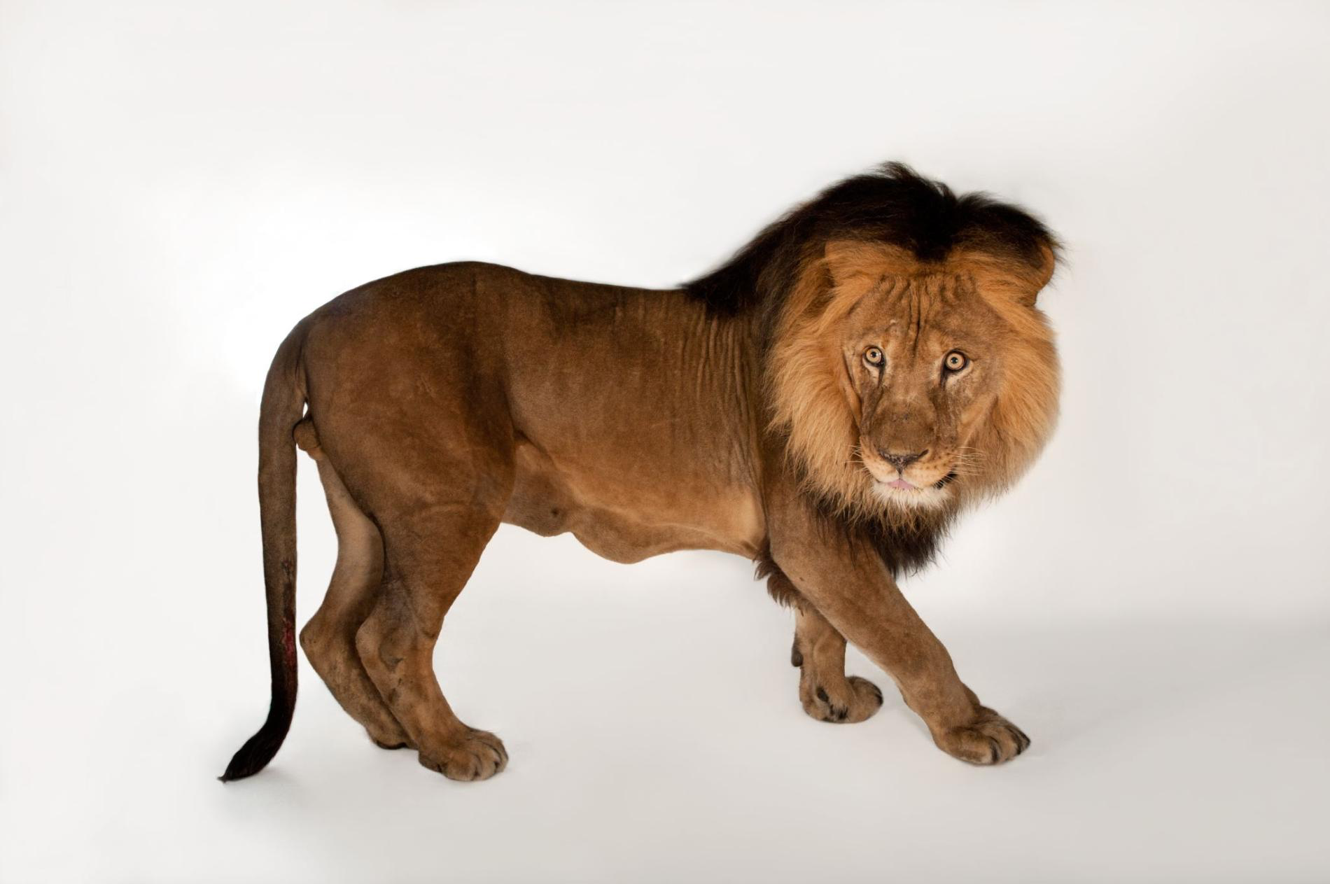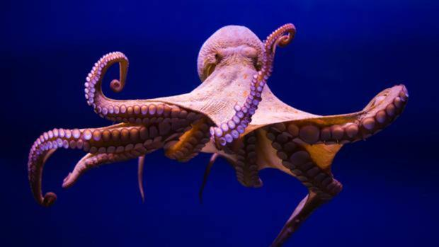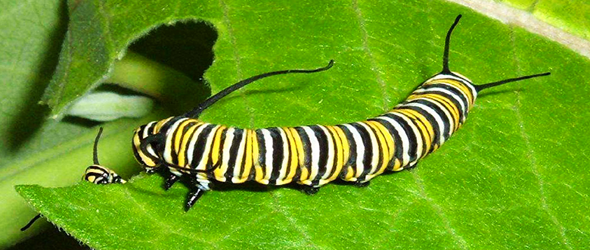
Invertebrates can be classified into different groups:
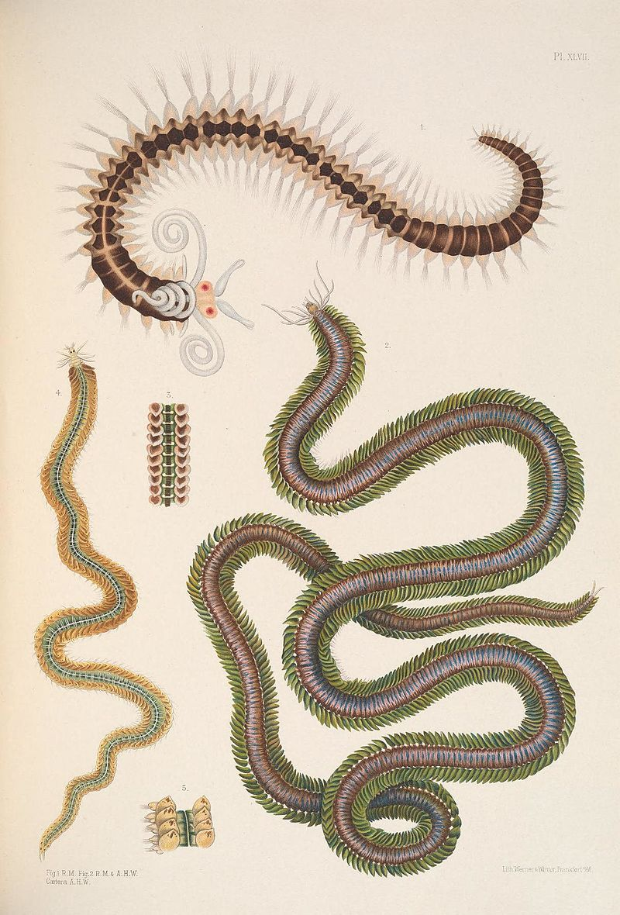
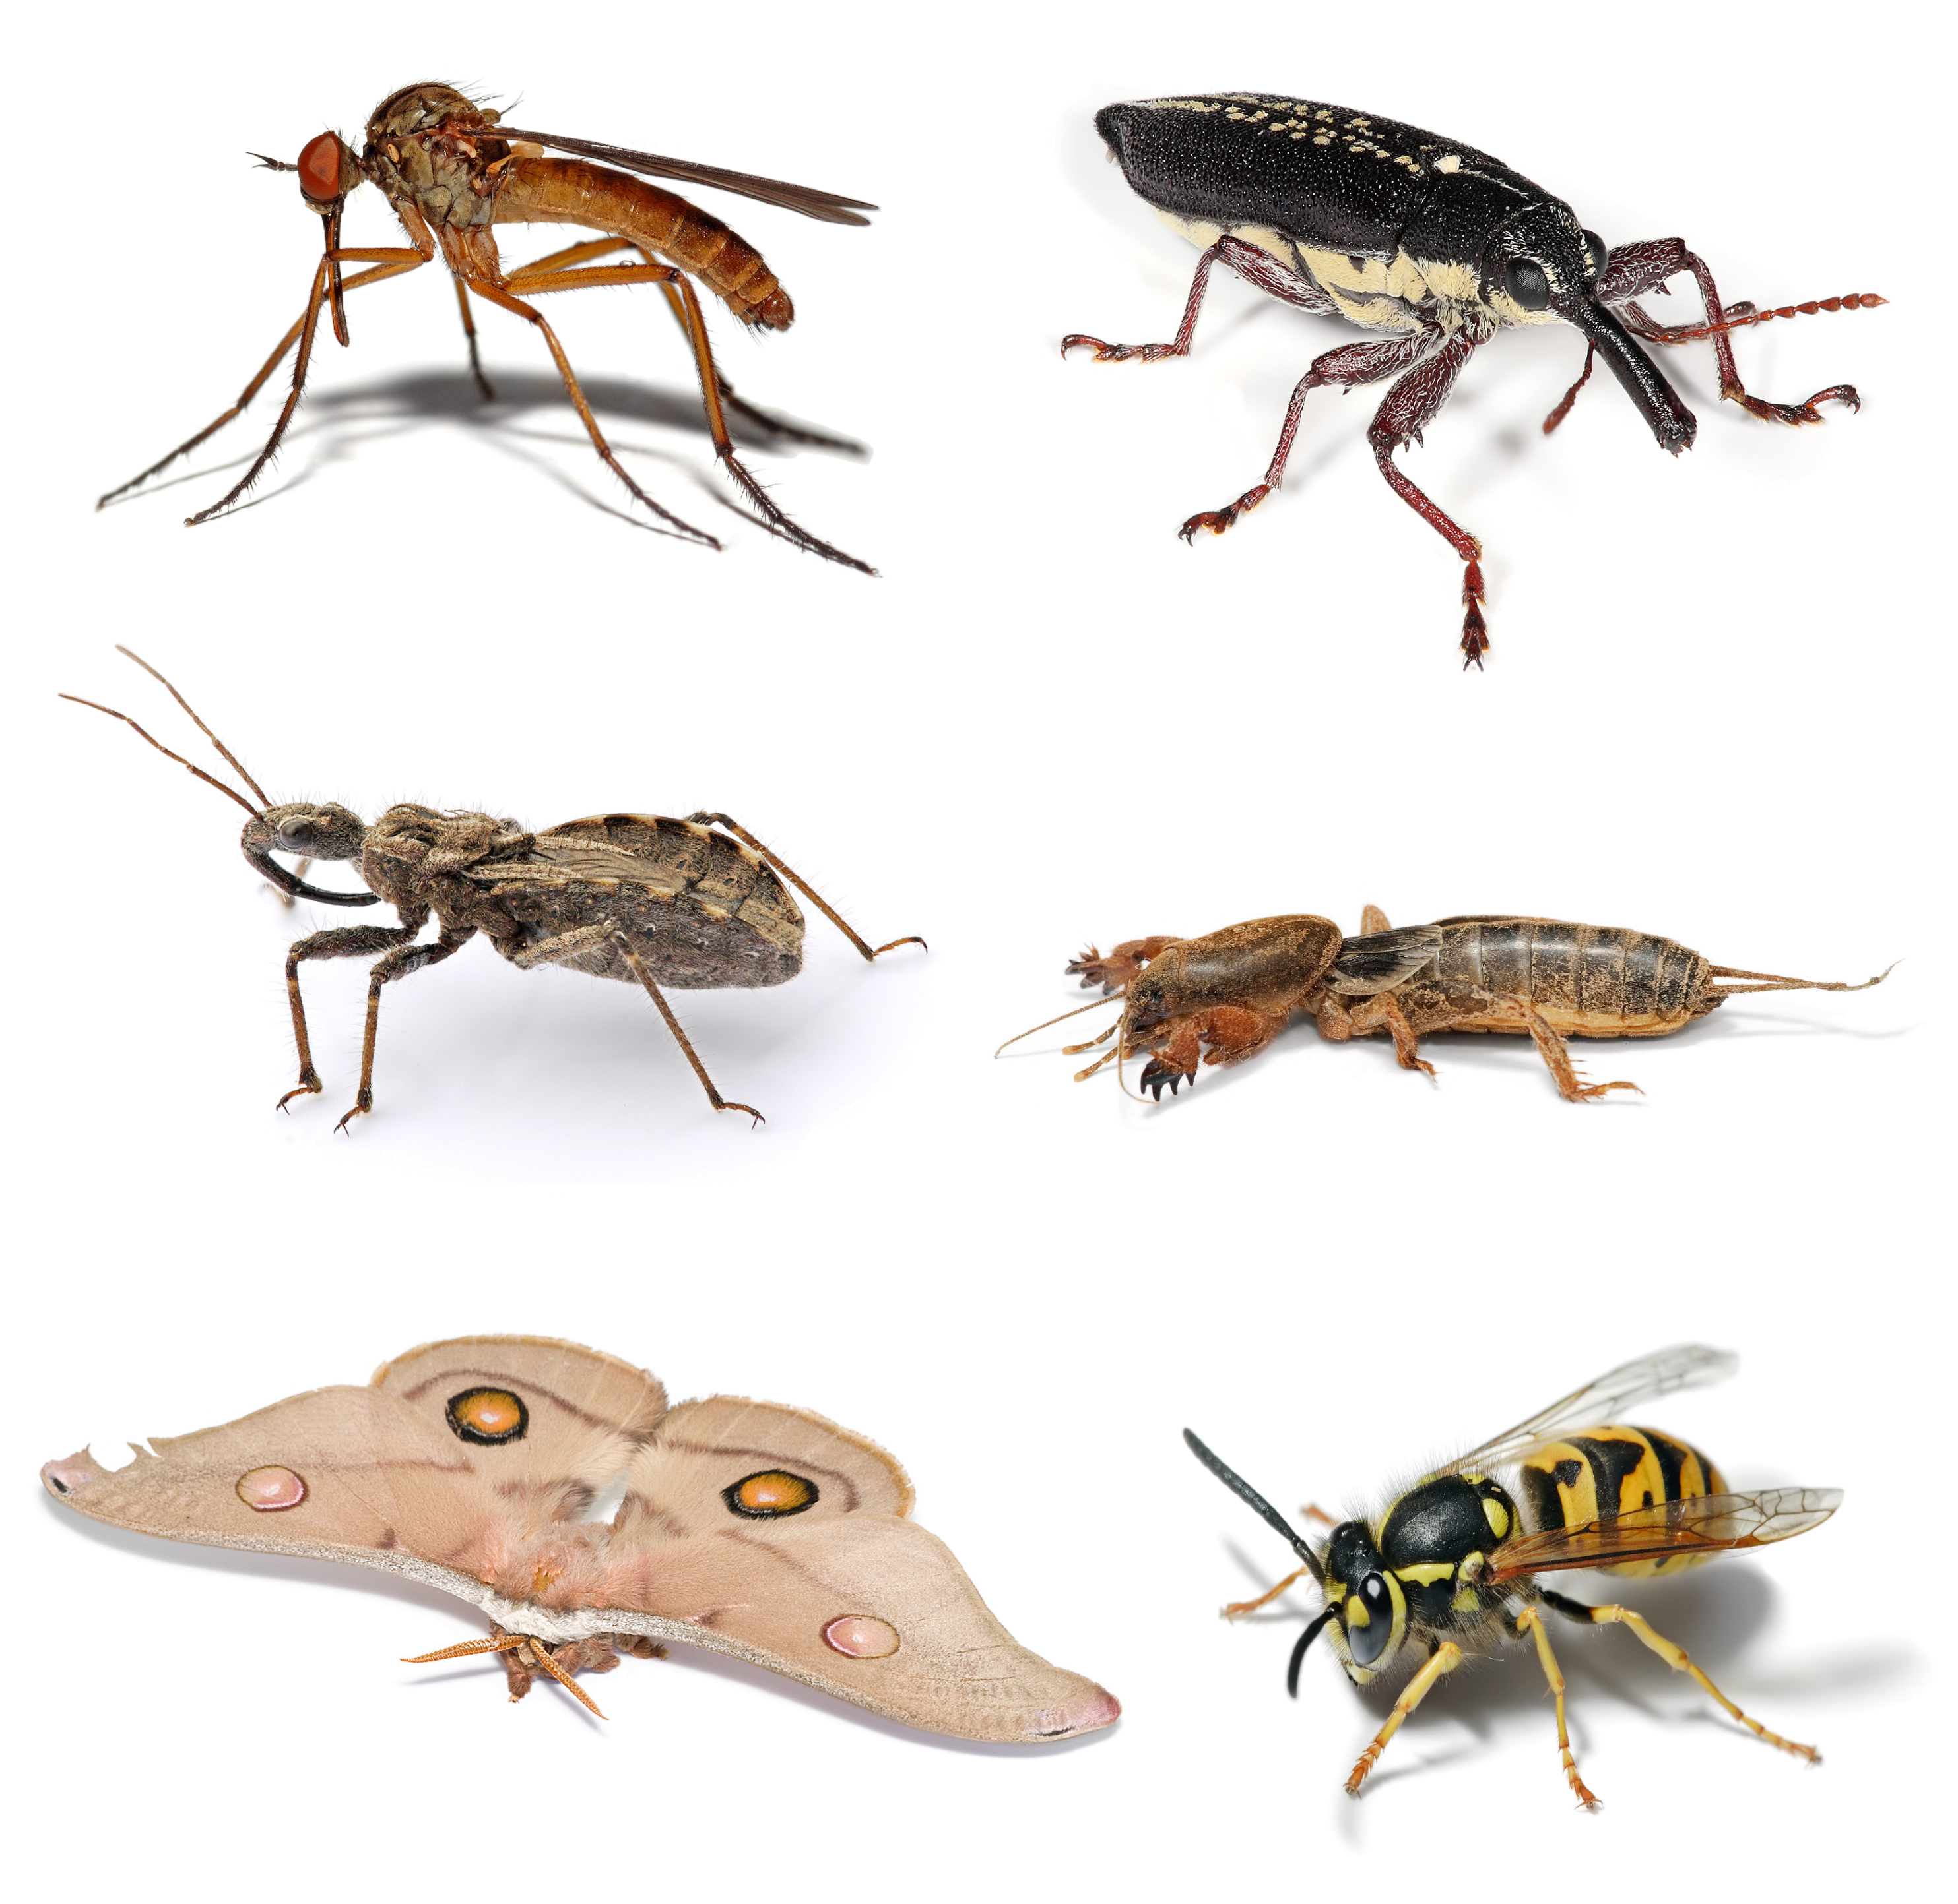
Insects: they have an exoskeleton covering their body that consists of 3 parts (head, thorax and abdomen). They have a pair of antennae on their head.

Annelids: they have bodies divided into segments. They don’t have any limbs. (Worms)
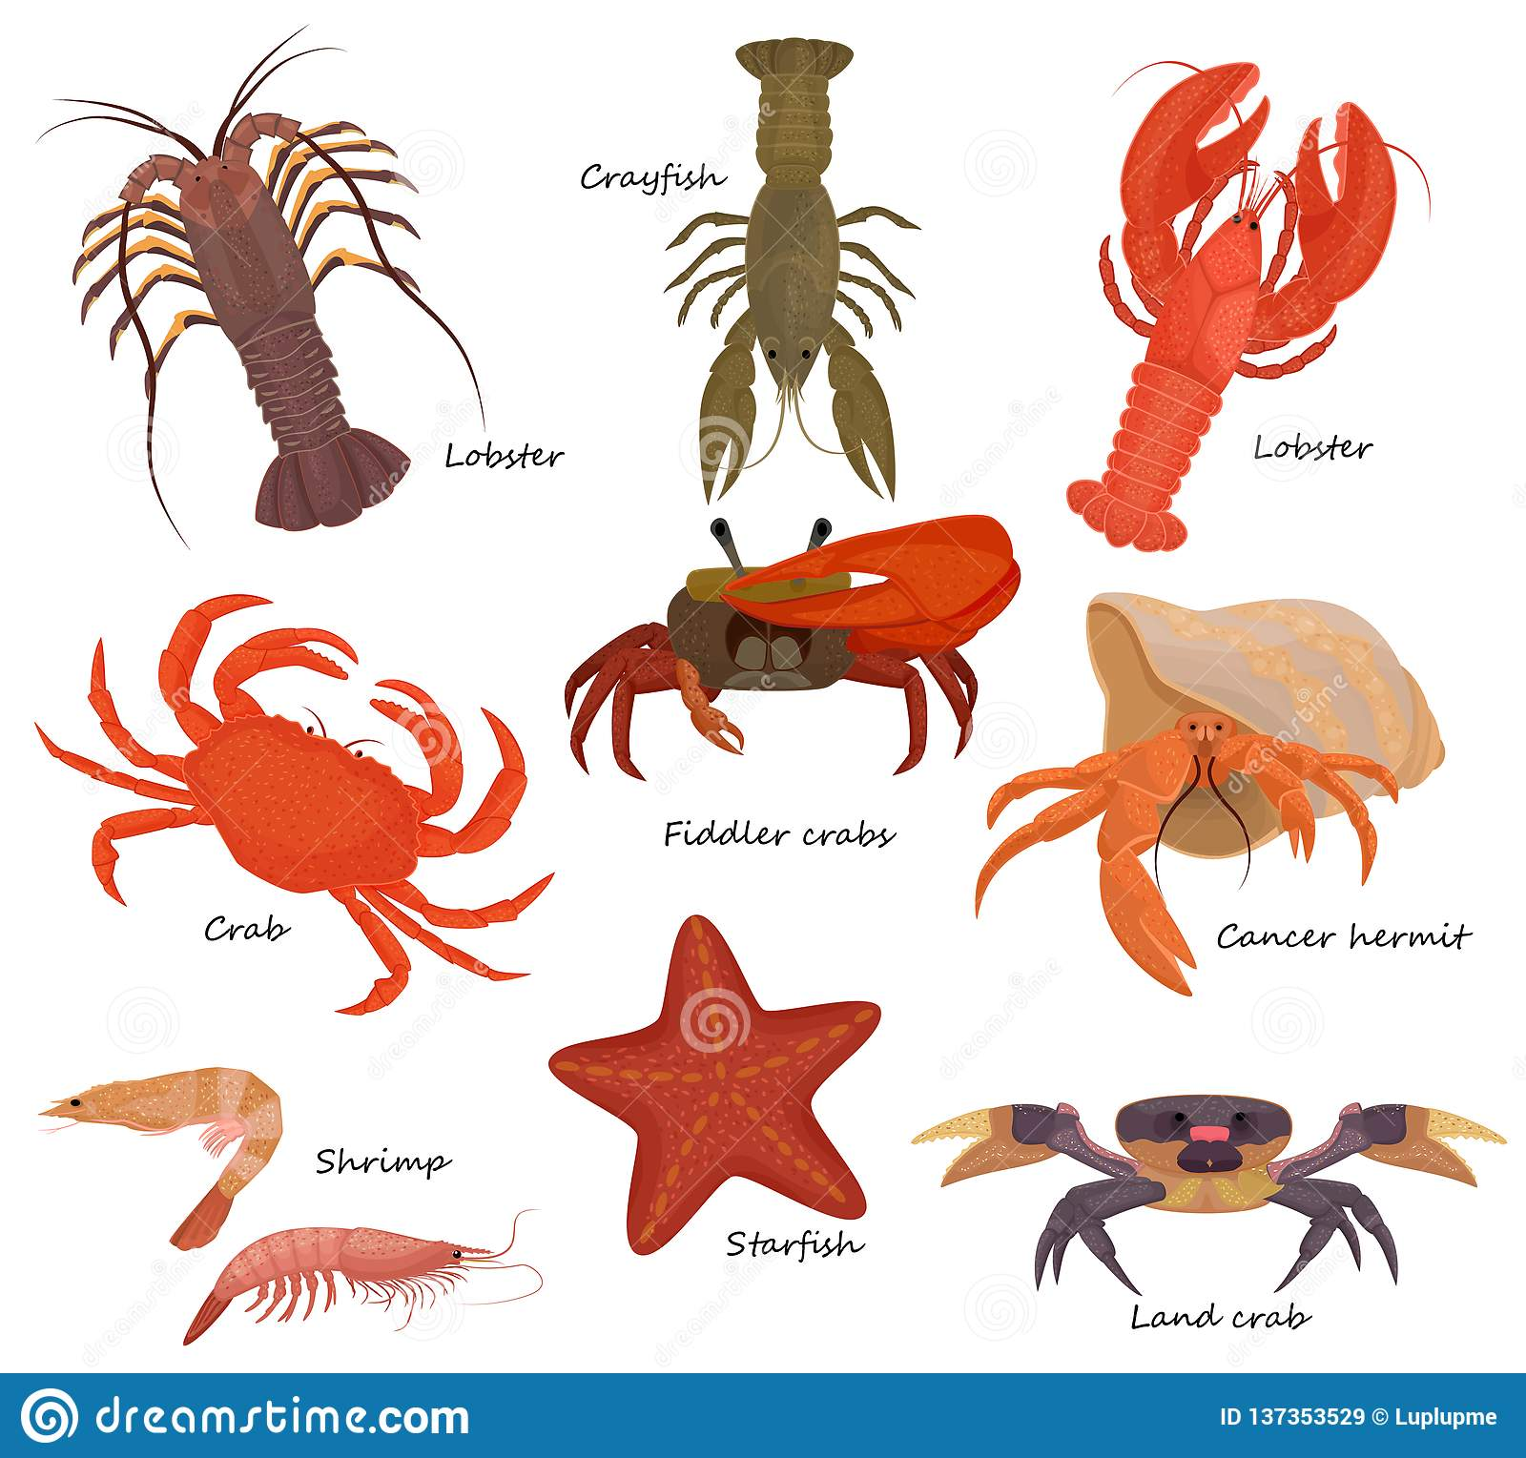
Crustaceans: they have a hard external shell that protects their body. They have a dead and abdomen. Mostly live the ocean or other waters. Many have claws to help them to crawl and eat.

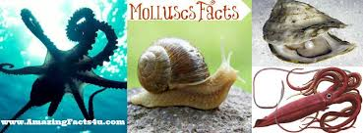

Molluscs: most have a soft, skin-like organ covered with a hard outside shell.

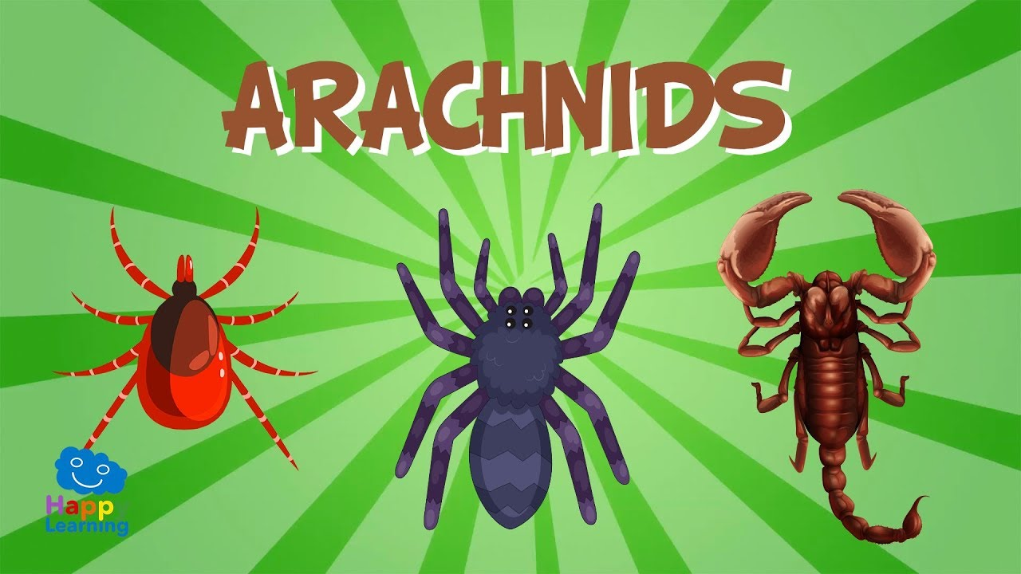
Arachnid: most have 4 pairs of legs. They have a hard exoskeleton and jointed legs for walking. They do not have antennae.

Echinoderms: they live in the ocean. They have arms or spines that radiate from the centre of their body. The central body contains their organs and their mouth for feeding.
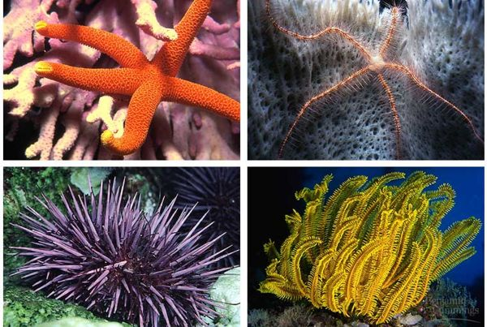

White hat: What kinds of invertebrate would you find in your local area?
_______________________________________________________________________________________________________________________________________________________________________________________________________________________________________________________________________________________________________________________________________________________________

White hat: What do you think is the habitat of an invertebrate?
_______________________________________________________________________________________________________________________________________________________________________________________________________________________________________________________________________________________________________________________________________________________________

Invertebrate often inhabit small homes called microhabitats. Some of the microhabitats where we can find invertebrates are: under stones and rocks, in short grass, inside or under rotting wood, in and on soil, in tall flowers and grasses, under fallen leaves…

As invertebrates are so small we need to observe them really close to help us to classify them into different groups. The different parts we need to look carefully at the time of classifying invertebrates are: in they have antenna or not, head, how many legs they have, if they are divided into segments, if they have a shell.

Here you have some examples of invertebrate keys.
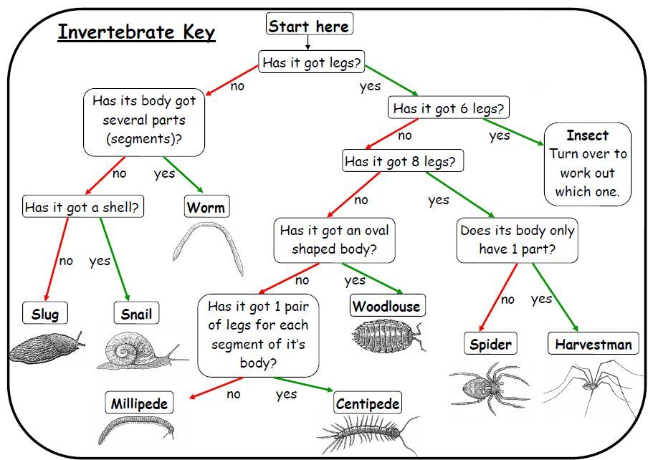

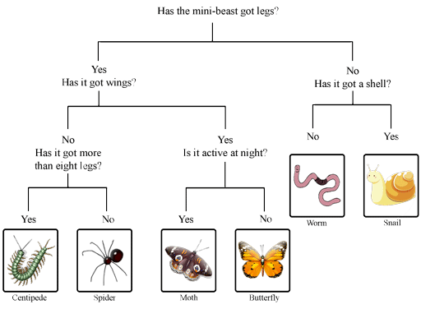

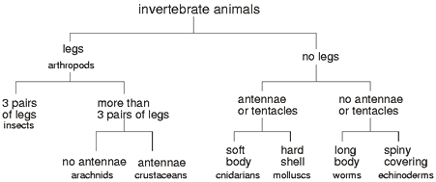

Have a look to the following websites to help you to learn more about invertebrates.

https://www.bbc.co.uk/bitesize/topics/zn22pv4/articles/z8mbqhv
https://www.youtube.com/watch?v=rzxFTrktN1c
https://www.dkfindout.com/uk/animals-and-nature/invertebrates/
https://www.ducksters.com/animals/invertebrates.php

TASK 1: Complete the following chart with the characteristics of different invertebrates

Insects | 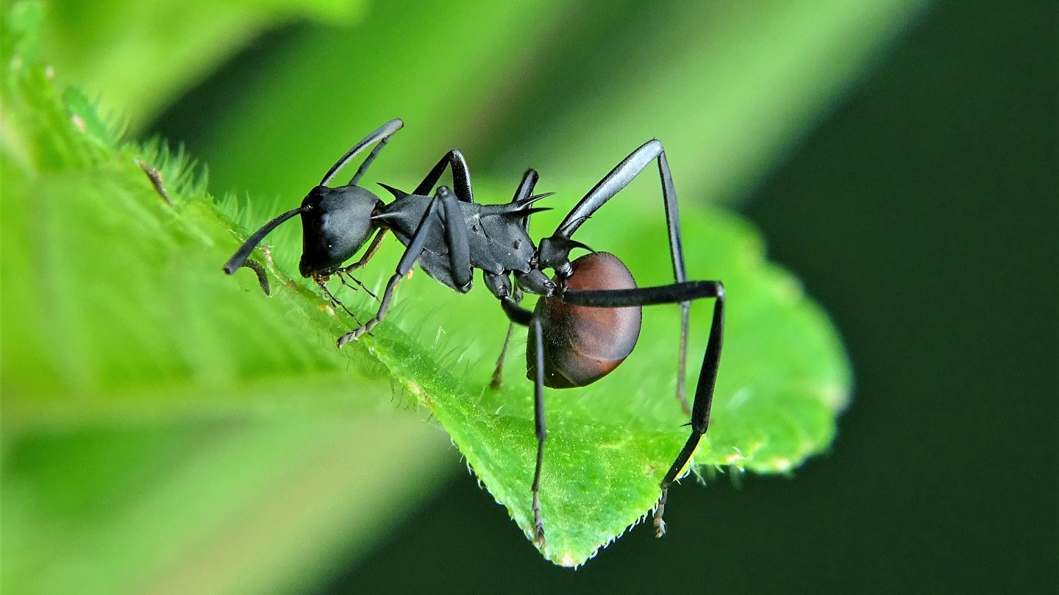
Annelids | 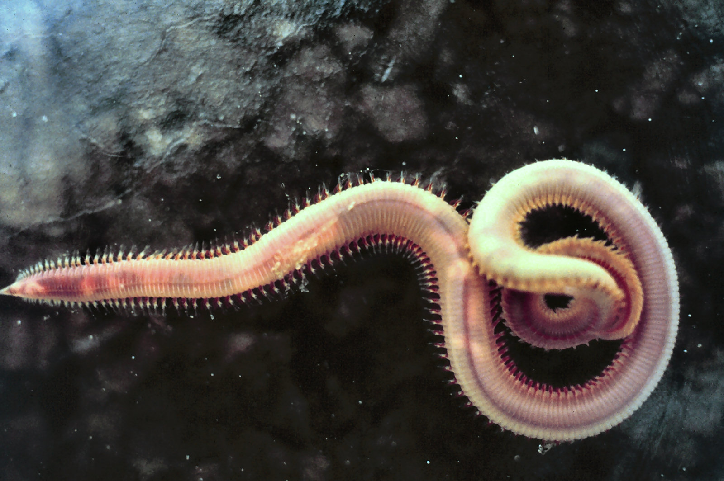
Arachnids | 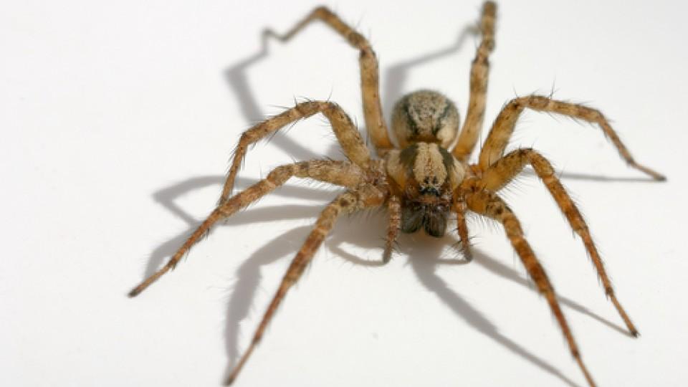
Crustaceans | 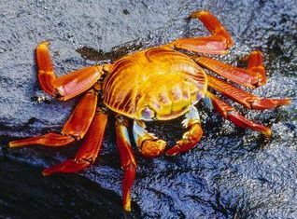
Molluscs | 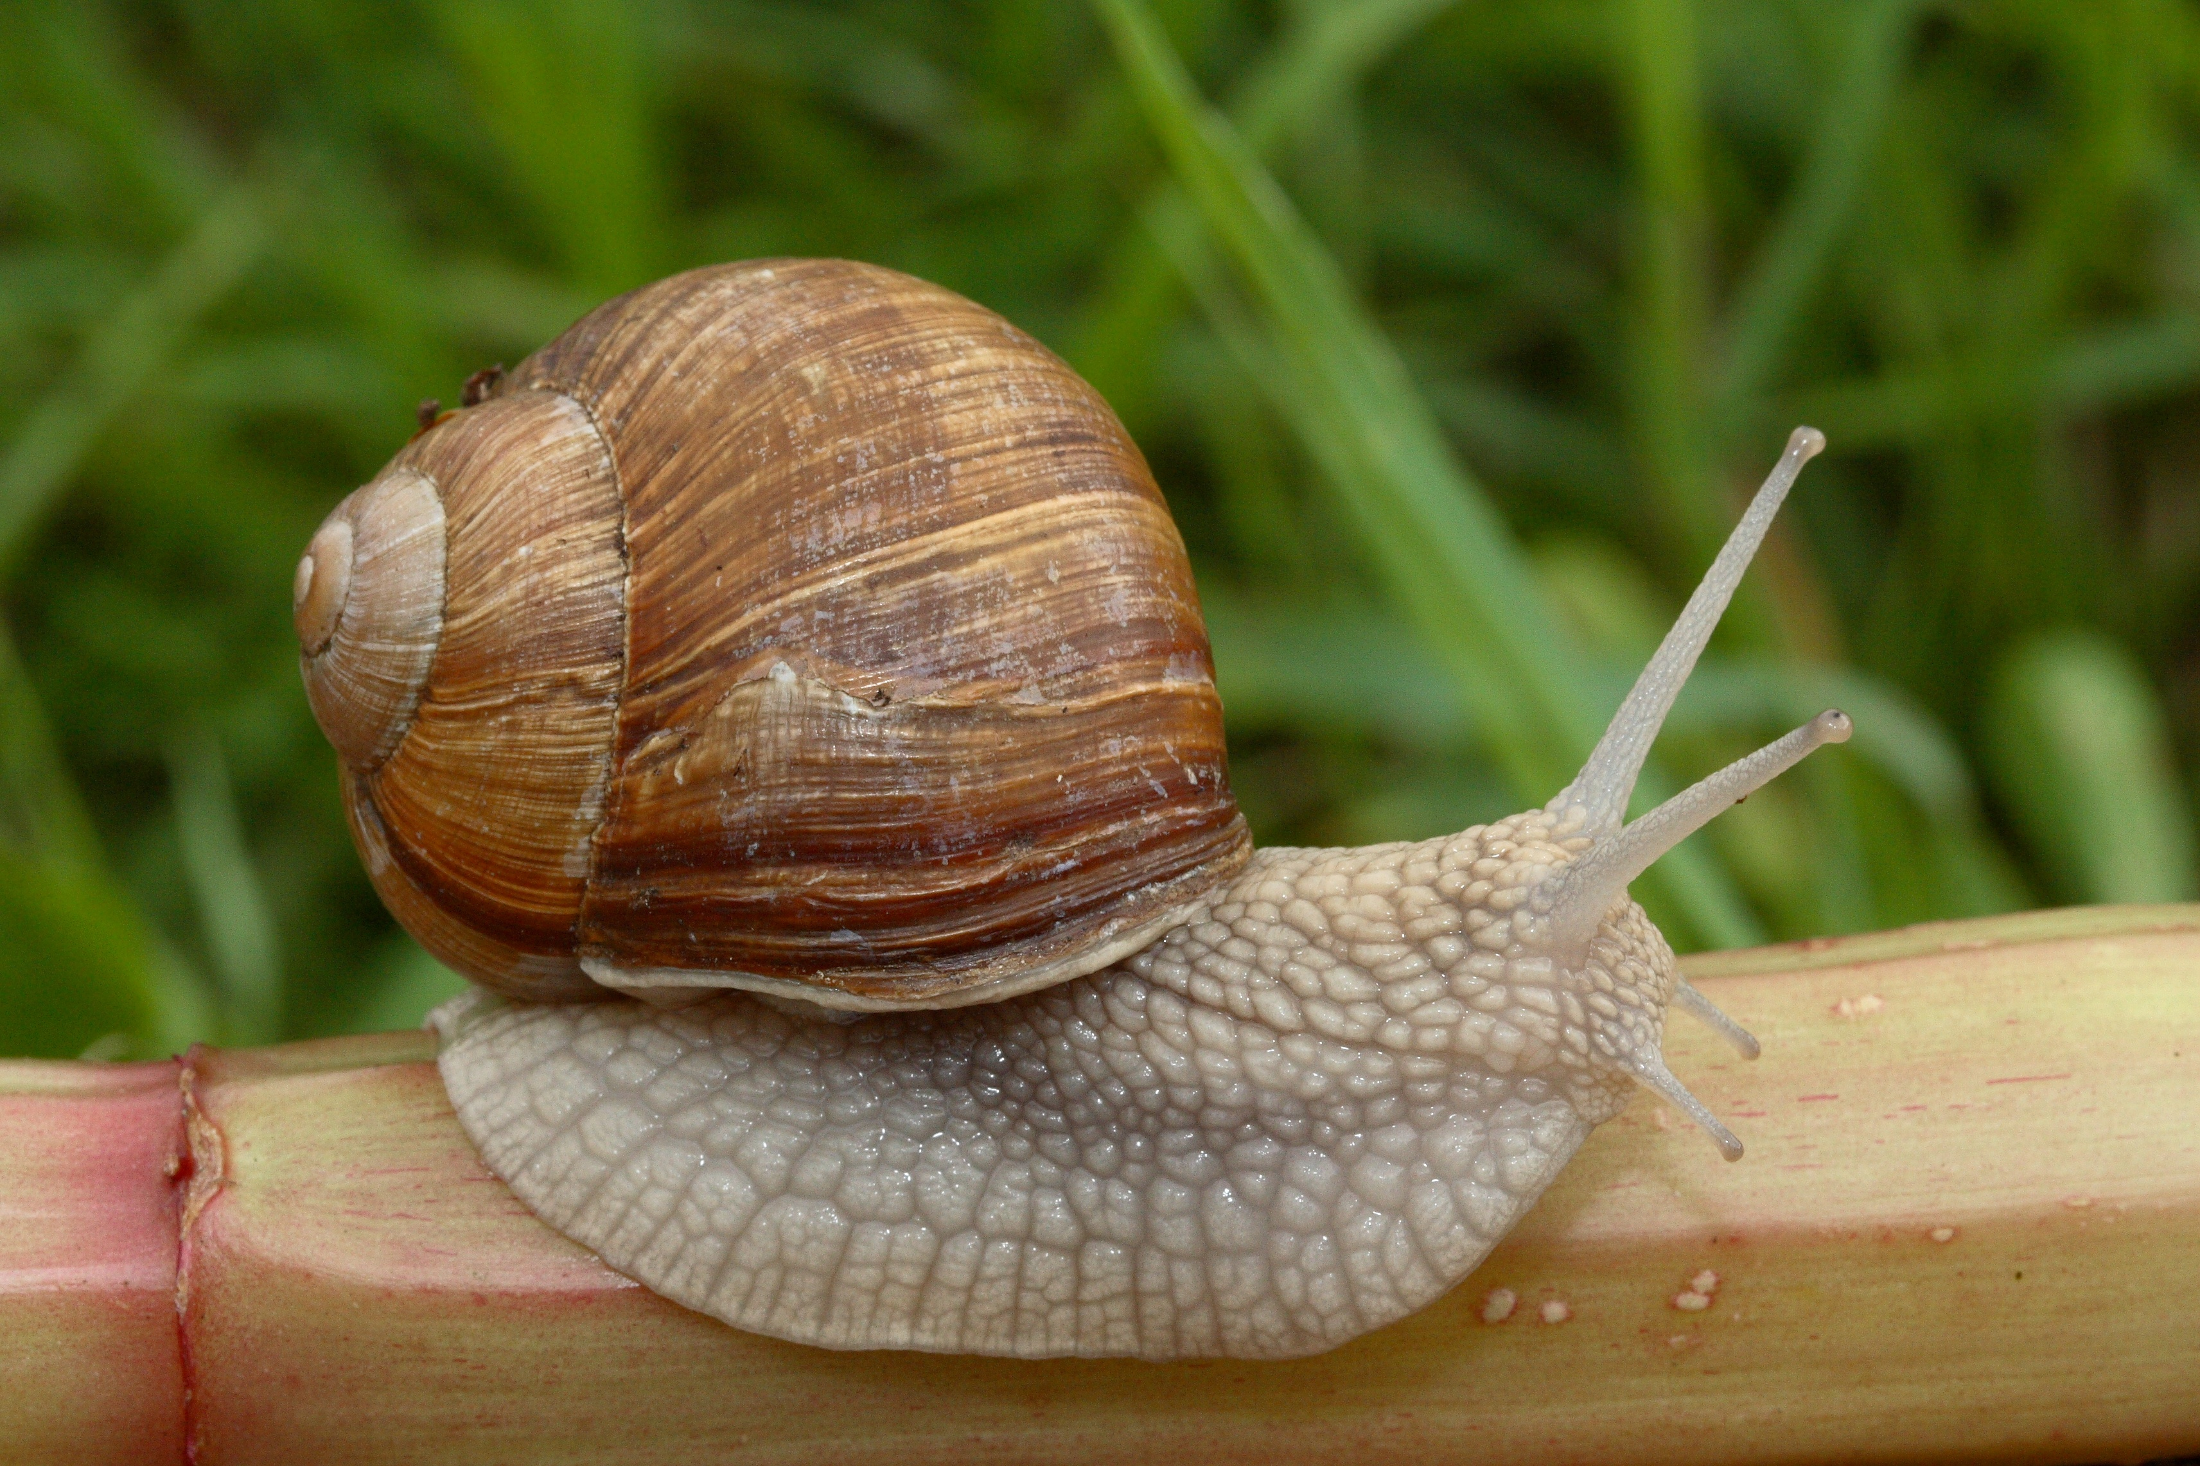
Echinoderms | 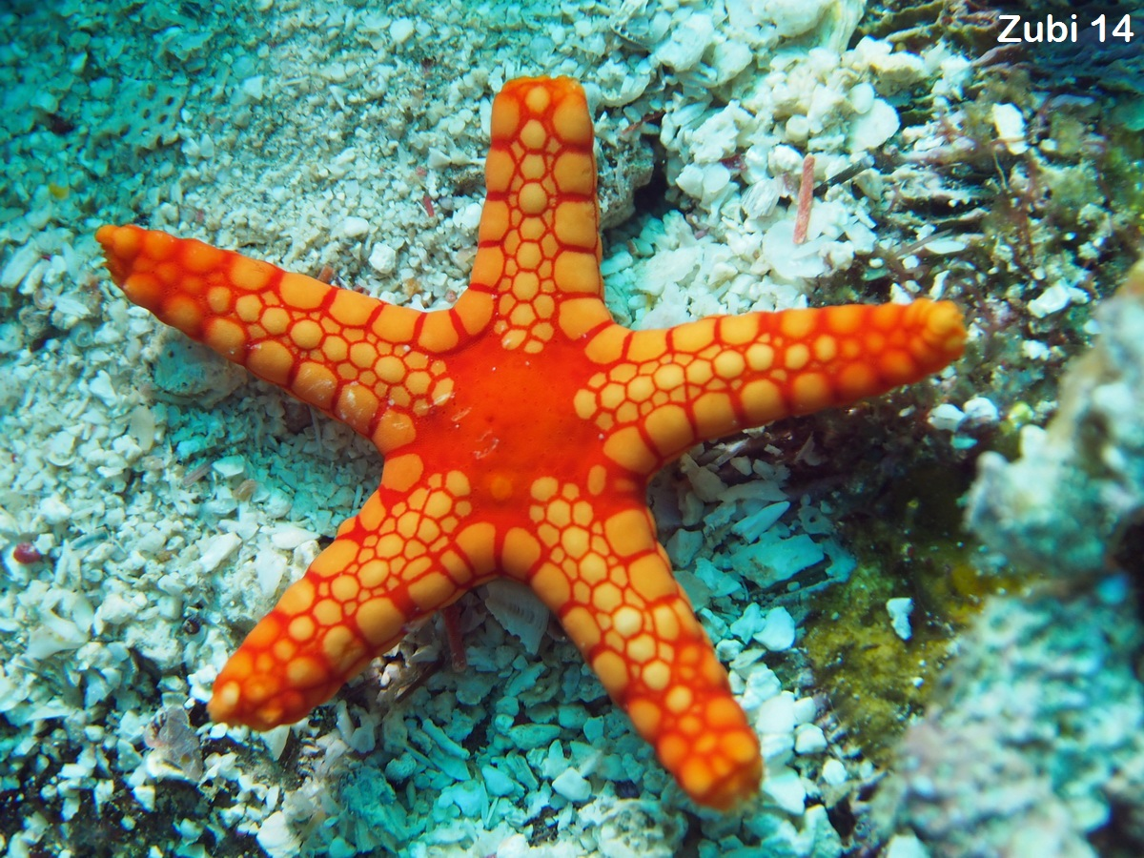

TASK 2: Create a classification key for the following invertebrates.

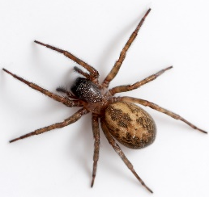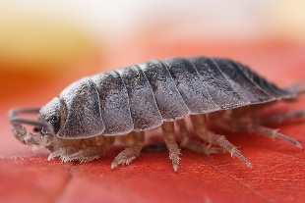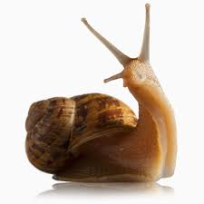
spider woodlouse snail

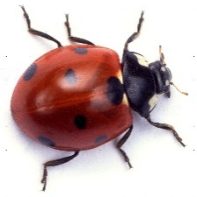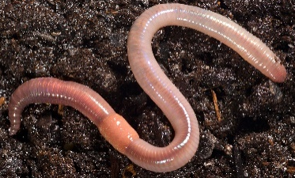
ladybird earthworm earwig

Think about the questions you are going to ask for your key. Think about how many legs, antennae, how many parts have it body….
Remind that the questions must always have a yes/no answer. The yes and no then leads to either another question or an insect. There will be one less question than the number of insects.

TASK3: Minibeast hunt. Look around your area, in your garden, in the park when you go for a walk, in your road when you are looking through the window… Look for different invertebrates, look at them carefully and classify them. Draw them in a piece of paper and write down their characteristics. You can look for them over a week or two. As the more you record the better.

