WRITING LESSON WEEK 9
LO:
HOM
INTRO/WARM UP
Look at the picture below very carefully
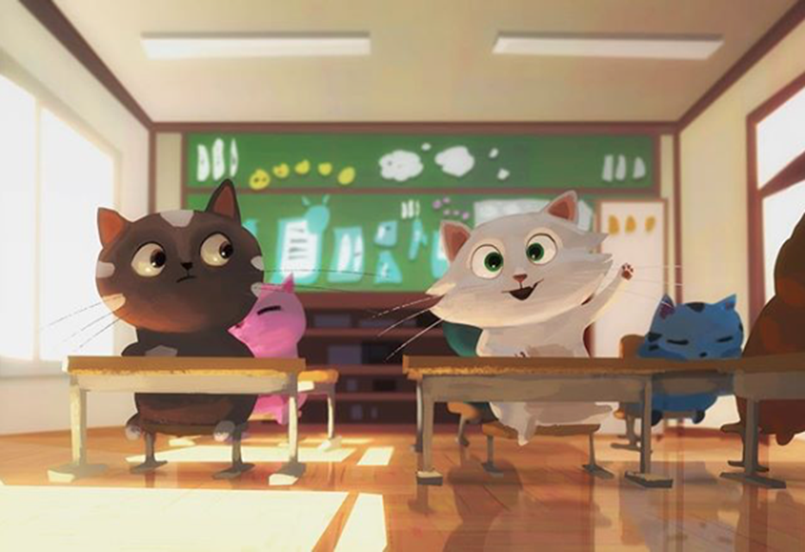
Now take your time to think and answer these questions below very carefully. Some of the questions are inference and some are deduction questions.

Where do you think this is?
_____________________________________________________________________
How do you know?
_____________________________________________________________________
How many cats are in this class?
_____________________________________________________________________
What time of day is it?
______________________________________________________________________
Why do you think that?
____________________________________________________________________________________________________________________________________________
Why is the white cat putting its paw up?
____________________________________________________________________________________________________________________________________________
What are the other cats doing/thinking?
______________________________________________________________________________________________________________________________________________________________________________________________________________________________________________________________________________________________________________________________________________________________
How is the black cat feeling? Why?
__________________________________________________________________________________________________________________________________________________________________________________________________________________
Which cat is the cleverest? Why do you think this?
__________________________________________________________________________________________________________________________________________________________________________________________________________________
Which cat is the best behaved? Why do you think this?
__________________________________________________________________________________________________________________________________________________________________________________________________________________

Draw/describe what you think their teacher looks like.
Draw the teacher below. | Describe the teacher here.  _________________________________________  _________________________________________  _________________________________________  _________________________________________  _________________________________________  _________________________________________  _________________________________________  _________________________________________  _________________________________________

What do you think the other classes in the school are like?
____________________________________________________________________________________________________________________________________________________________________________________________________________________________________________________________________________________________________________________________________________________________________________________________________________________________________
What lessons are taught in cat school? Think creatively. Remember the characteristics of a cat, their likes and dislikes, as you give your answer.
____________________________________________________________________________________________________________________________________________________________________________________________________________________________________________________________________________________________________________________________________________________________________________________________________________________________________
TASK 2
Compare this classroom to ‘Dash’s classroom’ and record the similarities and differences. Do this on the separate comparison sheets.
TASK 3
The white cat has her hand up because she wants to tell the teacher about the latest addition to their home……. A dog. Her family have decided to but a dog from a shelter and they have spent their first enjoyable weekend together.
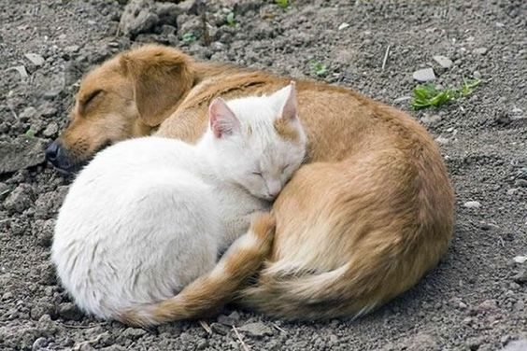
Here they are having a nap completely tired out. The dog is a Golden retriever’ and the family, including ‘cat’ are overly excited to have their latest pet at home, especially as the dog is very gentle and has settled in as though ‘dog and cat’ have always lived together.
So you (cat) have raised your hand in class to tell your teacher all about the latest family member and to explain how you introduced ‘dog’ to the house and what the two of you did all weekend long.
Write your great adventure story below. Remember to give yourself and dog a name and to describe what dog looks like. Make your story as exciting as possible and also give your story an eye-catching title.
Good lucK!
______________________________________________________________
__________________________________________________________________________________________________________________________________________________________________________________________________________________________________________________________________________________________________________________________________________________________________________________________________________________________________________________________________________________________________________________________________________________________________________________________________________________________________________________________________________________________________________________________________________________________________________________________________________________________________________________________________________________________________________________________________________________________________________________________________________________________________________________________________________________________________________________________________________________________________________________________________________________________________________________________________________________________________________________________________________________________________________________________________________________________________________________________________________________________________________________________________________________________________________________________________________________________________________________________________________________________________________________________________________________________________________________________________________________________________________________________________________________________________________________________________________________________________________________________________________________________________________________________________________________________________________________________________________________________________________________________________________________________________________________________

