LO: To recognise how the Vikings were able to travel successfully overseas.
HOM: To be persistent.

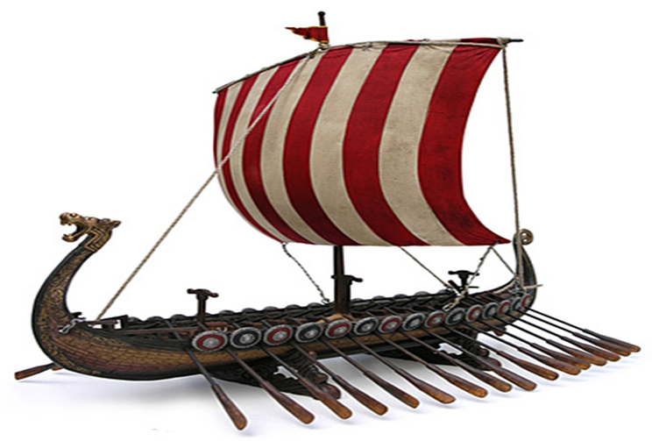
Here is a picture of a Viking Long Boat.
Now watch this video.
https://www.bbc.co.uk/bitesize/clips/zgmxpv4
Answer these questions:
White Hat: What is a Viking longboat?

Green Hat: What are the different features of Viking longboats?

Yellow Hat: What were the benefits of the shape and size of the longboats?

What did the Vikings trade?
The Vikings traded all over Europe and as far east as Central Asia. They bought goods and materials such as silver, silk, spices, wine, jewellery, glass and pottery. In return, they sold items like honey, tin, wheat, wool, wood, iron, fur, leather, fish and walrus ivory. Everywhere they went, the Vikings bought and sold slaves too. Viking traders carried a set of folding scales which they used to weigh coins to make sure they got a fair deal.

How did they find their way?
Vikings sailed close to the coast whenever possible, watching for land marks. Out of sight of land, they looked for the sun: west (towards the sunset) meant they were headed for England; east (towards the sunrise) meant home to Denmark or Norway.
The Vikings invented a kind of sun compass to help find their way. At night they watched the skies and could use the position of the stars to determine which direction they were heading.
Seamen knew a lot about winds and sea currents. By watching birds or even the colour of the water, an experienced sailor could tell when land was close.

Task:
Create your own 'Longship For Sale' leaflet, ensuring you include features which would be important to a Viking.

