L.O: To recognise that belief in the resurrection is a fundamental belief for Christians.
HOM- Thinking and communicating with clarity and precision
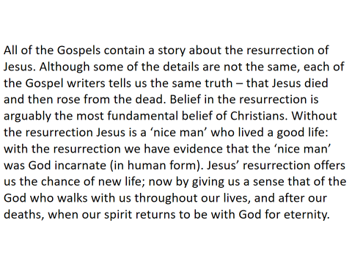
The Resurrection helps us to see,
- that Jesus is incarnate
- that Jesus resurrection offers us a chance of new life now
- that our spirit will be with God for eternity after we die

GH: What does INCARNATION mean?
GH: What does Resurrection mean?
RH: Is one more important than the other? Explain why.
WH: If Jesus was not incarnate (God in human form) would he have been able to rise from the dead? Why/Why not.

___________________________________________________________________________________________________________________________________________________________________________________________________________________________________________________________________________________________________________________________________________________________________________________________________________________________________________________________________________________________________________________________________________________________________________________________________________________________________________________________________________________________________________________________________________________________________________________________________________________________________________________________________________________________________________________________________________________________________________________________________________________________________________________________________________________________________________________________________________________________________________________
You are writing a diary entry explaining how and why the belief in the Resurrection (which occurred on Easter Sunday) is a fundamental belief for Christians.
Use the information below as a guideline to help you set out your work:
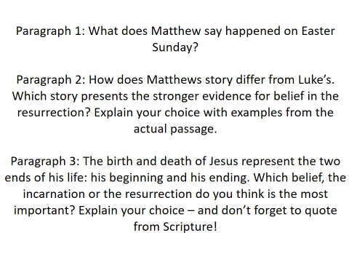

Use the work completed last week to help with your answer.
For paragraph one, look at Matthew’s gospel story.
For paragraph two, use your table of the similarities and differences to help.
For paragraph three, use the questions after the table to help.

____________________________________________________________________________________________________________________________________________________________________________________________________________________________________________________________________________________________________________________________________________________________________________________________________________________________________
____________________________________________________________________________________________________________________________________________________________________________________________________________________________________________________________________________________________________________________________________________________________________________________________________________________________________
____________________________________________________________________________________________________________________________________________________________________________________________________________________________________________________________________________________________________________________________________________________________________________________________________________________________________
____________________________________________________________________________________________________________________________________________________________________________________________________________________________________________________________________________________________________________________________________________________________________________________________________________________________________
____________________________________________________________________________________________________________________________________________________________________________________________________________________________________________________________________________________________________________________________________________________________________________________________________________________________________
_______________________________________________________________________________________________________________________________________________________________________________________________________________________________________________________________________________________________________________________________________________________________________________________________________________________________________________________________________________________________________________________________________________________________________________________________________________________________________________________

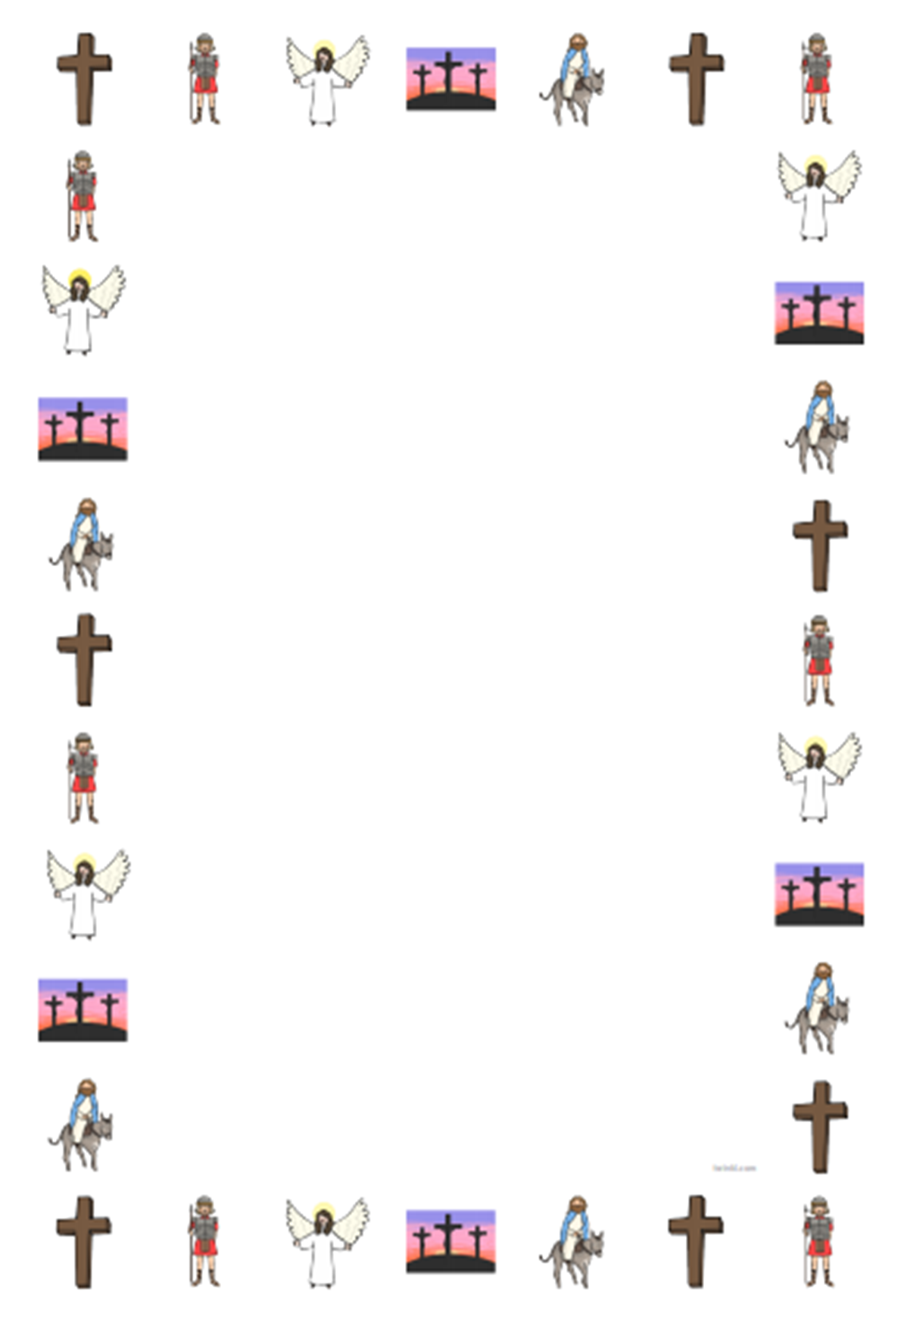
____________________________________________________________________________________________________________________________________________________________________________________________________________________________________________________________________________________________________________________________________________________________________________________________________________________________________________________________
____________________________________________________________________________________________________________________________________________________________________________________________________________________________________________________________________________________________________________________________________________________________________________________________________________________________________________________________
____________________________________________________________________________________________________________________________________________________________________________________________________________________________________________________________________________________________________________________________________________________________________________________________________________________________________________________________
____________________________________________________________________________________________________________________________________________________________________________________________________________________________________________________________________________________________________________________________________________________________________________________________________________________________________________________________
____________________________________________________________________________________________________________________________________________________________________________________________________________________________________________________________________________________________________________________________________________________________________________________________________________________________________________________________
_____________________________________________________________________________________________________________________________________________________________________________________________________________________________________________________________________________________________________________________________________________________________________________________________________________________________________________________________________________________________________________________________________________________________________________________________________________________________________________________________________________________________________________________________________________________________________________________________________________________________________________________________________

L.O to be able to explain that my choice of Easter symbol expresses the new life that the Resurrection offers. (AT 1 (i) lv3)
HOM: Thinking and Communicating with Clarity and Precision.
Choose two Easter symbols that show or express Matthew’s belief that Jesus Rose from the dead. Which symbols show the ‘new life’ that is promised by the Resurrection. Explain why. (You can use eggs, rabbits etc.)
Draw  Write | Draw  Write
_______________________________________  _______________________________________  _______________________________________  _______________________________________  _______________________________________  _______________________________________  _______________________________________  _______________________________________  _______________________________________  _______________________________________  _______________________________________  _______________________________________  _______________________________________  _______________________________________  _______________________________________  _______________________________________  _______________________________________  _______________________________________  _______________________________________  _______________________________________  _______________________________________  _______________________________________  _______________________________________  _______________________________________ | _______________________________________  _______________________________________  _______________________________________  _______________________________________  _______________________________________  _______________________________________  _______________________________________  _______________________________________  _______________________________________  _______________________________________  _______________________________________  _______________________________________  _______________________________________  _______________________________________  _______________________________________  _______________________________________  _______________________________________  _______________________________________  _______________________________________  _______________________________________  _______________________________________  _______________________________________  _______________________________________  _______________________________________

