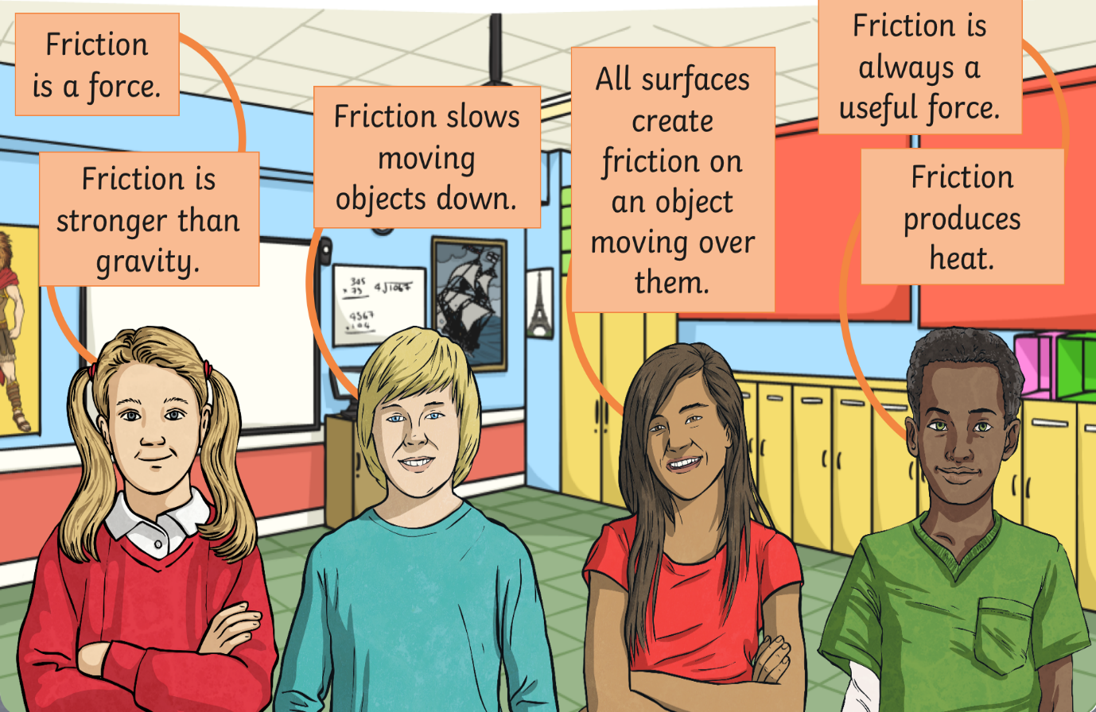
LO: To explain and investigate the effects of friction.
HOM: Managing impulsivity.

What statements do you believe are correct? Explain your reasons.
_______________________________________________________________________________________________________________________________________________________________________________________________________________________________________________________________________________________________________________________________________________________________________________________________________________________________________________________________________________________________________________________________________________________________________________________________________________________________________________________________________________________________________________________________________________________________________________________________________________________________________________________________________________________________________________________________________________________________________________________________________________

https://www.youtube.com/watch?v=C7NPD9W0kro

What is friction?
____________________________________________________________________________________________________________________________________________________________________________________________________________________________________________________________________________________________________________

Slide your shoe across the carpet and then slide your foot with just your socks on the carpet. What one has the most friction? Why do you think this?
____________________________________________________________________________________________________________________________________________________________________________________________________________________________________________________________________________________________________________

What are ways in which friction affects your life?
____________________________________________________________________________________________________________________________________________________________________________________________________________________________________________________________________________________________________________

How are things designed with friction in mind?
____________________________________________________________________________________________________________________________________________________________________________________________________________________________________________________________________________________________________________

Investigation:
Conduct an experiment on the effects friction has on a moving object.
Test different surfaces and test which surface will produce the fastest race time.
You may decide to measure the distance the item has travelled or the time it takes a toy car to move from the start line to the end line on various surfaces.

Rub your finger against each surface. Which one is the smoothest? Which one is the roughest? Can you feel any friction between your finger and the different surfaces?
_______________________________________________________________________________________________________________________________________________________________________________________________________________________________________________________________________________________________________________________________________________________________________________________

Decide on an item that you can push along different surfaces.
For example, I might decide to push my shoe across the carpet, across a wooden table and across the grass. I will measure the distance the shoe has moved. To make this a fair test, I must ensure I apply the same, or a similar force each time I push the shoe.

Prediction: Which surface do you think will produce the fastest race time?
____________________________________________________________________________________________________________________________________________________________________________________________________________________________________________________________________________________________________________

Results:
Surface | Attempt 1 | Attempt 2 | Attempt 3 | Mean

We are investigating how far the vehicle travels on different surfaces

Surface

Distance travelled in centimetres

Fill out your results on the table.

Write a conclusion.
____________________________________________________________________________________________________________________________________________________________________________________________________________________________________________________________________________________________________________

