LO: To understand what Viking people wore and the importance of the clothes when identifying people of importance.
HOM: Creativity.

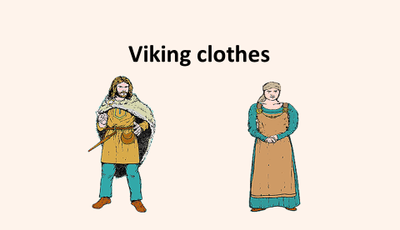
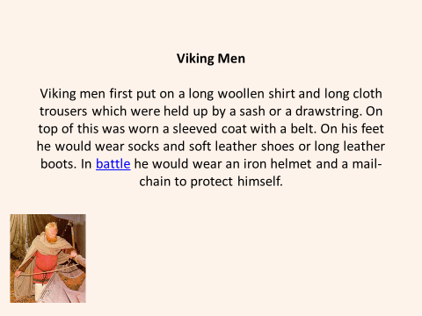
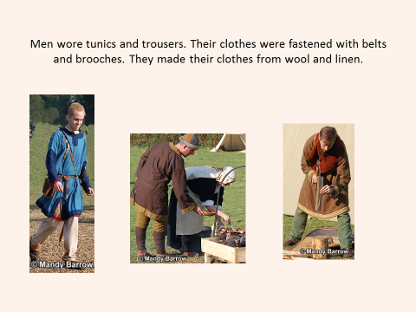
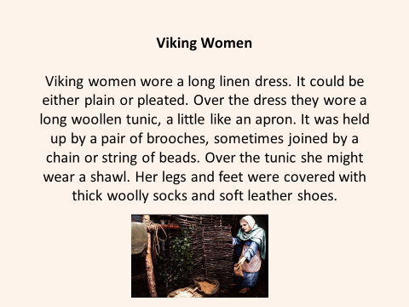
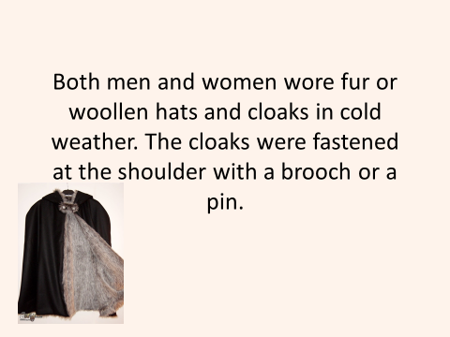
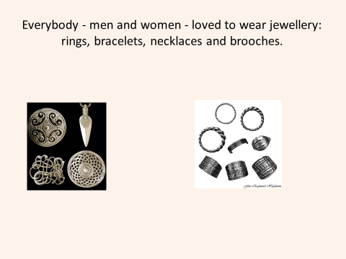

Now watch this video on Viking clothing.
https://www.bbc.co.uk/bitesize/clips/zksfb9q

Task: Research Viking fashion and design your own Viking clothes. (Design 2 outfits and explain the reasons for your choice)
Consider their role, which clothes would be appropriate for the role you design for and a Viking's importance within society by identifying what they are wearing and what this may tell us about them. Consider where the materials used was sourced from and whether we still use them today.

Outfit 1

Outfit 2

Explanation for outfit No. 1:
__________________________________________________________________________________________________________________________________________________________________________________________________________________________________________________________________________________________________________________________________________________________________________________________________________________________________________________________________

Explanation for outfit No. 2:
__________________________________________________________________________________________________________________________________________________________________________________________________________________________________________________________________________________________________________________________________________________________________________________________________________________________________________________________________

