LO: To explain how levers, pulleys and gears work.
HOM: Thinking flexibly.

What do you think these are examples of?
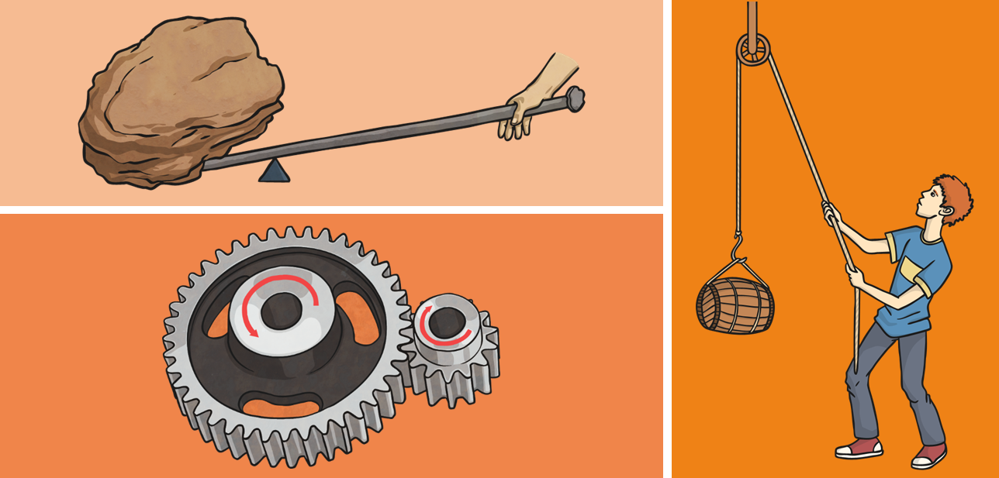

________________________________________________________________________________________________________________________________________________________________________________________________________________________________________________________________________________________________________________________________________________________________________________________________________________________________________________________________________________________________________________________________________________________________________________________________________________________

Levers, gears and pulleys are all mechanisms that make jobs easier to do.

What is a mechanism?
_______________________________________________________________________________________________________________________________________________________________________________________________________________________________________________________________________________________________________________________________________________________________________________________
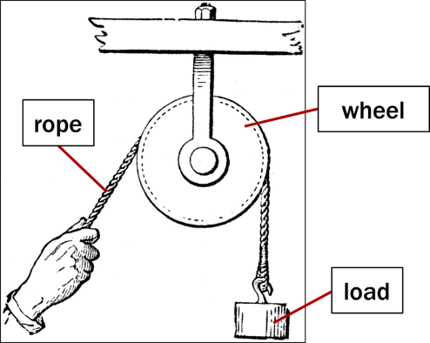
What is a pulley?
____________________________________________________________________________________________________________________________________________________________________________________________________________________________________________________________________________________________________________

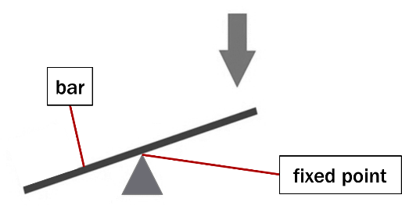
What is a lever?
____________________________________________________________________________________________________________________________________________________________________________________________________________________________________________________________________________________________________________
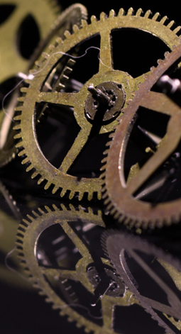
What are gears?
____________________________________________________________________________________________________________________________________________________________________________________________________________________________________________________________________________________________________________

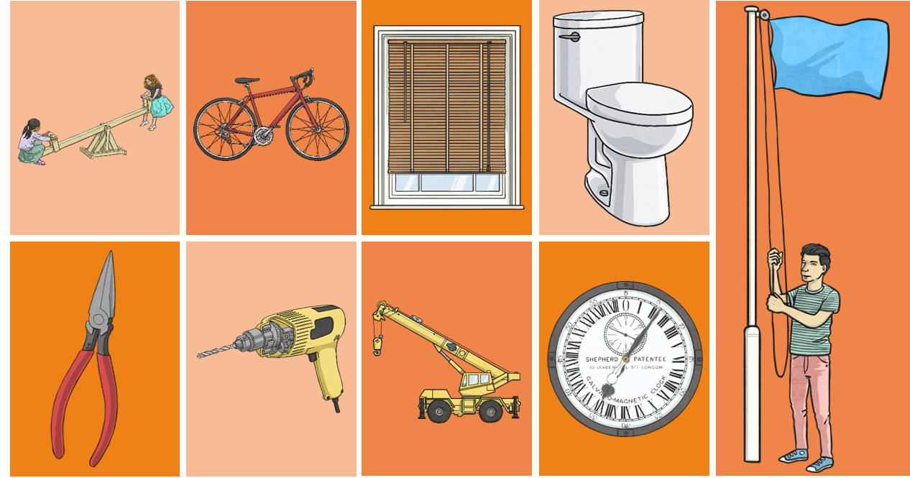
Decide which ones are levers, pulleys or gears. Explain why.

____________________________________________________________________________________________________________________________________________________________________________________________________________________________________________________________________________________________________________________________________________________________________________________________________________________________________________________________________________________________________________________________________________________________________________________________________________________________________________________________________________________________________________________________________________________________________________________________________________________________________________________________________________________________________________________________________

Create your own mechanism to complete a job.
Will it require a pulley, a lever or gears?
Below, explain how your machine works.

______________________________________________________________________________________________________________________________________________________________________________________________________________________________________________________________________________________________________________________________________________________________________________________________________________________________________________________________________________________________________________________________________________________________________________________________________________________________________________________________________________________________________________________________________________________________________________

