LO: To learn about the Viking tradition of ‘Up Helly Aa’ day.
HOM: Remain open to continuous learning.
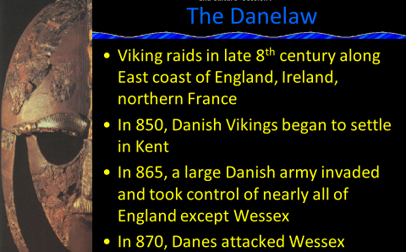
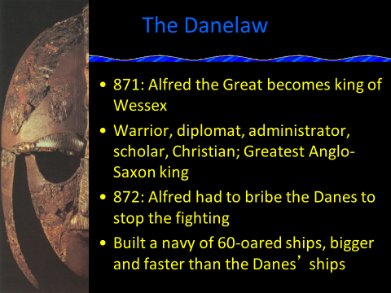
GH: Research the definition of a diplomat?
________________________________________________________________________________________________________________________________
GH: What is a scholar?
________________________________________________________________________________________________________________________________
What is a bribe?
________________________________________________________________________________________________________________________________

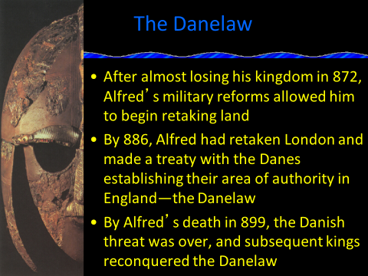
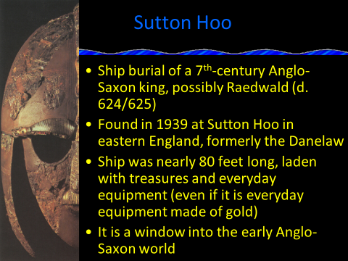
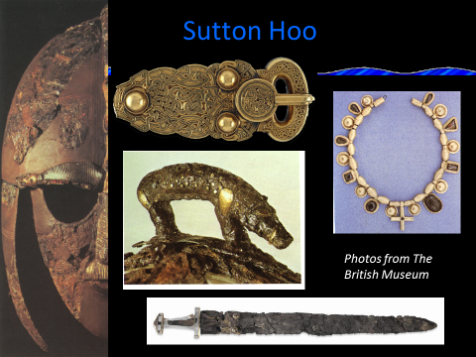
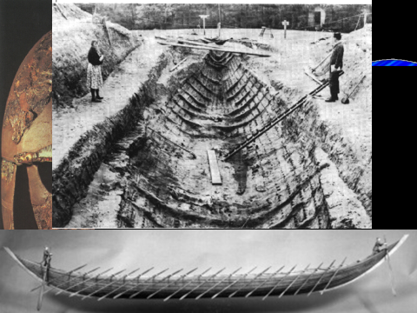
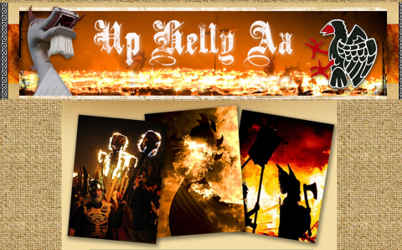

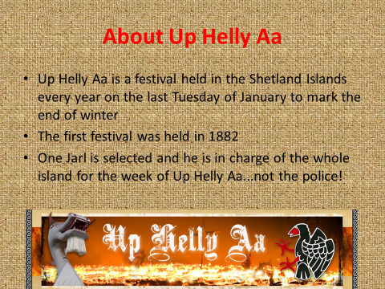
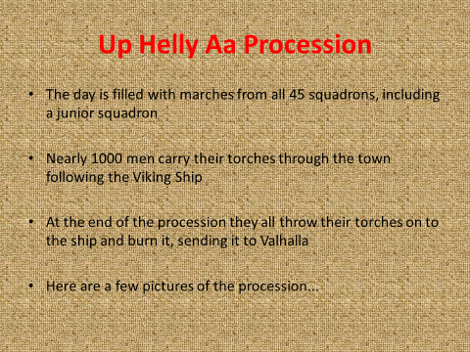
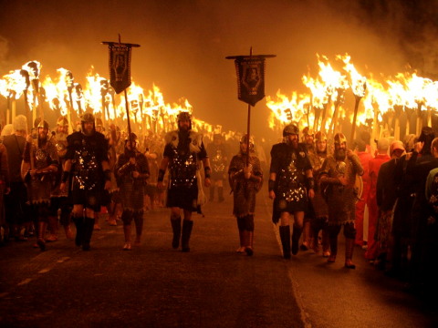
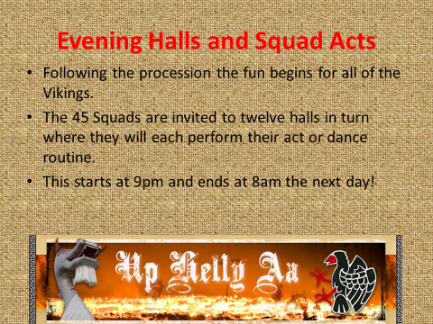

Now find the answer to these questions:
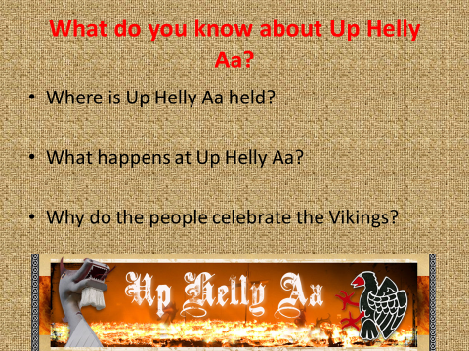
- _________________________________________________________________________________________________________________________________________________________________________________
- _________________________________________________________________________________________________________________________________________________________________________________
- ____________________________________________________________________________________________________________________________________________________________________________________________________________________________________________

You are to create a leaflet advertising Up Helly Aa festival.
You must include,
- What you can do there
- The dates
- Where it is
- Who it is for
- What it’s about
- Include drawings
https://www.uphellyaa.org/ Use this website to help you.

