LO: To evaluate your products, identifying strengths and areas for development.
HOM: To be persistent.

You said you wanted How well does your Viking Longboat do with each of these things?
your design to do
these things
(copy your design
criteria here) Lesson 3

Ask at least one person to complete the evaluation.

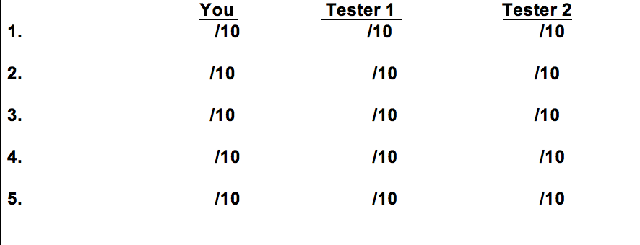

How many people liked your Viking Longboat?
You YES/NO
Tester 1 YES/NO
Tester 2 YES/NO

What would you change if you were making Viking Longboat again?
____________________________________________________________________________________________________________________________________________________________________________________________________________________________________________________________________________________________________________________________________________________________________________________________________________________________________________________________________________________________________________________________________________________________________________________________________________________________________________________________

