LO: To create a presentation based on what we have learnt throughout the topic.
HOM: Gathering data through all senses.

What forces are affecting them?
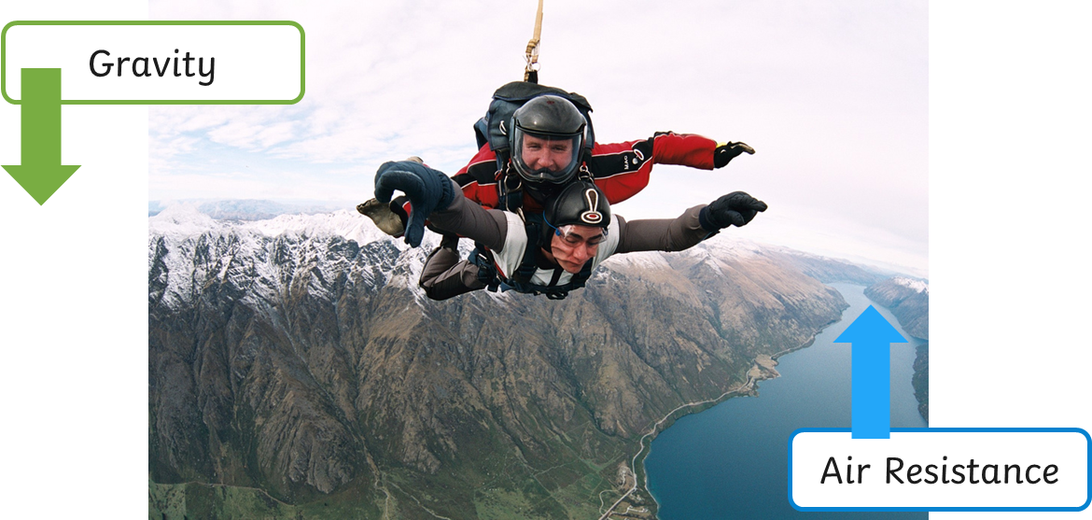

What forces are affecting them?
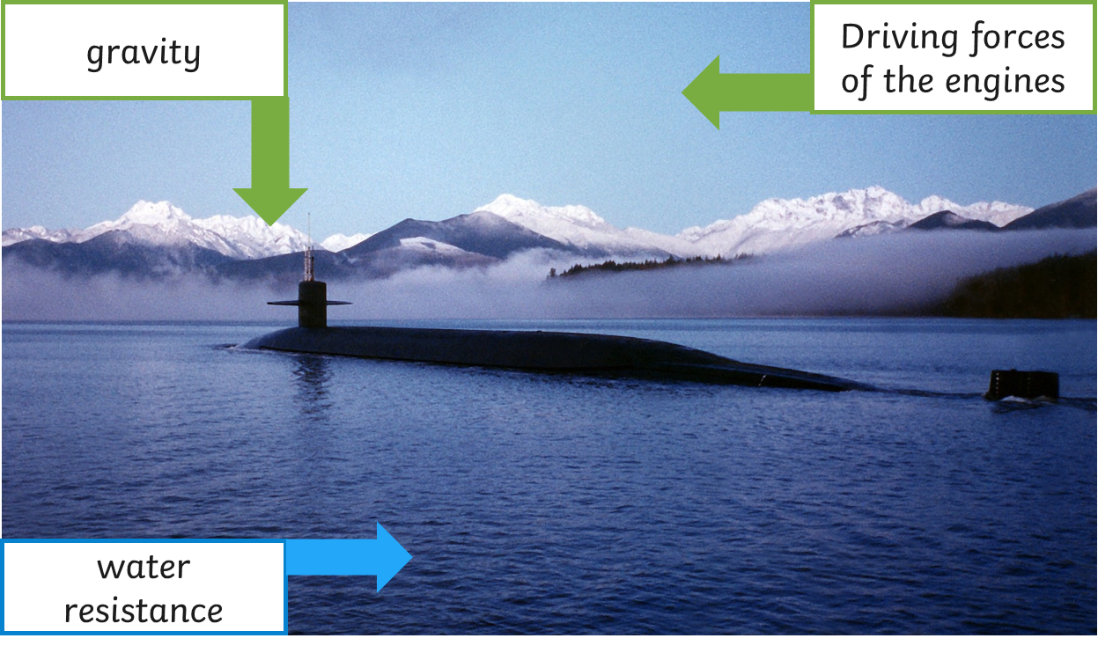

Read over what you have learnt over the course of the topic.
You will be creating a presentation on what we have learnt over the course of the topic.

You may decide to create a PowerPoint presentation, a poster, a leaflet or any other ideas you may have.

