LO: To be able to understand what the Vikings ate and how they grew their crops.
HOM: Remain open to continuous learning.

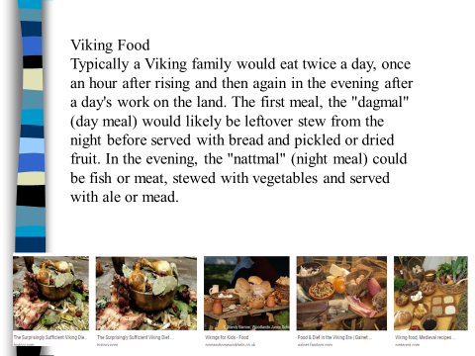
There were no supermarkets or shops to buy food so the Vikings ate what food they could grow or hunt.
Plants
Vegetables e.g. leeks, onions, turnips, parsnips and carrots.
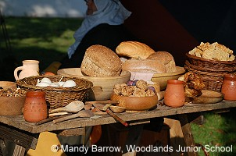
Wild nuts e.g. hazelnuts and walnuts.
Berries e.g. gooseberries, blackberries and blueberries.
Grains to make bread and also porridge
Herbs e.g. fennel, common sorrel, wild garlic, parsley
Leaves e.g. nettles and spinach
Animal
Wild animals e.g. deer, wild boar, fox, beaver, and bear.
Fish e.g. trout, mackerel, and salmon.
Domesticated animals e.g. chicken, goat, sheep and pigs.
Eggs from hens and wild birds eggs.
Viking Feast
While the Vikings ate a relatively simple diet, they did enjoy feasts. Feasts celebrated seasonal events such as Winter Nights and Jul, harvest festivals like Mabon and religious rituals. Personal occasions such as weddings, successful raidings and births often also called for feasts. Foods in feasts varied, and would usually depend on the wealth of the host. For more humble hosts, feasts would usually involve the typical Viking meal food mentioned above, but plenty more of it.
Whereas wealthier feast hosts would commonly offer roasted and boiled meats, buttered root vegetables, nuts, fruits and plenty of strong ales and mead. The food they served was also an opportunity to show off their successful European raids, as any of their more exotic foods would have been raided.
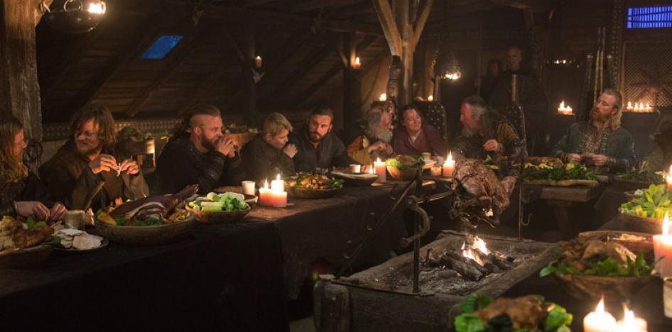

GH: What types of food did the Vikings eat?
______________________________________________________________________________________________________________________________________________________
GH: Were there supermarkets for the Vikings to shop in?
___________________________________________________________________________
GH: How many meals would a Viking family eat each day?
_________________________________________________________________________________________________________________________________________________________________________________________________________________________________
GH: what is a Viking feast and how did they celebrate it?
____________________________________________________________________________________________________________________________________________________________________________________________________________________________________________________________________________________________________________

https://www.bbc.co.uk/bitesize/clips/z4pnvcw
Watch this clip and answer the questions.
How did Vikings make their bread?
_________________________________________________________________________________________________________________________________________________________________________________________________________________________________
What colours were the carrots?
___________________________________________________________________________

What else did they use the animals for besides meat?
______________________________________________________________________________________________________________________________________________________

Make a list of the similarities and differences between Viking food and the food we eat today.
Similarities | Differences

Using what you have seen and read about Viking food you must design a menu for a feast. There are 5 different courses in a feast so you need 5 dishes.
Remember
They had no shops so the food you include must be able to be grown or made.

MENU

