LO: To use onomatopoeia in our art work.
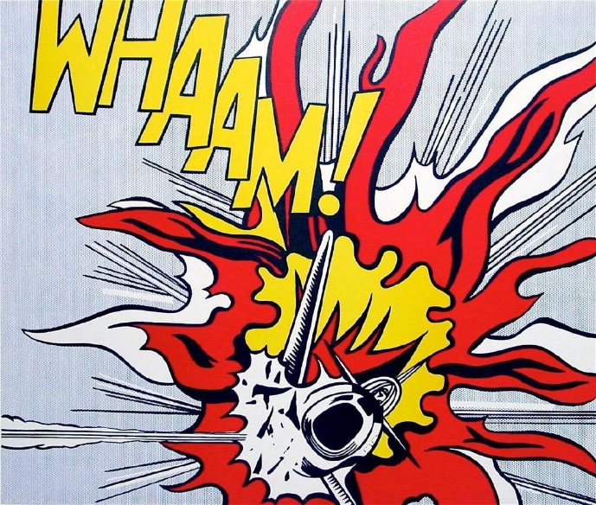
HOM: Creating, imagining, and innovating.

List some adjectives that you would use to describe this artistic style.
1) ___________________________________
2) ___________________________________
3) ___________________________________
4) ___________________________________
5) ___________________________________
6) ___________________________________
7) ___________________________________
8) ___________________________________

Select a word that sounds like a sound. Use the link to help you.
https://examples.yourdictionary.com/examples-of-onomatopoeia-for-kids.html
Select one word and create a piece of pop-art style work to decorate the word. Use the examples given of Roy Lichtenstein’s art work to give you some inspiration. Think about the colours and techniques that you use.

