LO: To understand when the Vikings came to raid Britain and where they stayed.
HOM: To listen with understanding and empathy. 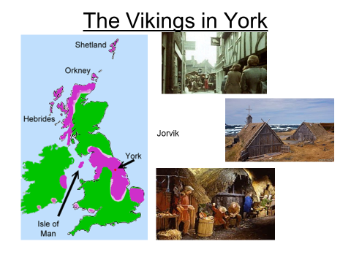
Read this passage:
Their longships brought families who settled in villages. There were farmers, who kept animals and grew crops, and skilful craft workers, who made beautiful metalwork and wooden carvings. Everyone lived together in a large home called a longhouse. With just one room for all the family to share with their animals, a longhouse would have been a crowded and smelly place to live. There was no bathroom inside, but the Vikings kept clean by washing in a wooden bucket or beside a stream. Instead of toilets, people used a cesspit, which was a hole outside dug for toilet waste.
Many Vikings worked as farmers. Everything had to be done by hand on a Viking farm, so life was tough. Farmers grew oats, barley and wheat. Then they ground the grain to make flour, porridge and ale. They planted vegetables too, and kept animals like cows, sheep, pigs and chickens.
Other Vikings were craft workers. They made the things that people needed. Woodworkers and leatherworkers made plates, cups, belts and shoes. Jewellers made rings and brooches from precious metals. Blacksmiths hammered and twisted red-hot iron into tools, knives and swords. Potters baked clay pots in an oven heated by wood fires.
People took these goods to market to sell. Here a family could buy anything from amber beads and apples, to walrus tusks and wolf-skins. Viking traders sold their goods even further away. They sailed the seas to buy silver, silk, spices and furs to bring back home.

Watch this clip explaining why the Vikings settled in York.
https://www.bbc.co.uk/programmes/p0118b7g
Task 1: Answer these questions.
White Hat: Where is York?
Green Hat: What are the reasons why the Vikings chose to settle in York? (7 lines)
GH: What jobs had the Viking settlers? (3 lines)
GH: Describe the houses the Vikings lived in?
Yellow Hat: Describe 3 benefits of settling near the coast?
Red Hat: How might the people living in York have felt about the Viking’s arrival?
Blue Hat: What steps did the Vikings take to settle in York?

Task 2: Watch this clip about the Vikings and answer the questions.
https://www.bbc.co.uk/programmes/p01189j2
GH: What did the remains of the Viking found tell us about his rank?
WH: Why did the Vikings attack the monastery?
GH: List 10 words that come from Norse language that we still use today?

Now take a look at this table. With the help of the clip you just watched and google maps, fill out this table.
