|  |
| --- |
| **Les matières** |

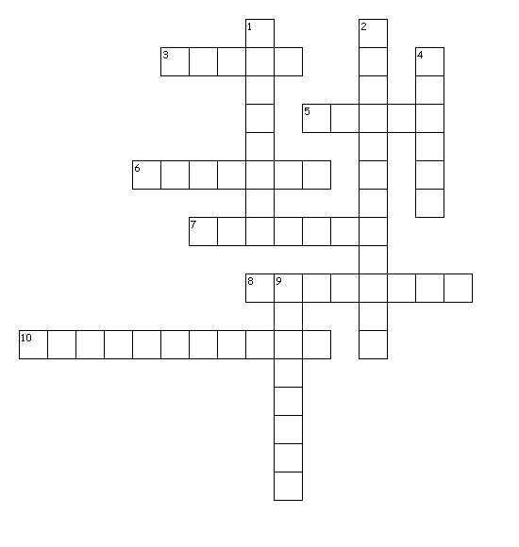

|  |  |
| --- | --- |
| Across 3. PE  5. - Maths  6. English  7. Music  8. Spanish  10. Technology | **Down**  1. French  2. History-Geography  4. Art  9. Sciences |