FOCUS QUESTION
How does the Liturgy of Easter Sunday celebrate the events Matthew describes? ATi (ii)
L.O: To explain the main actions of Easter Sunday: the fire and the preparation of the paschal candle.
HOM: Remaining Open to Continuous Learning.
https://www.tripadvisor.co.uk/ShowUserReviews-g186338-d211750-r571692079-Westminster_Cathedral-London_England.html
Watch the clips, draw a bubble map of the important information, pay particular attention to what is being said about the fire and the paschal candle.

Now read resource 6 and look at these websites to help to complete task 1.

https://rcdow.org.uk/cardinal/news/easter-celebration-at-westminster-cathedral/
http://www.bernardallenart.com/westminster-paschal-candle-2019/

Resource 6: Key action of Easter Sunday
Easter Sunday
On Easter Sunday we gather to remember the event which has given us our most important belief: that Jesus rose from the dead. This event would eventually prompt the community to begin a new community, one that would be called Christian. On Easter Sunday we remember the resurrection!

Reading: Mt 28:1-10
The Resurrection of Jesus

After the sabbath, as the first day of the week was dawning, Mary Magdalene and the other Mary went to see the tomb. 2And suddenly there was a great earthquake; for an angel of the Lord, descending from heaven, came and rolled back the stone and sat on it. 3His appearance was like lightning, and his clothing white as snow. 4For fear of him the guards shook and became like dead men. 5But the angel said to the women, ‘Do not be afraid; I know that you are looking for Jesus who was crucified. 6He is not here; for he has been raised, as he said.
Come, see the place where he lay. 7Then go quickly and tell his disciples, “He has been raised from the dead, and indeed he is going ahead of you to Galilee; there you will see him.” This is my message for you.’ 8So they left the tomb quickly with fear and great joy, and ran to tell his disciples. 9Suddenly Jesus met them and said, ‘Greetings!’ And they came to him, took hold of his feet, and worshipped him. 10Then Jesus said to them, ‘Do not be afraid; go and tell my brothers to go to Galilee; there they will see me.’

Special action: To remember this day we usually have a fire outside the Church and then a procession into it. The Paschal Candle is also readied for the new season. It is to be large – bigger than any of the candles on the altar. It has to stand tall and proud in the Church and show that Christ is the light of the world.

Here is what the missal says about what we do.
- A blazing fire is prepared in a suitable place outside the church. When the people are gathered there, the Priest approaches with the ministers,

one of whom carries the paschal candle. The processional cross and candles are not carried outside to the fire.
- The Paschal Candle is brought forward. It is NOT alight. This candle should be made of wax, never be artificial, and be new each year.
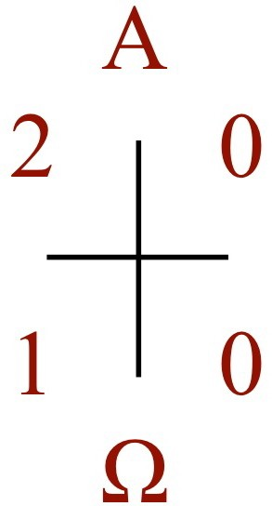
- The Priest then cuts the shape of a cross into the candle with a knife. Then he makes the Greek letter Alpha above the cross, the letter Omega below it, and the four numerals of the current year between the arms of the cross. After these rites, the priest lights the candle from the fire and says: May the light of Christ, rising in glory, dispel the darkness of our hearts and minds. (EV, no.14)
- There is then a procession into the Church.
- The Priest wears white vestments.

Task 1: Explain the main actions of Easter Sunday.
________________________________________________________________________________________________________________________________________________________________________________________________________________________________________________________________________________________________________________________________________________________________________________________________________________________________________________________________________________________________________________________________________________________________________________________________________________________________________________________________________________________________________________________________________________________________________________________________________________________________________________________________________________________________________________________________________________________________________________________________________________________________________________________________________________________________________________________________________________________________________________________________________________________________________________________________________________________________________________________________________________________________________________________________________________________________________________________________________________________________________________________________________________________________________________________________________________________________________________________________________________________________________________________________________________________________________________________________________________________________________________________________________________________________________________________________________________________________________________________________________________________________________________________________________________________________________________________________________________________________________________________________________________________________________________________________________________________________________________________________________________________________________________________________________________________________________________________________________________________________________________________________________________________________________________________________

Task 2 : Create a symbol for each day Palm Sunday, Holy Thursday, Good Friday and Easter Sunday : go back and look at the key action and find a symbol for each day.

Task 3

Task 2: Create a symbol for each day Palm Sunday, Holy Thursday, Good Friday and Easter Sunday : You may need to remind yourself of the actions for these days in church and link your symbols to these. You can research this. Also you could think about what actions take place in your own parish on these days.
Task 3: Pick one of the words or phrases you chose for each day. Explain why you chose them, think about how they link to the celebration of Easter, do any of them reinforce the belief in Jesus the Messiah?
Day | Word/phrase chosen. Why?
Palm Sunday
Holy Thursday
Good Friday
Easter Sunday

