LO: To identify reversible and irreversible changes.
HOM: Persisting.

What does reversible mean?
______________________________________________________________________________________________________________________________________________________________________________________________________________________________________________________
What does irreversible mean?
______________________________________________________________________________________________________________________________________________________________________________________________________________________________________________________

Examples of irreversible changes area heating, mixing, burning and rusting.
https://www.bbc.co.uk/bitesize/topics/zcvv4wx/articles/z9brcwx

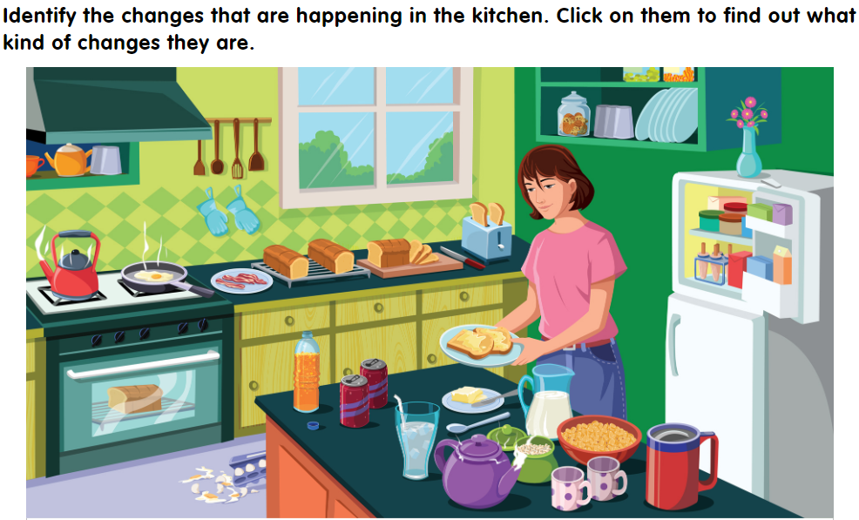

What is changing? How is it changing? Do you think you can get back to the original materials?
________________________________________________________________________________________________________________________________________________________________________________________________________________________________________________________________________________________________________________________________________________________________________________________________________________________________________________________________________________________________________________________________________________________________________________________________________________________________________________________________________________________________________________________________________________________________________________________________________________________________________________________________________________________________________________________________________________________________________________________________________________________

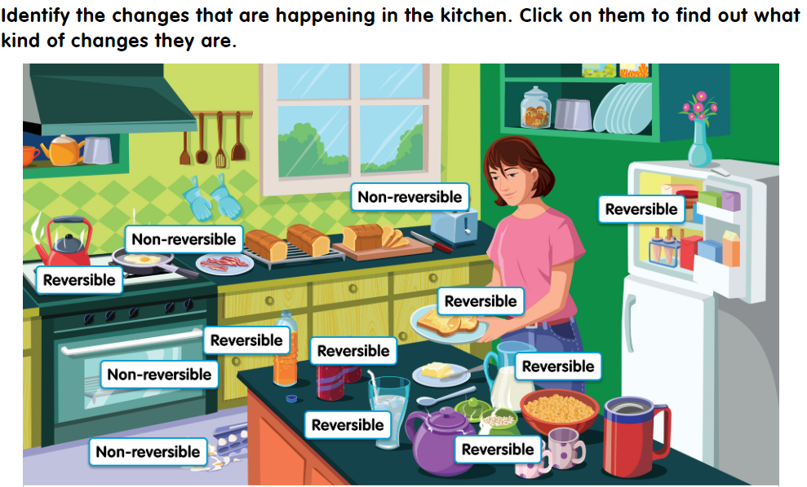

Look at each change listed in the table. Decide if it is reversible or non-reversible.
Name of change Is it reversible? Explanation
 | Yes | No | Maybe
Melting chocolate

Sprinkling salt on
an icy pavement

Squirting shaving
foam
Making toffee

Adding sugar to
tea

Opening a bottle
of lemonade
Baking bread

Making toast

Explain your decisions. Try to think of some other changes. Add them to the table.

Do you think it is possible to get the original materials back? Can you explain why you think a particular change is reversible or non-reversible?
________________________________________________________________________________________________________________________________________________________________________________________________________________________________________________________________________________________________________________________________________________________________________________________________________________________________________________________________________________________________________________________________________________________________________________________________________________________________________________________________________________

