LO: To conduct a comparative and fair test based on the physical changes.
HOM: Thinking flexibly.

YOU MAY REQURE THE PERMISSION AND HELP OF AN ADULT FOR THIS LESSON!

What is evaporation?

____________________________________________________________________________________________________________________________________________________________________________________________________________________________________________________________________________________________________________________________________________________________________________________
You will be required to conduct an experiment in your own homes. You will need to mix some water and salt together in a see through glass.

STEP 1: First measure out 50ml of water and pour into a glass (you don’t want too much water as this will take too long to evaporate).
STEP 2: Add 3 teaspoons of salt into the water and stir until you cannot see the salt anymore (this will turn a cloudy colour).
STEP 3: Draw a mark on the glass of the water level (check with an adult first)
STEP 4: Leave the saltwater by a window.
STEP 5: Continue to observe daily and make notes of what is happening.

What do you predict will happen?

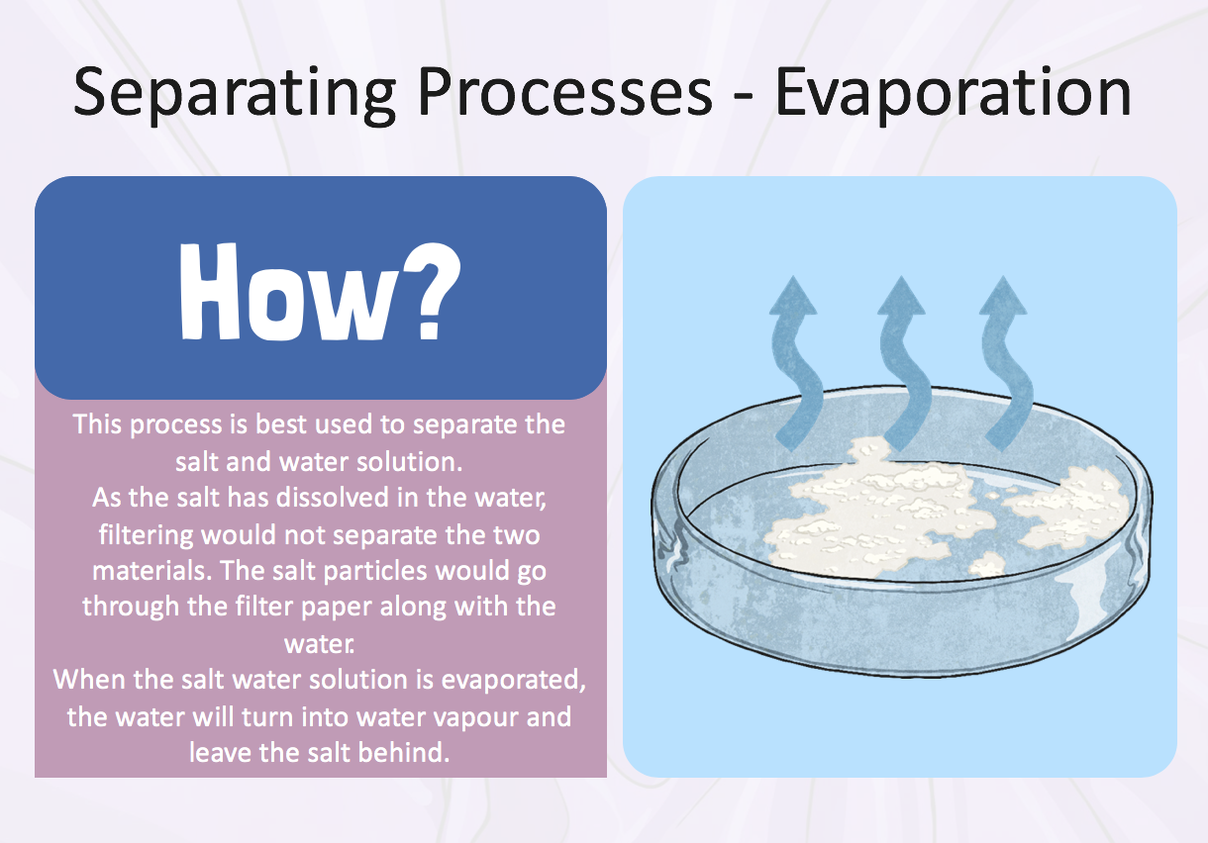

Fill out this table when you check your mixture and explain what you can see happening – are there any changes?

Day | Observation

Explanation:

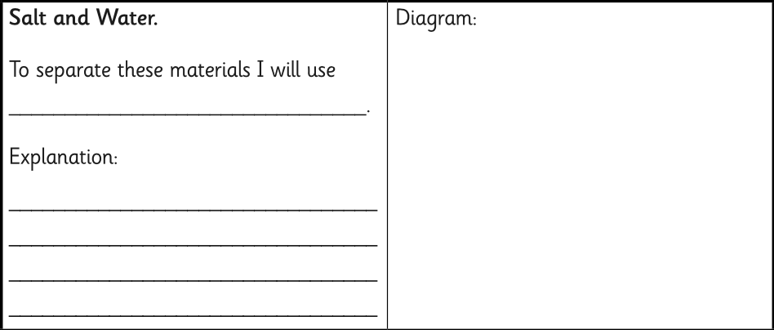

Conclusion:

What conclusions can you form from the experiment that you have conducted?

__________________________________________________________________________________________________________________________________________________________________________________________________________________________________________________________________________________________________________________________________________________________________________________________________________________________________________________________________________________________________________________________________________________________________________________________________________________________________________________________________________________________________________________________________________________________________________________________________________________________________________________________________________________________________________________________________________________________________

Plenary:






