LO: To know what evidence of Viking settlements in Britain is left behind today.
HOM: Questioning and Posing Problems

In this lesson, we are learning:
- Why the Vikings came to Britain.
- Where the Vikings settled.
- About York and why the Vikings settled there.

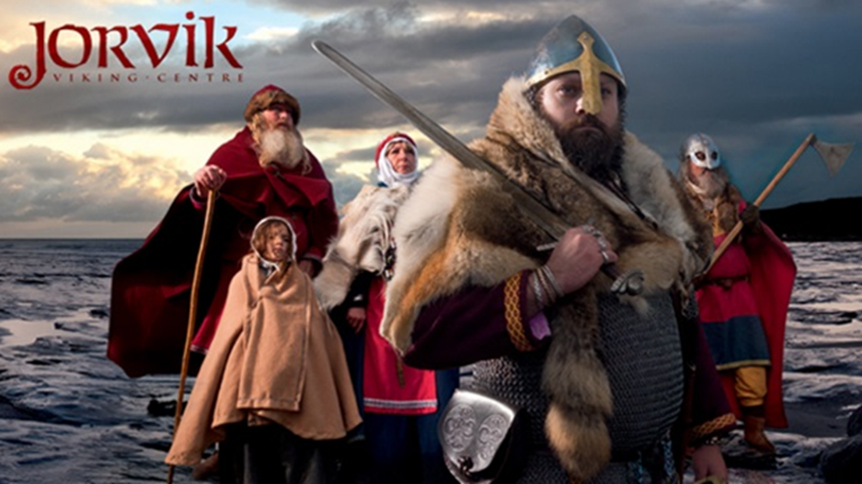
Task 1: What have you learned about the Vikings so far? (Write 6 things you’ve learned)
- __________________________________________________________________________________________________________________________________________
- __________________________________________________________________________________________________________________________________________
- __________________________________________________________________________________________________________________________________________
- __________________________________________________________________________________________________________________________________________
- __________________________________________________________________________________________________________________________________________
- _____________________________________________________________________

https://www.jorvikvikingcentre.co.uk/about/jorvik-artefact-gallery/
https://www.theguardian.com/artanddesign/2014/mar/03/viking-world-british-museum-neil-macgregor-exhibition
Now look at these websites.
They contain artefacts left behind by the Vikings. Look through these items and read the descriptions about them.
Task 2: Answer these questions.
- White Hat: What evidence has been left behind from the Vikings in York?
- Green Hat: What different artefacts have been preserved for historians to analyse?
- Blue Hat: What can we learn about the Vikings from these artefacts?
__________________________________________________________________________________________________________________________________________________________________________________________________________________________________________________________________________________________________________________________________________________________________________________________________________________________________________________________________________________________________________________________________________________________________________________________________________________________________________________________________________________________________________________________________________________________________________________________________________________________________________________________________________________________________________________________________________________________________________________________________________________________________________________________________________________________

Task 3: You are a Viking man, you’re writing a letter to your friend that stayed in Norway. You tell them about your typical day and all the things you’ve made to use in your typical day. (It must be AT LEAST 12 lines long)

