Focus Question: How do people live the Spirit of Pentecost? AT 1 (iii)
LO: To be able to explain the feast of Pentecost and understand the importance of the Holy Spirit.
HOM: Responding with wonderment and awe.

Read this piece of text:
After the resurrection, Jesus appeared to his disciples commissioning them to go into the world and baptise people. (Matthew 28:16-29) Matthew’s gospel then ends. In Luke’s Gospel (Lk 24:50-53) though Jesus blesses the disciples and returns to God in spirit form. We celebrate this event in the feast of the ascension, on May 21, 2020. Luke also tells us that Jesus would send the Holy Spirit to the disciples to be their support and guide (Lk 24:49) – their advocate (one who speaks on their behalf.) This happens in Acts 2:1-4 when Luke tells us the spirit came during the Jewish festival of Shavuot or Pentecost.

Task 1: Now watch this clip and read Kip’s mums letter and fill in the bubble map of everything new that you learn about Shavuot:
https://www.youtube.com/watch?time_continue=32&v=kq4h3Opy-Xc&feature=emb_title
https://www.kipandfriends.com/letter---shavuot.html
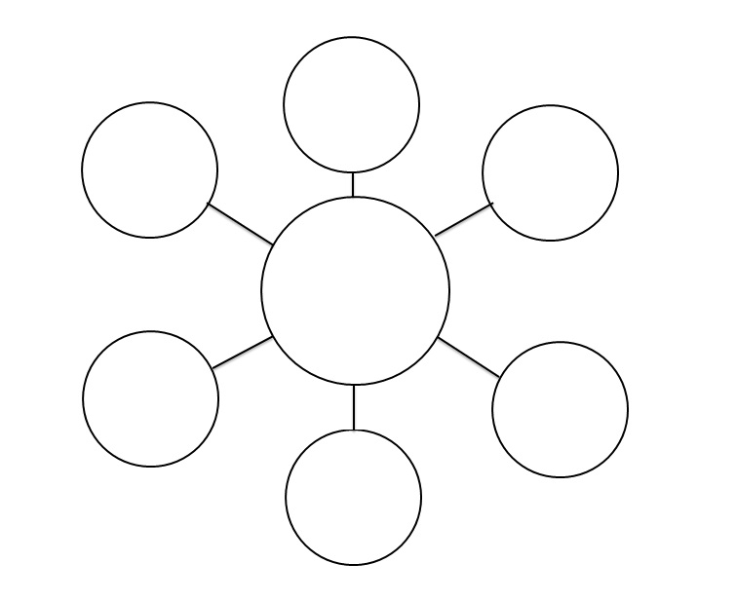
Focus Question: How does Pope Francis live the Spirit of Pentecost? AT 1 (iii)
LO: To be able to explain how Pope Francis lives the Holy Spirit.
HOM: remaining open to continuous learning.

The Church believes that the Spirit, which came at Pentecost, remains in the Baptised, the Church and world today. Just as it energised and enabled the disciples to speak to the crowds in Jesus’ day, it now guides Christians today. The Spirit is the ‘life force’ that helps us and strengthens us.
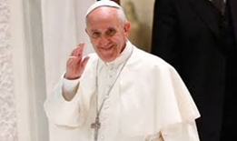

Task: You are going to create a fact file on Pope Francis.
Answer these questions to begin with and use them to inform your factfile.
WHITE HAT: What is his name?
WHITE HAT: What does he do?
WHITE HAT: What is he wearing?
WHITE HAT: Why does he wear white?
WHITE HAT: Why is he important?
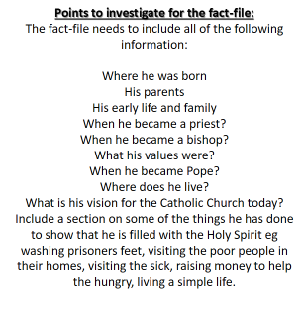
You could also look at these links:
Pope Francis washes the feet of prisoners https://www.youtube.com/watch?v=4OOkBIrW60w

Pope plays with a little boy who wandered onto the stage during a meeting with Catholic families from around the world http://www.youtube.com/watch?v=MI5GwdFjnJA
article - Pope embraces two disfigured men http://www.dailymail.co.uk/news/article-2510595/Pope-Francis- compassion-brings-joy-disfigured-man.html
article – Pope Francis ‘sneaks’ out to feed homeless in Rome http://rt.com/news/pope-francis-disguise-homeless-rome-670/
Turn your page landscape and complete the table on Pope Francis.
- Answer the questions below.
- How do we, as a school, act with compassion towards others?
_______________________________________________________________________________________________________________________________________________________________________________________________________________________________________________________________________________________________________________________________________________________________________________________________________________________________________________________________________________________________________________________________________________________________________________________________________________________________________________________________________________________________________________________________________

- If Pope Francis were to visit out school, how would he see us acting towards each other?
_______________________________________________________________________________________________________________________________________________________________________________________________________________________________________________________________________________________________________________________________________________________________________________________________________________________________________________________________________________________________________________________________________________________________________________________________________________________________________________________________________________________________________________________________________

