LO: To reflect on the artists that we have covered over the course of the year and re-create your favourite piece.
HOM: Striving for accuracy.

What three artists have we covered this year?

_____________________________________________________________________________________________________________________________________________________________________________________________________________________________________________

Provide a brief description of each artist’s style of art work.

- ………………………………………..
____________________________________________________________________________________________________________________________________________________________________________________________________________________________________________________________________________________________________________________________
_____________________________________________________________________________________________________________________________________________________________________________________________________________________________________________

- ………………………………………..
____________________________________________________________________________________________________________________________________________________________________________________________________________________________________________________________________________________________________________________________
_____________________________________________________________________________________________________________________________________________________________________________________________________________________________________________

- ………………………………………..
____________________________________________________________________________________________________________________________________________________________________________________________________________________________________________________________________________________________________________________________
_____________________________________________________________________________________________________________________________________________________________________________________________________________________________________________

Select an artist’s piece of work that you want to re-create.

Kandinsky: Warhol:
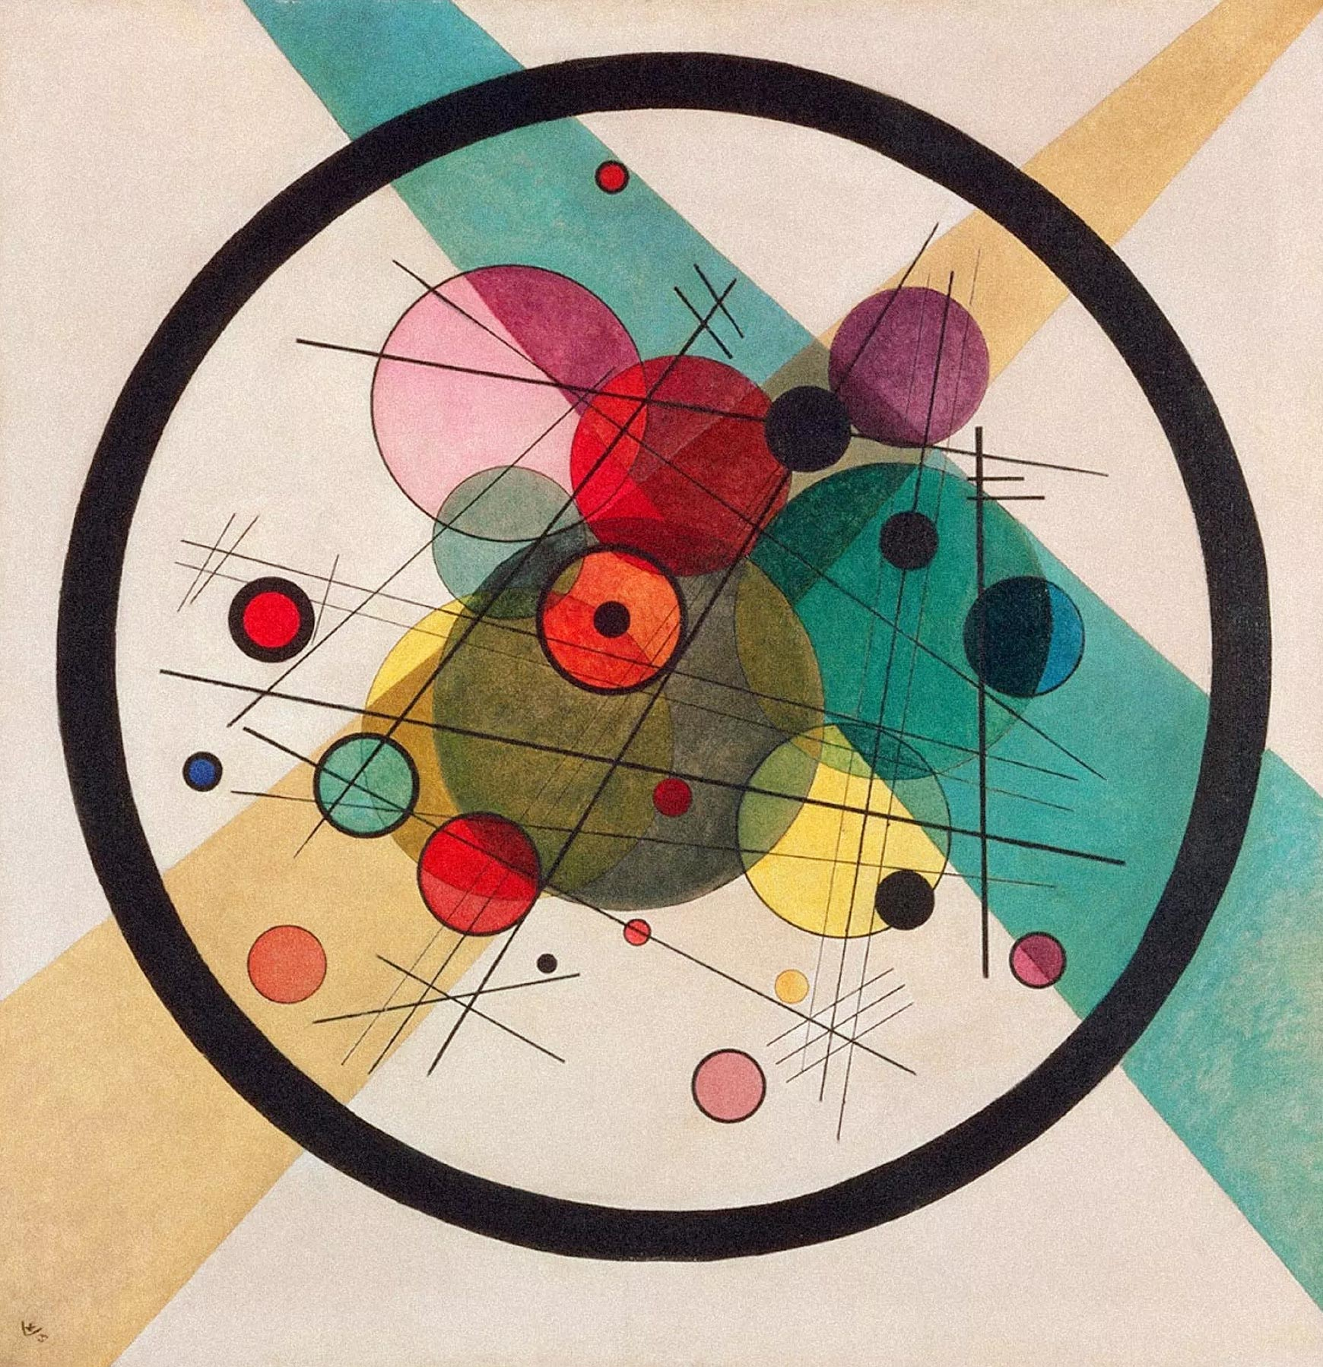
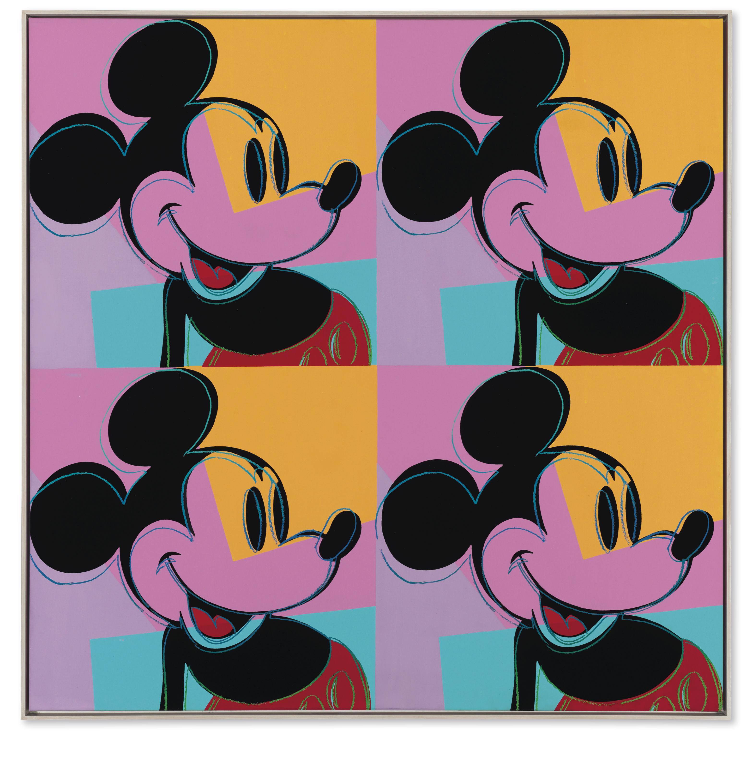

Lichtenstein:
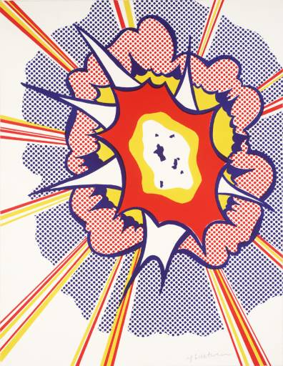

You can re-create any piece of artwork by one of these artists, you do not have to use the ones I’ve included – these are just examples.

