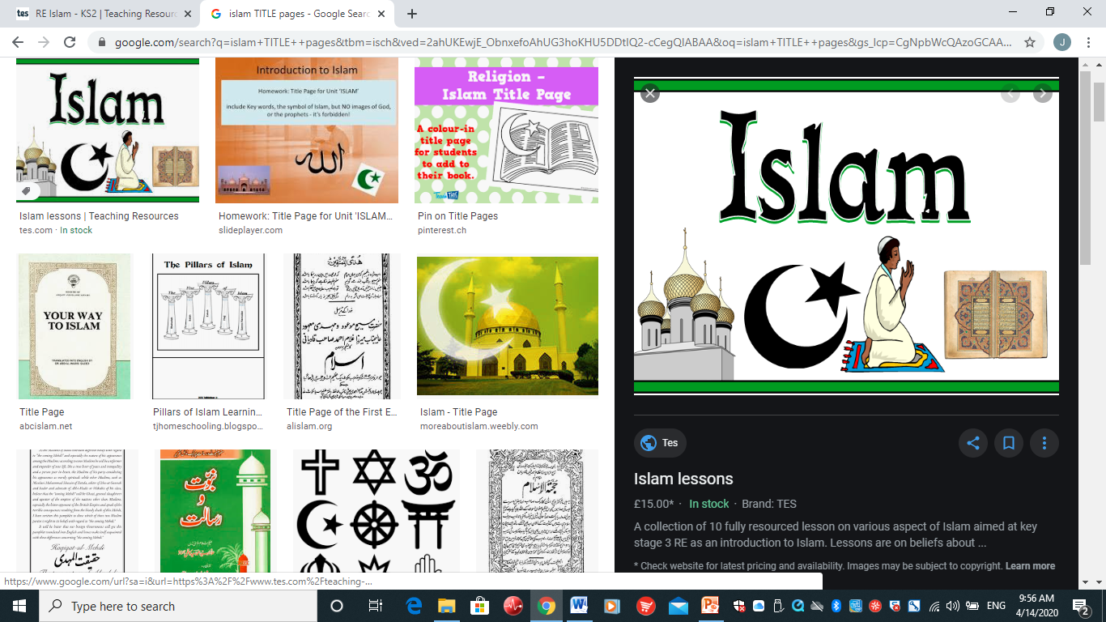

NAME ……………………..

LO: Learning about the pillars of Islam.

HOM: Striving for accuracy.

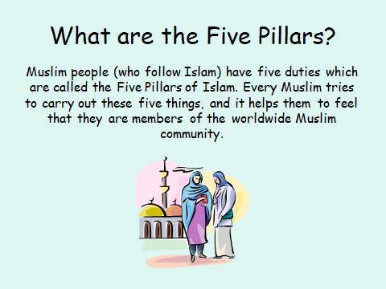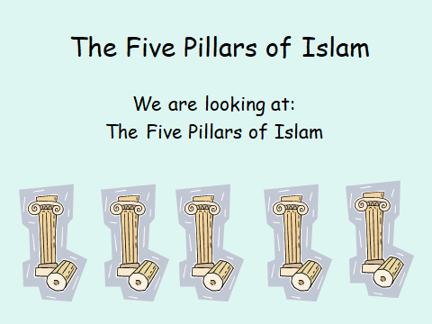

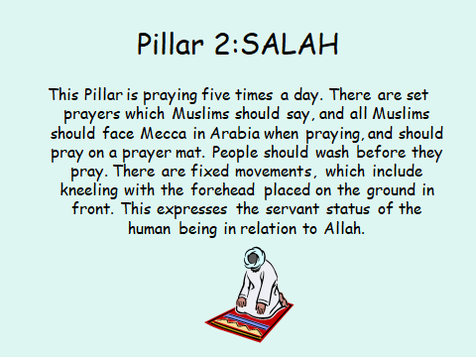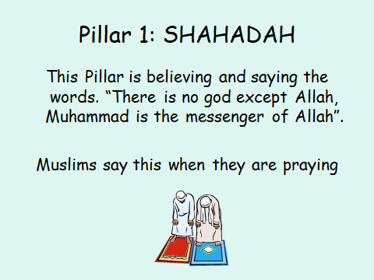

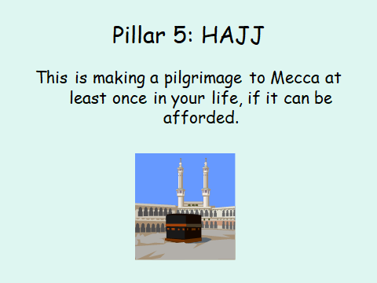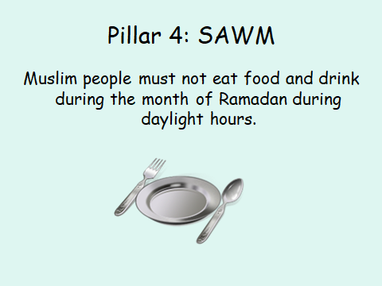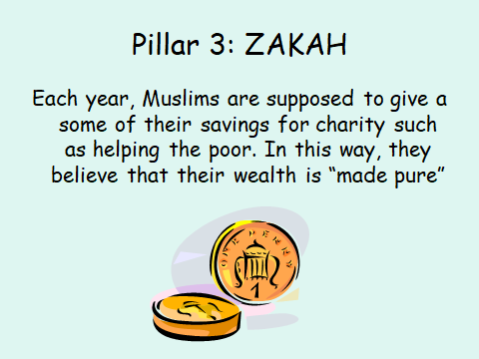

Look at the booklet below and match the saying to what pillar they are in.

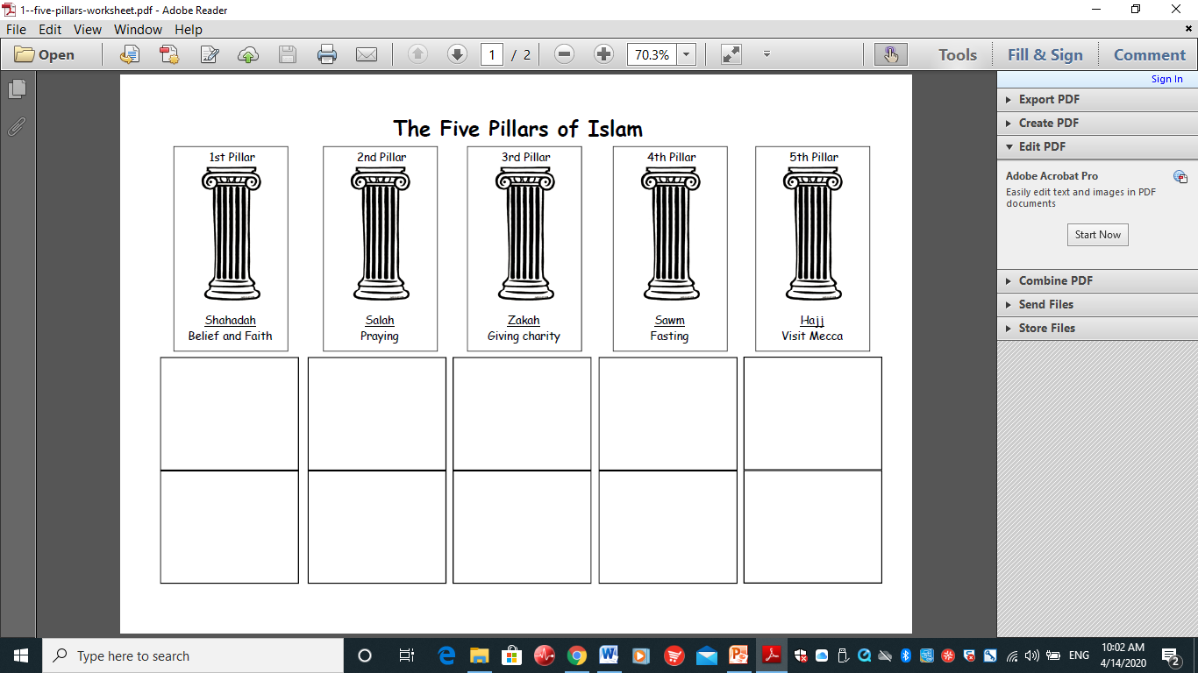

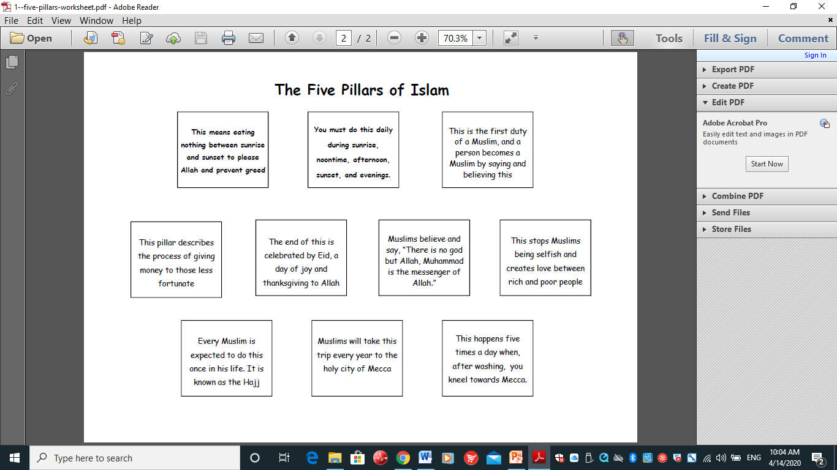

Lesson 2

**L.O : To research the Muslim pilgrimage to Mecca, the Hajj and create an information leaflet to demonstrate my understanding.**

**HOM: Remaining Open to Continuous Learning**

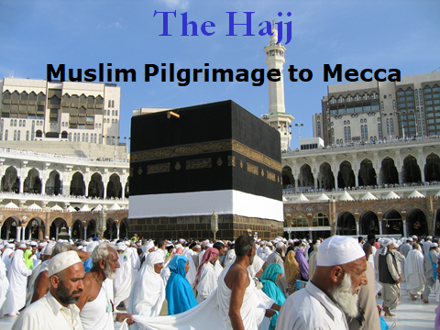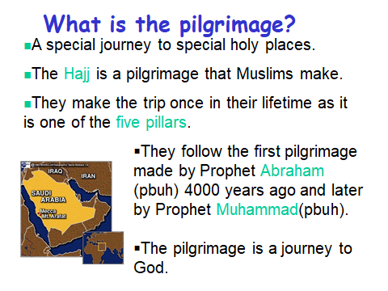

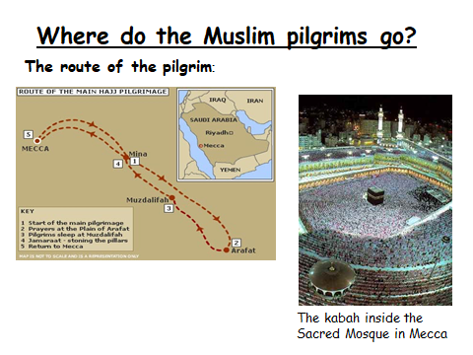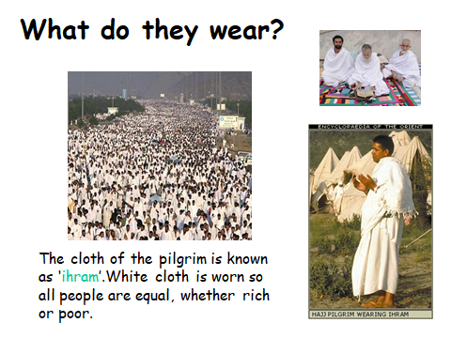

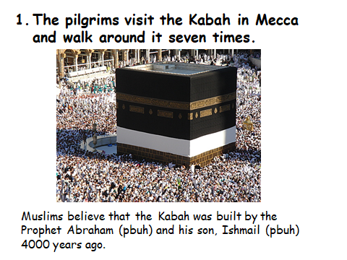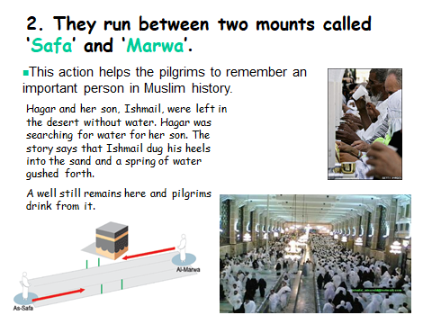

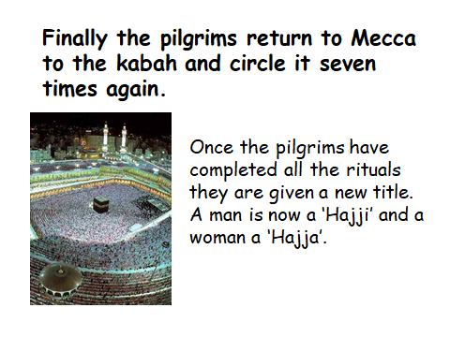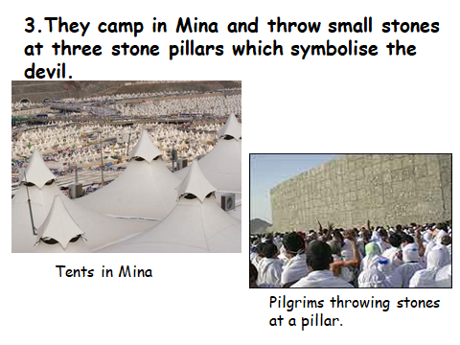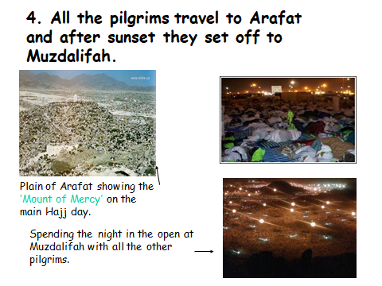

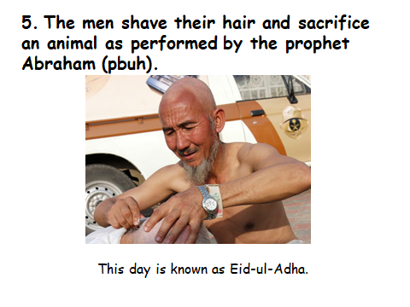

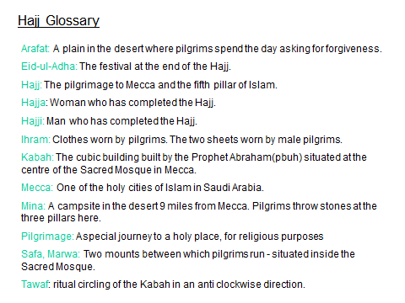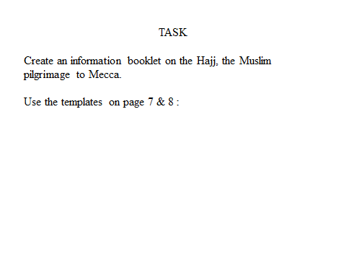

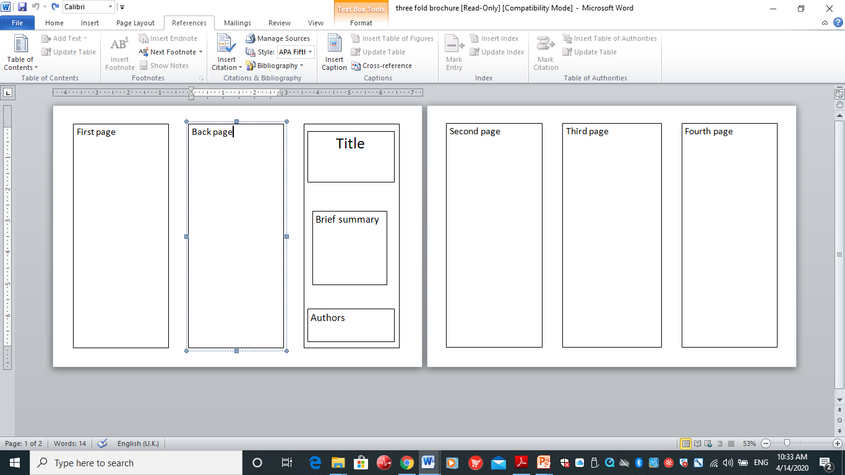**Look at the way you layout the booklet below. Now create your own about your understanding of the 5 pillars of Islam.**

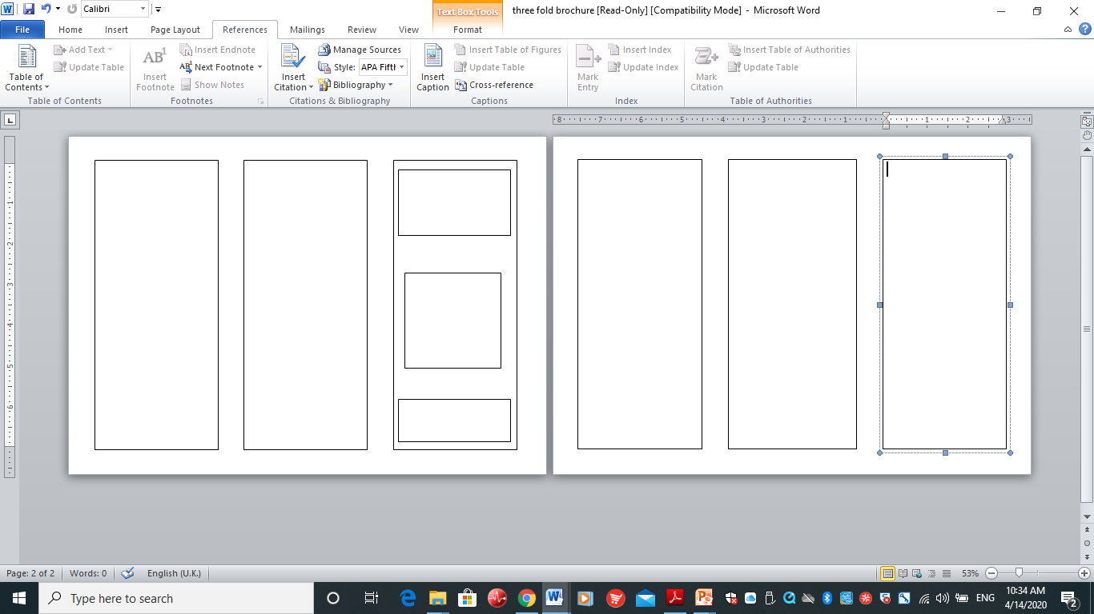

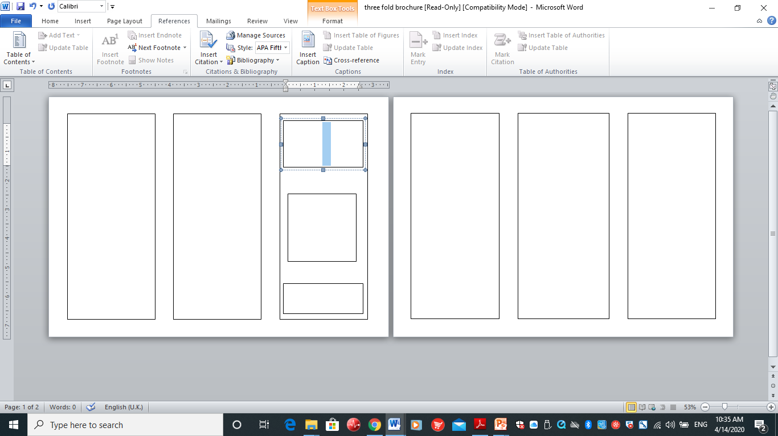

**LO: To know why Muslims fast at Ramadan and reflect on how that feels.**

**HOM: thinking and communicating with clarity and precision.**



