LO: To understand the effects of gravity.
HOM: Responding with wonderment and awe

Forces

What is force?

_________________________________________________________________________________________________________________________________________________________________________________________________________________________________________________________________________________________________________________________________________________________________________________________________________________________________________________________________________________

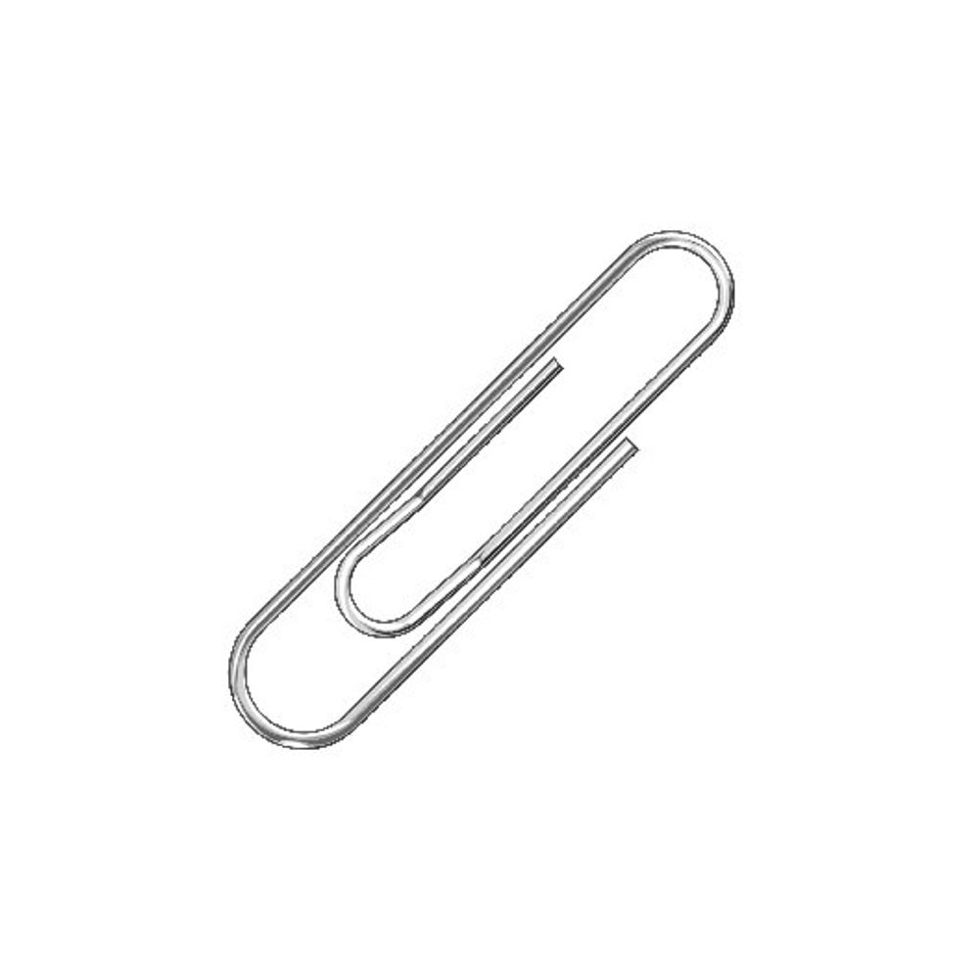
What do you think would happen if I dropped these objects from the same height?

_________________________________________________________________________________________________________________________________________________________________________________________________________________________________________________________________________________________________________________________________________________________________________________________________________________________________________________________________________________

Watch this video:

https://www.youtube.com/watch?v=ljRlB6TuMOU

What is gravity?

_________________________________________________________________________________________________________________________________________________________________________________________________________________________________________________________________________________________________________________________________________________________________________________________________________________________________________________________________________________

Experiment:

Flat paper vs Screwed paper
What will happen if I drop a flat piece of A4 paper horizontally at the same time as a piece of A4 paper screwed into a ball?

What do you predict will happen?

_________________________________________________________________________________________________________________________________________________________________________________________________________________________________________________________________________________________________________________________________________________________________________________________________________________________________________________________________________________

Complete investigation, what did you find?

_________________________________________________________________________________________________________________________________________________________________________________________________________________________________________________________________________________________________________________________________________________________________________________________________________________________________________________________________________________

Why do you think this happened? You may want to research answers.

_________________________________________________________________________________________________________________________________________________________________________________________________________________________________________________________________________________________________________________________________________________________________________________________________________________________________________________________________________________

Why does air resistance affect the flat paper more than the screwed up paper?

_________________________________________________________________________________________________________________________________________________________________________________________________________________________________________________________________________________________________________________________________________________________________________________________________________________________________________________________________________________

Who is correct?

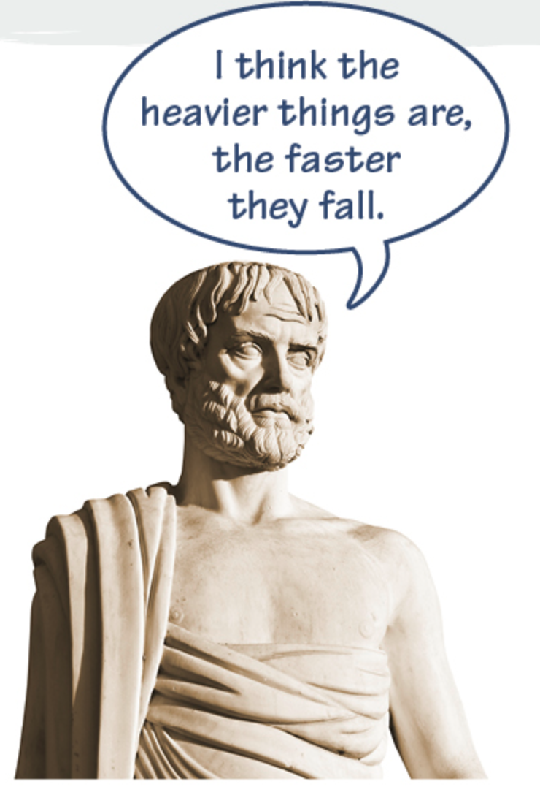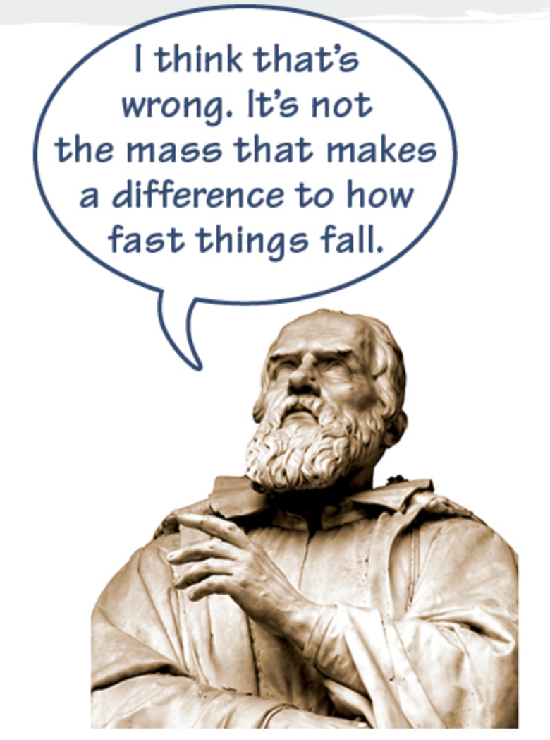
Aristotle or Galileo – research.
__________________________________________________________________________________________________________________________________________________________________________________________________________________________________________________________________________________________________________________________________________________________________________________________________________________________________________________________________________________________________________________________________________________________________________________________________________________________________________________________________________________________________________________________________________________________________________________________________________________________________________________________________________________________________________________________________________________________________

Plenary - Explain why gravity is important:

__________________________________________________________________________________________________________________________________________________________________________________________________________________________________________________________________________________________________________________________________________________________________________________________________________________________________________________________________________________________________________________________________________________________________________________________________________________________________________________________________________________________________________________________________________________________________________________________________________________________________________________________________________________________________________________________________________________________________

