LO: To learn the names and roles of Viking Gods, the creation of the universe and the end of the world.
HOM: To remain open to continuous learning.
Success criteria:
- I understand and can explain in my own words how Vikings thought the Universe was created.
- I understand the role and relationships of the most important Viking Gods.
- I understand and can explain in my own words how the world ends according to the Vikings.

Creation of the Universe
https://www.youtube.com/watch?v=8WbGEXzZgbY
Watch this video about the Viking Gods.
Make notes of the important information throughout.
Now answer these questions:
- Name the 2 groups of gods in Norse mythology.
________________________________________________________________________________________________________________________________________________
- What is the name of the Viking god of fire?
________________________________________________________________________
- What is the name of the chief of the god’s?
________________________________________________________________________
- What is the name of the Golden City that Odin creates for the gods?
________________________________________________________________________
- Where do the humans live?
________________________________________________________________________
- What is the name of the frozen land where the giants live?
________________________________________________________________________
- Frigg is the wife if which god?
________________________________________________________________________
- What did Odin’s ravens do?
________________________________________________________________________________________________________________________________________________________________________________________________________________________
- Who is Thor?
________________________________________________________________________________________________________________________________________________________________________________________________________________________
- Who is Freyja, what is she the goddess of?
________________________________________________________________________________________________________________________________________________________________________________________________________________________

TASK 1:
Choose either Odin or Thor and write an information paragraph (8/10 sentences) about them. (You can use the information from the video plus your own research)

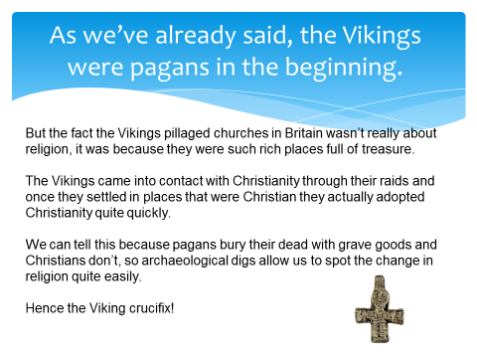

https://www.youtube.com/watch?v=68o_1Sc9Fjs
Now watch this clip about the end of the world.

Answer these questions:
- What was Ragnarok?
_____________________________________________________________________________________________________________________________________________________________________________________________________________________________________________
- How long did the winter last for?
_______________________________________________________________________________
- What was the purpose of the 3 roosters?
__________________________________________________________________________________________________________________________________________________________________________________________________________________________________________________________________________________________________________________________________________________________________________________________________________________________
- What was the ship the gods sailed on made from?
__________________________________________________________________________________
- Who slayed the serpent?
__________________________________________________________________________________
- Summarise ALL the events of Ragnarok.
__________________________________________________________________________________________________________________________________________________________________________________________________________________________________________________________________________________________________________________________________________________________________________________________________________________________________________________________________________________________________________________________________________________________________________________________________________________________________________________________________________________________________________________________________________________________________________________________________________________________________________________________________________________________________________________________________________________________________________________________________________________________________________________________________________________________________________________________________________________________________________________________________________________________________________________________________________________________________________________________________________________________________________________________________________________________________________________
In each of the four boxes below, draw a Viking god or goddess and write three sentences about them.

Research the answers to these questions. https://www.bbc.co.uk/bitesize/clips/zyy9wxs
Which do you think was the most important Viking God/Goddess and why?
Why would a Viking have preferred to die in battle than to die in bed?
What did the Vikings believe about death and the underworld?
Why did the Vikings eventually convert to Christianity? Do you think this would have been easy?
In the beginning, most Vikings were Pagans. What did this mean?
Viking Religious Beliefs

