LO: To identify existing examples of Longboats.
HOM: To use past knowledge.

Product Analysis
Longboat | Appearance | Durability | Materials | Dislike | Like | Comment
1

2

3

4

Look at the images on the following page. Describe their appearance, their durability and the materials you think they are made from. Decide whether you like or dislike this design and explain why.

- 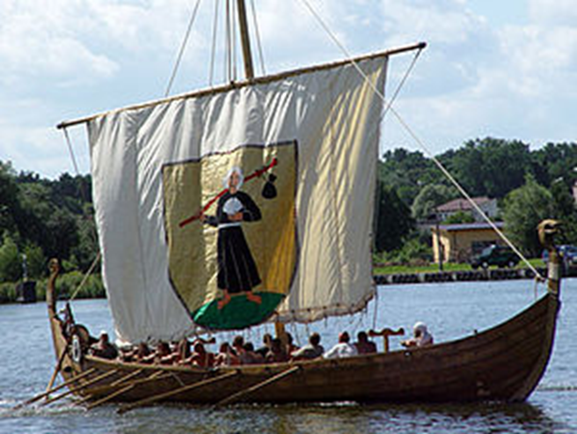

2.

 