LO: To investigate the effects of air resistance.  
HOM: Questioning and posing problems.

What is air resistance?

_________________________________________________________________________________________________________________________________________________________________________________________________________________________________________________________________________________________________________________________________________________________________________________________________________________________________________________________________________________

<https://www.bbc.com/bitesize/articles/zxw6gdm>

Look at the two diagrams below.

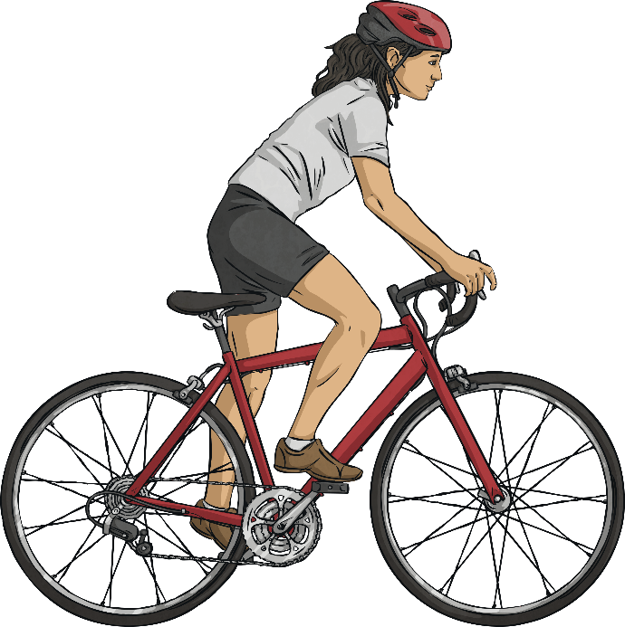

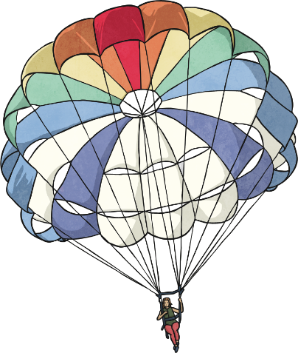



Which one shows a useful effect of air resistance, and which one shows an unhelpful effect of air resistance? Explain

_________________________________________________________________________________________________________________________________________________________________________________________________________________________________________________________________________________________________________________________________________________________________________________________________________________________________________________________________________________

__________________________________________________________________________________________________________________________________________________________________________________________

<https://www.youtube.com/watch?v=vZYwsAvHgVw>

The Super Skydiving Company are redesigning the parachute they use to allow people to perform skydives from aeroplanes. They want to make sure that the parachute they use allows their customers to fall from the aeroplane as slowly and safely as possible.

You are going to investigate a helpful effect of air resistance by finding the best design for their new parachute.

The perfect parachute will be the one that makes a person fall the slowest. It will cause air resistance to push it up with the biggest force.

Equipment - what equipment have you decided to use?

1) ____________________________________________________

2) ____________________________________________________

3) ____________________________________________________

4) ____________________________________________________

5) ____________________________________________________

6) ____________________________________________________

7) ____________________________________________________

8) ____________________________________________________

Attach something to the bottom of the parachute you have made.

Drop your parachute from the same height each time to ensure this is a fair test. Record the timings of each drop.

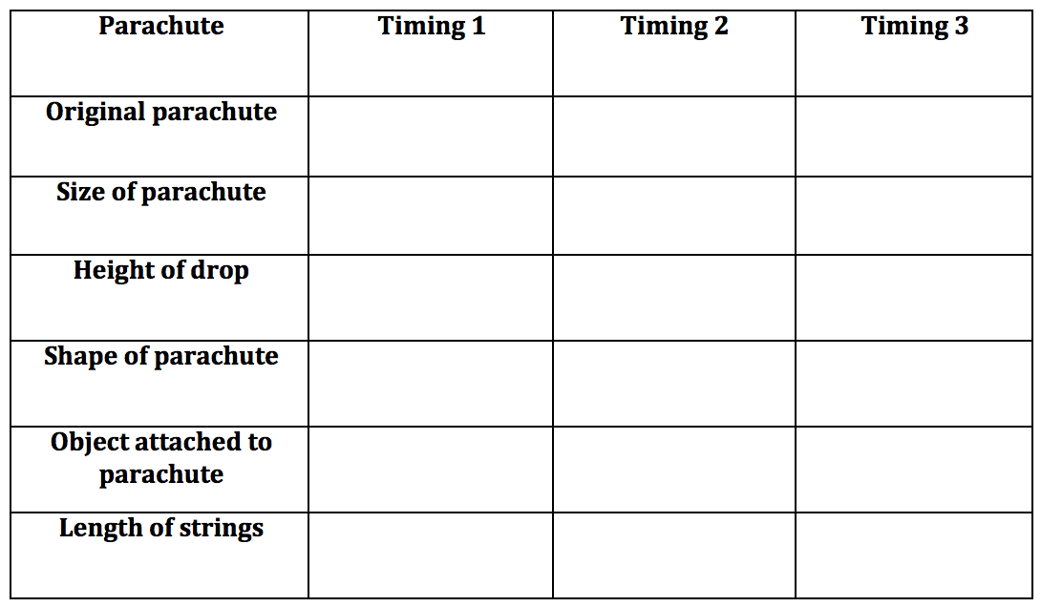

Identify the variables that you could change if they wanted to make a parachute that falls to the ground more slowly.

_________________________________________________________________________________________________________________________________________________________________________________________________________________________________________________________________________________________________________________________________________________________________________________________________________________________________________________________________________________

____________________________________________________________________________________________________________________________________________________________________________________________________________________________________________________________________________________________________________________________________________________________________________________