LO: To revise the gods from last lesson and learn about Norse mythology.
HOM: Communicating with clarity and precision.
Success Criteria:
- To know the gods and what their roles were.
- To learn a Viking myth and comprehend it.

TASK 1: This table of gods are all mixed up. Take what you have learned and go back over last week’s lesson to help you match the description with the correct god.

Thor | The “all father”, God of war
Baldur | God of war and God of the skies
Hel | Wife of Thor, Goddess of harvest
Loki | Queen of the Viking underworld
Odin | Goddess of wisdom
Sol | Trickster and God of mischief
Vor | God of fertility
Tyr | Goddess of Sun
Nott | Goddess of night
Freyr | Son of Odin and God of thunder and battle
Sif | God of revenge
Vali | God of beauty, innocence and peace
Can you fill in the blanks to work out the names of these Viking gods?
T_o_ _or
B_l_ur T_r
H_l N_ _t
L_ _ i Fre_ _
Od_ _ S_f
So_ V_ _i
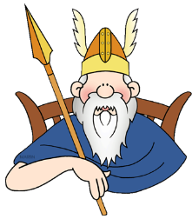

Read the myth of Sif and answer the questions.
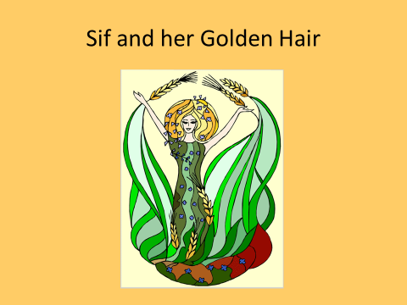
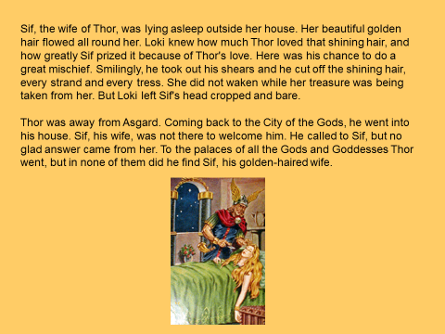
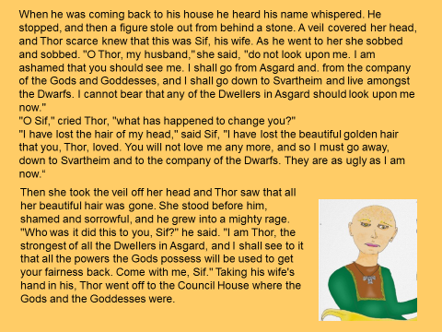
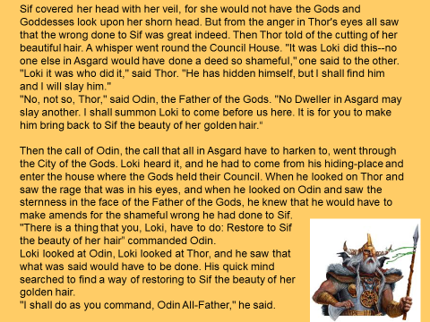
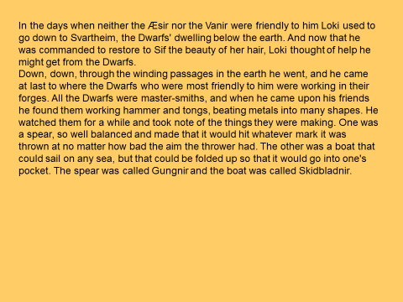
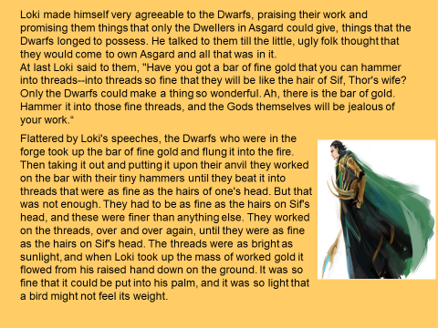
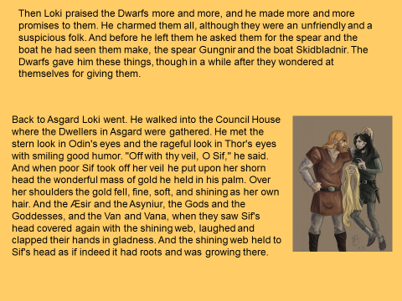
Questions:
- Why was Sif upset when Thor got home?
________________________________________________________________________________________________________________________________
- Where was Sif going to go?
________________________________________________________________________________________________________________________________
- What did Thor vow to do?
________________________________________________________________________________________________________________________________________________________________________________________________
- Who took Sif’s hair?
________________________________________________________________
- How did Loki fix the problem?
________________________________________________________________________________________________________________________________________________________________________________________________
- How do you think Sif felt when she got her new hair? Give 2 reasons for your answer.
________________________________________________________________________________________________________________________________________________________________________________________________________________________________________________________________

Write the script of the speech that would take place between Thor and Sif when she got her hair back.
Remember each speakers name in the margin, followed by a colon, then write the line they would say. No need for speech marks, and make sure you use correct punctuation.
Here is an example of the first 2 lines.
Sif: Oh my goodness Thor, look at these beautiful locks. I am so happy.
Thor: I told you I would do anything for you Sif.

