LO: To understand what water resistance is.
HOM: Taking responsible risks.

What is water resistance?

_________________________________________________________________________________________________________________________________________________________________________________________________________________________________________________________________________________________________________________________________________________________________________________________________________________________________________________________________________________

Do you think it is easier to run in air or in water? Explain your answer.

_________________________________________________________________________________________________________________________________________________________________________________________________________________________________________________________________________________________________________________________________________________________________________________________________________________________________________________________________________________

You will be investigating the best shape for the bow (front) of a speedboat.

Draw below what you think the best shape would be.

Why have you decided on this shape?
_________________________________________________________________________________________________________________________________________________________________________________________________________________________________________________________________________________________________________________________________________________________________________________________________________________________________________________________________________________

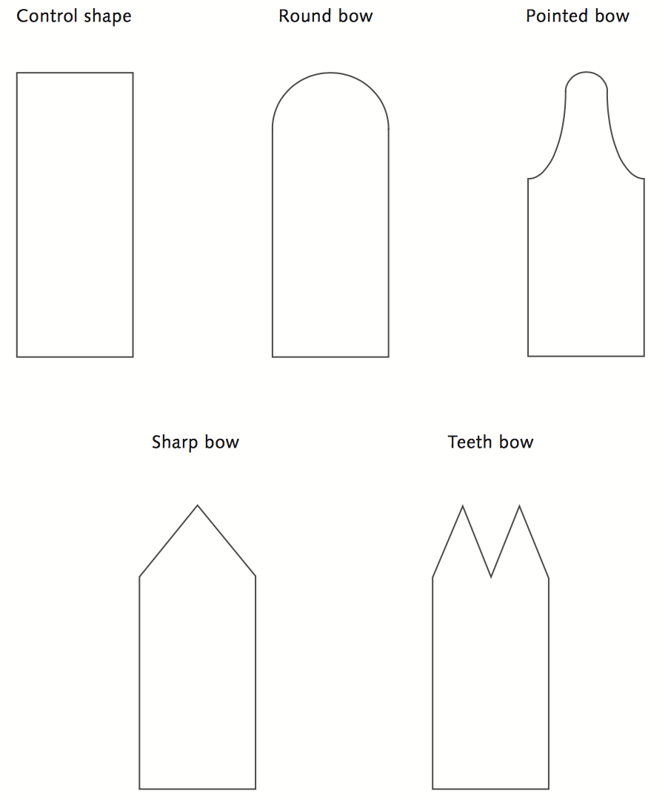

Make your prediction of what shape would get through the water best.

_________________________________________________________________________________________________________________________________________________________________________________________________________________________________________________________________________________________________________________________________________________________________________________________________________________________________________________________________________________

Investigation:

You may wish to conduct this as an experiment – if you have play-doh or clay or even a plastic milk bottle that you can cut or mould into these shapes.

Hold the shapes vertically, bow downwards, and partly submerged in a bubble bath mixture with the tip of the bow held at the start point.

Time how long it takes the bow to travel through the water.

Record your results:

To work out the average, you must calculate the mean. Add the results and divide by the number of times you’ve added.

Shape of bow | Test 1  Time (s) | Test 2  Time (s) | Test 3  Time (s) | Average  Time (s)

Write a conclusion about which shape would be best for a speedboat bow.

_________________________________________________________________________________________________________________________________________________________________________________________________________________________________________________________________________________________________________________________________________________________________________________________________________________________________________________________________________________

Why is it important for bows to be shaped this way?

_________________________________________________________________________________________________________________________________________________________________________________________________________________________________________________________________________________________________________________________________________________________________________________________________________________________________________________________________________________

