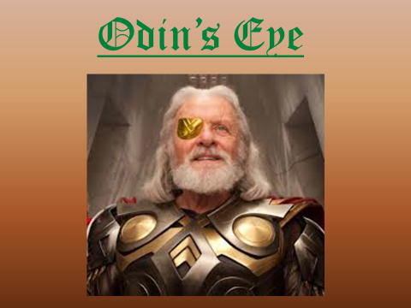
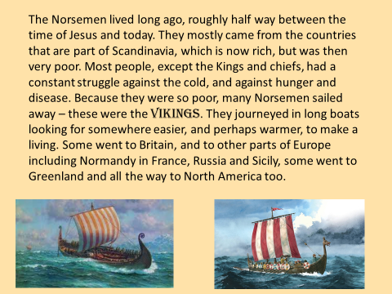
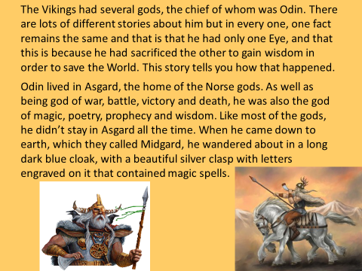
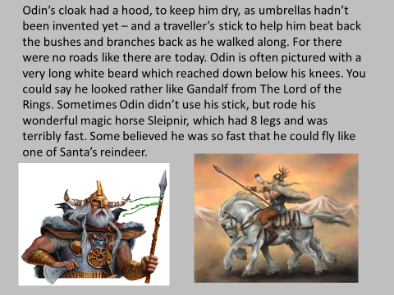
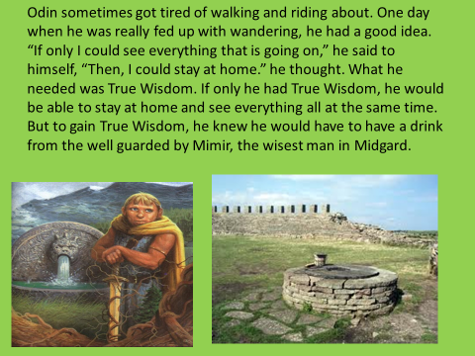
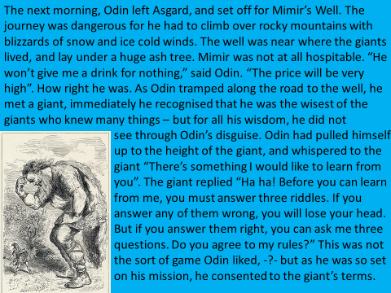
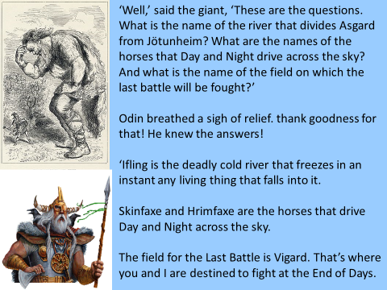
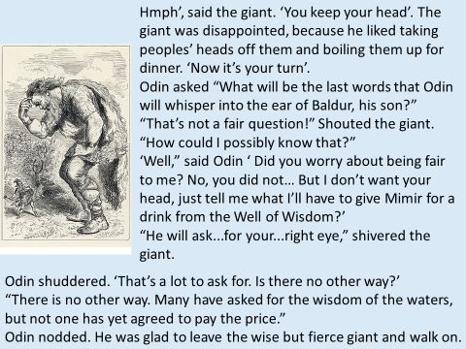
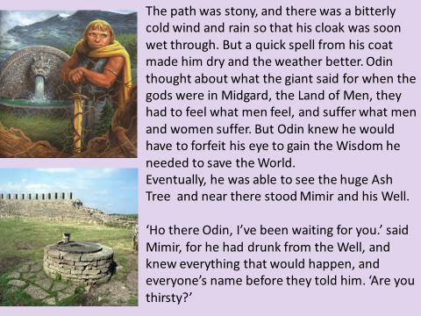
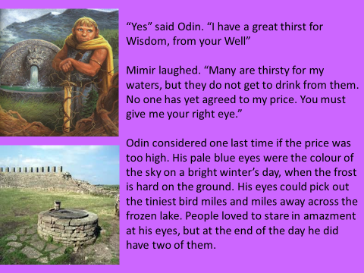
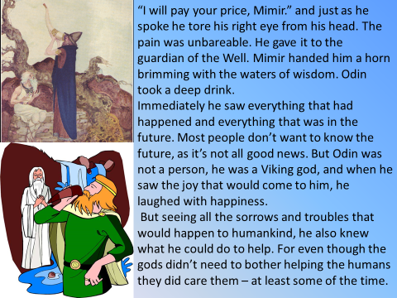
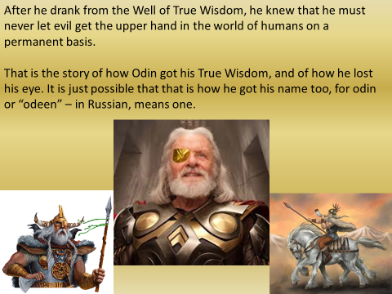
Answer these questions:
- Describe what Odin’s horse looked like?
____________________________________________________________________________________________________________________________________________________________________________________________________________________________________________________________________________________________________________
- Why did Odin want true wisdom?
____________________________________________________________________________________________________________________________________________________________________________________________________________________________________________________________________________________________________________
- What did the giant want Odin to do before he answered any questions?
____________________________________________________________________________________________________________________________________________________________________________________________________________________________________________________________________________________________________________
- Why was the giant disappointed when Odin answered his questions correctly?
____________________________________________________________________________________________________________________________________________________________________________________________________________________________________________________________________________________________________________
- What did Odin have to give Mirmir in order to drink from the well?
______________________________________________________________________________________________________________________________________________________
- What did Odin know after he drank from the well?
____________________________________________________________________________________________________________________________________________________________________________________________________________________________________________________________________________________________________________
- Now pick a scene from the story and draw it using the detail from the story.

