L.O To be able to place the Victorian period on a time line
HOM Applying Past Knowledge

Success Criteria:
I can consider where the Victorian period comes in time.
I can consider how the time period may affect the life of Victorians.
I can create a timeline of Victorian history.

Use task sheet 1. British History Timeline
Can you place the periods of time and events in the correct order? (cut and stick below)
Write two true of false questions about the timeline you have created. (eg. True or false – the Victorian times came before the atrocities of WWI and WWII)
_________________________________________________________________________________________________________________________________________________________________________________________________________________________________________________________________________________________________________________________________________________________________________________________________________________________________________________________________________________________________________________________

You will have heard things about the Victorian period. Complete the 5 bullet points with what you think you already know:
- ______________________________________________________________________________________________________________________________________________________________________________________________
- ______________________________________________________________________________________________________________________________________________________________________________________________
- ______________________________________________________________________________________________________________________________________________________________________________________________
- ______________________________________________________________________________________________________________________________________________________________________________________________
- ______________________________________________________________________________________________________________________________________________________________________________________________

Highlight the bullet point you think is the most accurate .

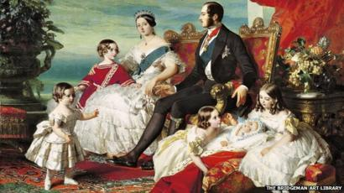

This is a picture of Queen Victoria with her husband Albert and some of her children. Do you recognise her?
What does the picture infer about the type of person Queen Victoria was?
____________________________________________________________________________________________________________________________________________________________________________________________________________________________________________________________________________________________________________________________________________________________________________________________________________________

On the 9th September 2015 Queen Elizabeth became the longest-reigning monarch when she surpassed the reign of her great-great-grandmother Victoria. Victoria’s reign lasted between 1841 and 1901.

Time to think…
What do you think life would have been like in Victorian times? What might have happened?
_____________________________________________________________________________________________________________________________________________________________________________________________________________________________________________________________________________________________________________________________________________________________________________________________________________________________________________________________________________________________________________________________________________________________________________________________________________________________________________________________________________________________________________________________________________________________________________________________________________________________________________________________________________________________________________________________________________

Use task sheet 2 – complete a Victorian time line (cut and stick, order the pictures)

