LO: To understand what life was like in the workhouse
HOM: Listening with understanding and empathy
Watch the clips. Make notes as you watch:
https://www.bbc.co.uk/programmes/p011m3yg
https://www.youtube.com/watch?v=-GX75XKoaKs
https://www.youtube.com/watch?v=-z8wZwg3mdc
Why do you think the workhouse existed?
______________________________________________________________________________________________________________________________________________________________________________________________________________________________________________________________________________________________________________________________________________________________________________________________________
Was it doing a good thing keeping people off the streets?
______________________________________________________________________________________________________________________________________________________________________________________________________________________________________________________________________________________________________________________________________________________________________________________________________
Victorian England was a hard place to live – the population had risen dramatically and poverty was increasing. Cholera had hit people hard and many children were orphaned.
The Poor Law Amendment Act of 1834 had ordered that any able bodied adult or child would only be given handouts if they lived and worked in the workhouses. Explain that in 1861 over 35,000 children were living and working in Victorian workhouses.
The Victorian government hated the idea of idleness and insisted on making the workhouses as desperately hard and miserable as possible to live in.

Do you think the workhouses were important to the Victorian era?
___________________________________________________________________________________________________________________________________________________________________________________________________
Research Victorian workhouses further and create a non-chronological report.
These websites will help:
http://www.primaryhomeworkhelp.co.uk/victorians/workhouses.html
http://www.primaryhomeworkhelp.co.uk/victorians/poor.html

Have a look at the information below before you start.
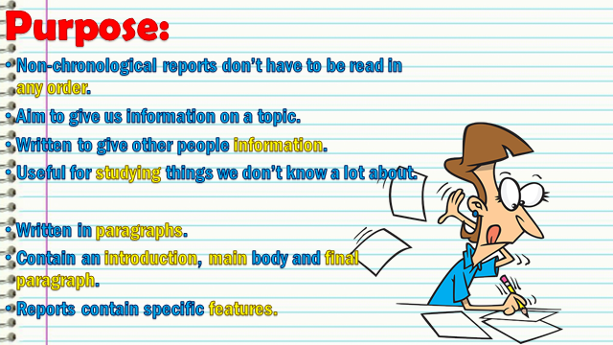
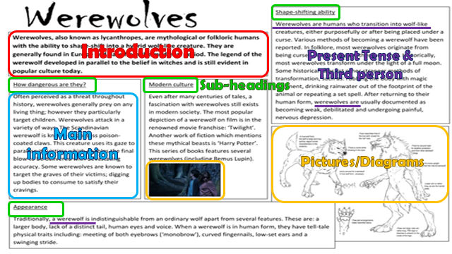
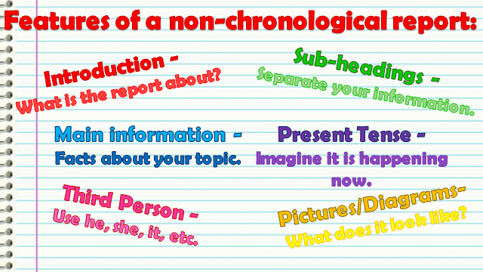
Use the next two pages for your report.

Non- Chronological Report

