L.O: To recognise that belief in the resurrection is a fundamental belief for Christians.
HOM- Thinking and communicating with clarity and precision

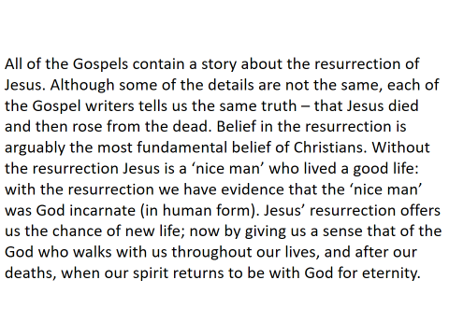
You are writing a letter to a friend explaining how and why the belief in the Resurrection is a fundamental belief for Christians.
Use the information below as a guideline to help you set out your work:
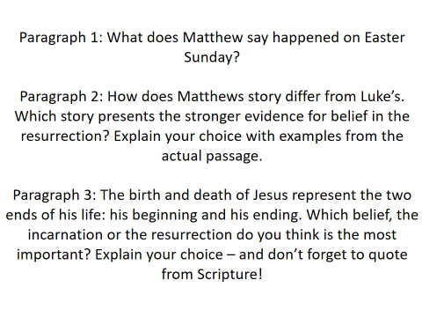

____________________________________________________________________________________________________________________________________________________________________________________________________________________________________________________________________________________________________________________________________________________________________________________________________________________________________
____________________________________________________________________________________________________________________________________________________________________________________________________________________________________________________________________________________________________________________________________________________________________________________________________________________________________
____________________________________________________________________________________________________________________________________________________________________________________________________________________________________________________________________________________________________________________________________________________________________________________________________________________________________
____________________________________________________________________________________________________________________________________________________________________________________________________________________________________________________________________________________________________________________________________________________________________________________________________________________________________
____________________________________________________________________________________________________________________________________________________________________________________________________________________________________________________________________________________________________________________________________________________________________________________________________________________________________
_______________________________________________________________________________________________________________________________________________________________________________________________________________________________________________________________________________________________________________________________________________________________________________________________________________________________________________________________________________________________________________________________________________________________________________________________________________________________________________________

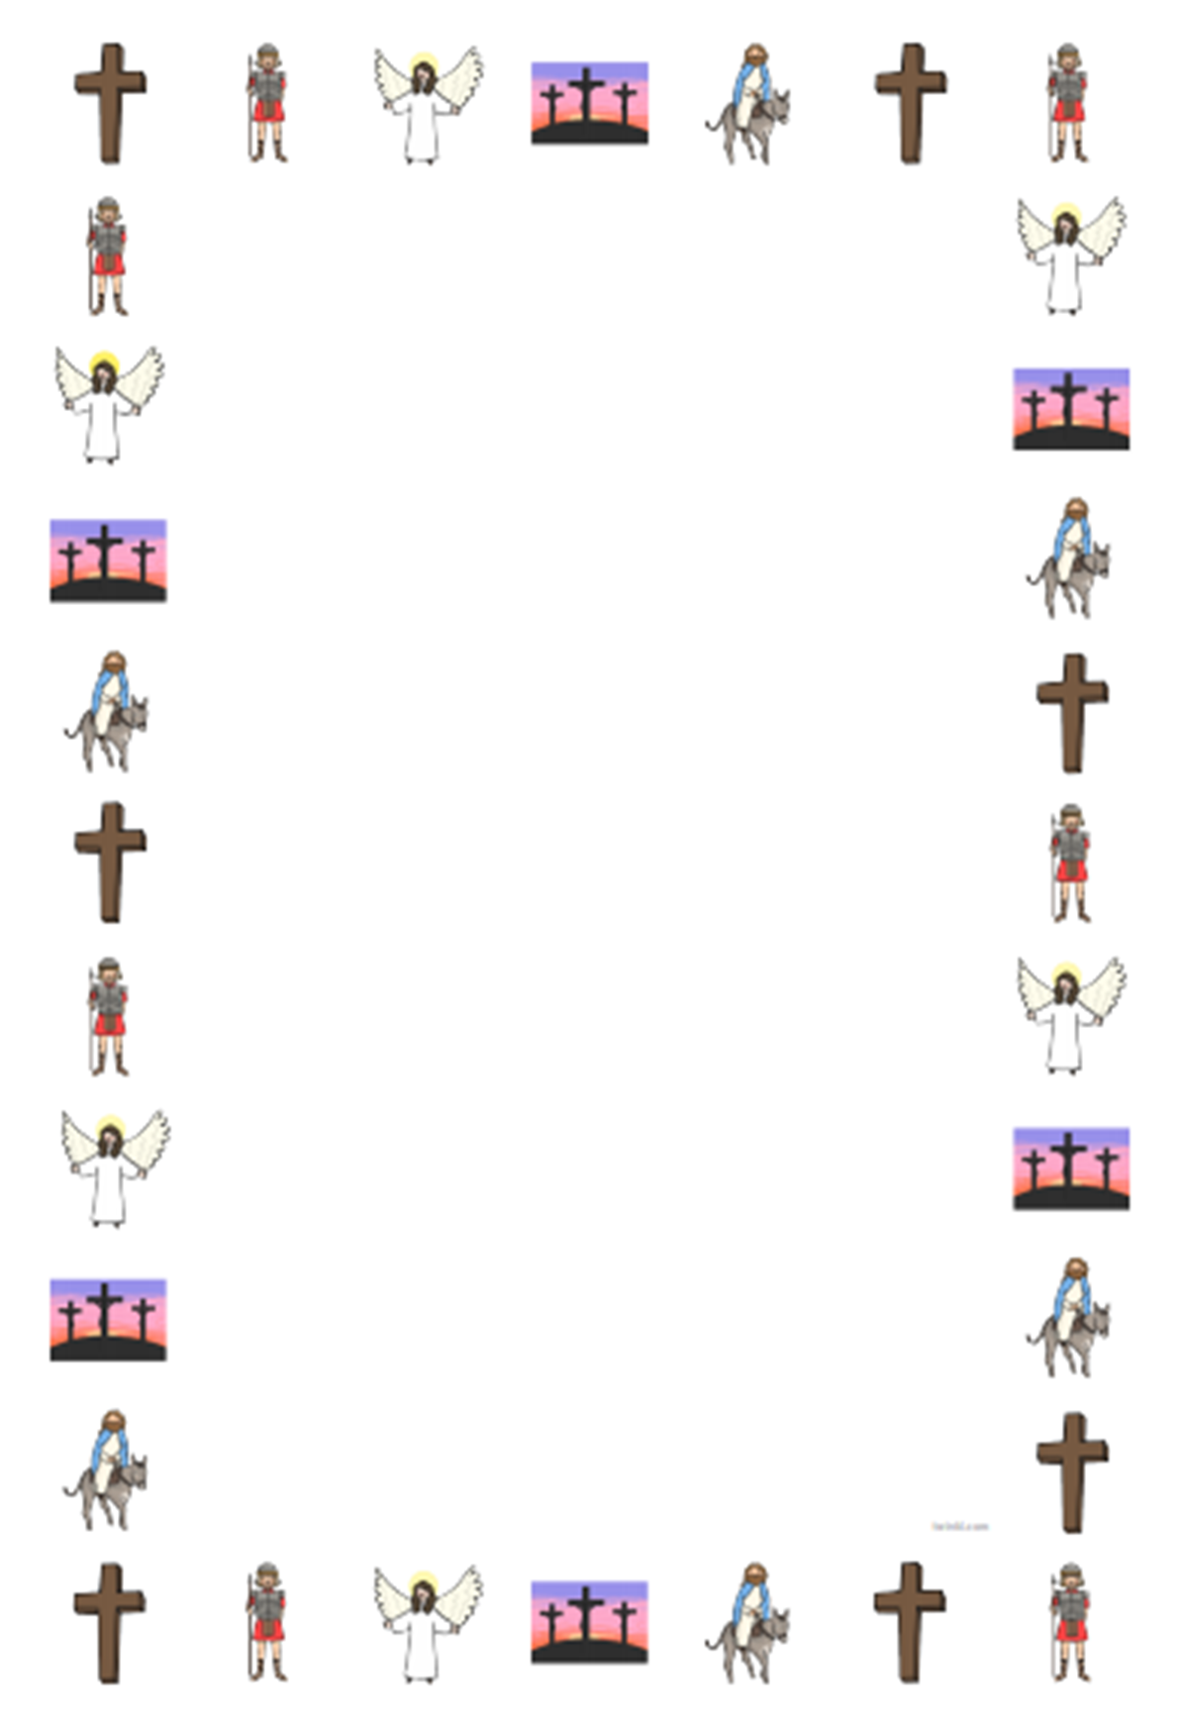
____________________________________________________________________________________________________________________________________________________________________________________________________________________________________________________________________________________________________________________________________________________________________________________________________________________________________________________________
____________________________________________________________________________________________________________________________________________________________________________________________________________________________________________________________________________________________________________________________________________________________________________________________________________________________________________________________
____________________________________________________________________________________________________________________________________________________________________________________________________________________________________________________________________________________________________________________________________________________________________________________________________________________________________________________________
____________________________________________________________________________________________________________________________________________________________________________________________________________________________________________________________________________________________________________________________________________________________________________________________________________________________________________________________
____________________________________________________________________________________________________________________________________________________________________________________________________________________________________________________________________________________________________________________________________________________________________________________________________________________________________________________________
_____________________________________________________________________________________________________________________________________________________________________________________________________________________________________________________________________________________________________________________________________________________________________________________________________________________________________________________________________________________________________________________________________________________________________________________________________________________________________________________________________________________________________________________________________________________________________________________________________________________________________________________________________

L.O to be able to explain that my choice of Easter symbol expresses the new life that the Resurrection offers. (AT 1 (i) lv3)
HOM: Thinking and Communicating with Clarity and Precision.
Choose two Easter symbols that show or express Matthew’s belief that Jesus Rose from the dead. Which symbols show the ‘new life’ that is promised by the Resurrection. Explain why.
_______________________________________  _______________________________________  _______________________________________  _______________________________________  _______________________________________  _______________________________________  _______________________________________  _______________________________________  _______________________________________  _______________________________________  _______________________________________  _______________________________________  _______________________________________  _______________________________________  _______________________________________  _______________________________________  _______________________________________  _______________________________________  _______________________________________  _______________________________________  _______________________________________  _______________________________________  _______________________________________  _______________________________________ | _______________________________________  _______________________________________  _______________________________________  _______________________________________  _______________________________________  _______________________________________  _______________________________________  _______________________________________  _______________________________________  _______________________________________  _______________________________________  _______________________________________  _______________________________________  _______________________________________  _______________________________________  _______________________________________  _______________________________________  _______________________________________  _______________________________________  _______________________________________  _______________________________________  _______________________________________  _______________________________________  _______________________________________

